Unit 1: Practice Questions

Part 1: What is Science?

1. Give three examples of scientific ideas that were determined to be incorrect. Explain the problem with each theory.
2. Explain why these examples of incorrect science ideas do not show a weakness in the scientific method, but rather show a strength in the scientific method.
3. Consider the following observations made about a cat (named Steamy Gene). Identify each observation as Qualitative, Quantitative or Neither

- The cat has short fur
- The cat has four legs
- The cat is very large
- Cats are better than dogs
- The cat is 108cm long
- The cat is 8.0kg
- The breed of that cat is a Maine Coon
- The cat is friendly
- The cat is grey
- Cats are mammals

4. Why do you think that the fact that an experiment can be repeated is so important?
5. I observe a man walking with an umbrella. I observe that it is raining. I conclude that when this man opened his umbrella it caused the rain. I make a hypothesis that whenever anyone opens an umbrella it rains. Explain how we can use the scientific method to test my hypothesis.
6. Explain why in the “Flat-Earth” example above the scientist cannot conclude that “The Earth must be a sphere”
7. I observe that when more people are wearing sweaters it is colder outside. I hypothesize that as people put on sweaters it causes the Earth to cool. I make very detailed measurements of the number of people in sweaters and the temperature by getting a team of top-notch scientists to sit on busy corners in cities all over the world and count the number of people wearing sweaters and measure the temperature every day for one year. I collect all the data and I analyze it. The measurements seem to confirm my hypothesis! The more people in sweaters, the lower the temperature. I am very excited as I predict that I can solve Global Warming and Climate Change by getting more and more people to put on sweaters! Explain the flaw in my reasoning.
8. Give 2 new examples (not given in the notes) of how things are classified in daily life.
9. Give an example of an observation that is not an estimate.
10. Explain the difference between an estimate and a measurement.
11. Give an example of a quantitative observation that does not require units.
12. In 1747 Benjamin Franklin published a paper explaining electricity as the flow of a liquid through certain materials. If an object had an increased amount, or too much, of this fluid it would have a positive charge, if the object had a decreased amount, or too little, of this fluid it would have a negative charge. Franklin outlined several experiments that were consistent with his ideas.
Is this an example of a law or a theory? Explain

13. For each of the following experiments identify the Independent Variable, the Dependent Variable and a list of Controlled Variables. Where possible identify the Experimental Control.

A. What type of insulation will best keep the coffee in an insulated cup hot?

Independent Variable: ________________________________________

Dependent Variable: _________________________________________

Controlled Variables: ______________________________________________________________________________________

Experimental Control: ________________________________________

B. How does the amount of salt in water affect the freezing point of the water?

Independent Variable: ________________________________________

Dependent Variable: _________________________________________

Controlled Variables: ______________________________________________________________________________________

Experimental Control: ________________________________________

C. How does the length of a pendulum affect the period of its swing?

Independent Variable: ________________________________________

Dependent Variable: _________________________________________

Controlled Variables: ______________________________________________________________________________________

Experimental Control: ________________________________________

D. The number of flowers on different breeds of bushes in a greenhouse is recorded every week for two months.

Independent Variable: ________________________________________

Dependent Variable: _________________________________________

Controlled Variables: ______________________________________________________________________________________

Experimental Control: ________________________________________

E. You give forty sunflowers different watering with either pure water or different concentrations of salt solutions. The flowers are split into four groups of ten. After a two-week period, the average height is measured.

Independent Variable: ________________________________________

Dependent Variable: _________________________________________

Controlled Variables: ______________________________________________________________________________________

Experimental Control: ________________________________________

F. You are asked to perform an experiment to see how the voltage of a battery affects the brightness of a lightbulb.

Independent Variable: ________________________________________

Dependent Variable: _________________________________________

Controlled Variables: ______________________________________________________________________________________

Experimental Control: ________________________________________

G. Pea plant clones are given different amounts of water for a three-week period. The first group receives 400 milliliters per day. The second group of pea plant receives 200 milliliters per day. The third group receives 100 milliliters per day. The fourth group of pea plants receives 50 mL of water per day. The height of the pea plants is recorded daily.

Independent Variable: ________________________________________

Dependent Variable: _________________________________________

Controlled Variables: ______________________________________________________________________________________

Experimental Control: ________________________________________

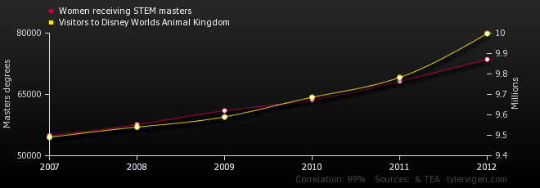

14. What type of correlation exists between women receiving masters degrees in STEM subjects and the number of visitors to Disney’s Animal Kingdom?
A. positive B. negative
C. no correlation D. cannot be determined
15. Which of the six explanations of correlations likely explains this data?
16. What type of correlation would you expect between speed of a car and braking distance?

Consider the following data that shows the pressure within a container versus the volume of the container. The amount of gas in the container and the temperature are controlled. In the experiment the volume of the container is directly altered by the experimenter and then the resulting pressure is measured.

Pressure (kPa) | 48 | 25 | 15 | 12 | 7 | 5 | 3 | 2 | 1
Volume (mL) | 10 | 20 | 30 | 40 | 60 | 100 | 150 | 200 | 500

17. Plot a scatterplot of the data.
SET ZERO AS THE LOWEST VALUE ON BOTH AXES!

Draw a TREND LINE for your data (if one exists).

18. What type of correlation exists? Circle the best choice from each grouping:

Positive OR Negative Strong OR Moderate OR Weak Linear OR Non-linear
19. A recent study showed that areas with more street lights had higher rates of automobile accidents than areas with few or no street lights. The study concluded that the street lights did NOT negatively impact the vision of drivers, but in fact improved vision. Provide a plausible explanation for this correlation.

20. In the Middle Ages, in Europe it was widely believed that lice prevented illness. This was because lice were extremely common but were rarely found on sick people. This was a false belief caused by an incorrect assumed causation. Research this and explain the true explanation for the correlation between the lack of lice and illness.
21. A scientist conducts an experiment to see how the flavour of a candy affects how quickly it is eaten by a child.
What is the DEPENDENT VARIABLE in this experiment?
22. A scientist conducts an experiment to see how the flavour of a candy affects how quickly it is eaten by a child.
What is the INDEPENDENT VARIABLE in this experiment?
23. A scientist conducts an experiment to see how the flavour of a candy affects how quickly it is eaten by a child.
List 3 CONTROLLED VARIABLES in this experiment?
24. A car company conducts an experiment to see how the design of the cars front bumper affects fuel economy. What is the INDEPENDENT VARIABLE?
25. A car company conducts an experiment to see how the design of the cars front bumper affects fuel economy. What is the DEPENDENT VARIABLE?
26. A car company conducts an experiment to see how the design of the cars front bumper affects fuel economy. List 3 variables that need to be CONTROLLED?
27. A scientist conducts an experiment to see how the vastibulation of a bwoog affects its tripipitude. What is the INDEPENDENT VARIABLE?
28. A scientist conducts an experiment to see how the vastibulation of a bwoog affects its tripipitude. What is the DEPENDENT VARIABLE?
29. Define OBSERVATION.
30. Define MEASUREMENT.
31. Explain the following statement: All measurements are observations, but not all observations are measurements.
32. Give an example of a QUALITATIVE observation about a cloud.
33. Give an example of a QUANTITATIVE observation about a cloud.
34. Give an example of a QUALITATIVE observation about a chair.
35. Give an example of a QUANTITATIVE observation about a chair.
36. Give an example of a MEASURMENT of a window.
37. Give an example of a QUALITATIVE observation of a window.
38. Give an example of a MEASUREMENT of a soccer ball.
39. Explain why repeatability is important for a scientific experiment.
40. Explain why it is important to have only one independent variable for an experiment to be valid.
41. Explain why, using a meter stick with the smallest division being millimetres, it would be almost impossible to determine the length of a living cat to the nearest millimeter.
42. You are told that a measurement of the mass of a baked potato is 412g $±$ 6g. This means that the mass of the potato could be anywhere between ______________g and _____________g.
43. You are told that the height of a tree is 24m $±$ 3m. This means that the height is between ____________ m and ______________ m.
44. A measurement of time for an event is known to be between 12.2s and 12.6s. Write that measurement as _______________________ $±$ _____________________.
45. What is the approximate height of the classroom in meters?
46. Make a sketch of a graph that shows a MODERATE, NEGATIVE, LINEAR relationship between 2 variables.
47. Make a sketch of a graph that shows a STRONG, POSITIVE, NON-LINEAR relationship between 2 variables.
48. Since 1986 +there has been a steady increase in both the number of Starbucks outlets and in average processing speed of laptop computers. What is the likely explanation of this correlation.
49. Do some research and find at least one example (not discussed in class) of a correlation explained by:
A. A causes C, which in turn causes B.
B. A and B have a common cause C.
50. In 1785 Charles-Augustine de Coulomb discovered that if particles with charge were brought close to each other they either attracted or repelled one-another. Through further studies he determined that the strength of this force increased as the charges were brought closer together and decreased if they were moved further apart. Using a very cleverly designed apparatus he found that the attraction or repulsion could be calculated mathematically by the following formula:

$$F=k\frac{Qq}{d^{2}}$$
Is this a scientific theory, or a natural law?
51. If you touch a hot piece of copper to a cold piece of copper, the hot copper will cool down and the cold copper will heat up. This can be explained by the molecular model of matter. The molecules of the hotter object are moving quickly, the molecules of the cooler object are moving slowly. When brought into contact the fast moving molecules collide with the slower molecules. These collisions cause the fast molecules to slow down, and the slow molecules to speed up.

Is the description above a natural law or a scientific theory?
56. Write 36520000000 in scientific notation.
57. Write 0.000000000000000265 in scientific notation.
58. Calculate: 2.22x10¹⁹ (7.11x10⁻⁵)
59. Calculate: $\frac{5.99x{10}^{13} }{9.21x{10}^{-6}}$
60. Consider the following graphs:
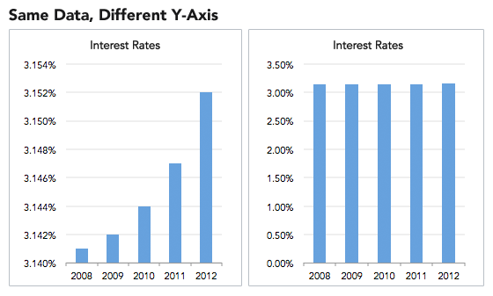

Explain why the graph on the left could be considered misleading.
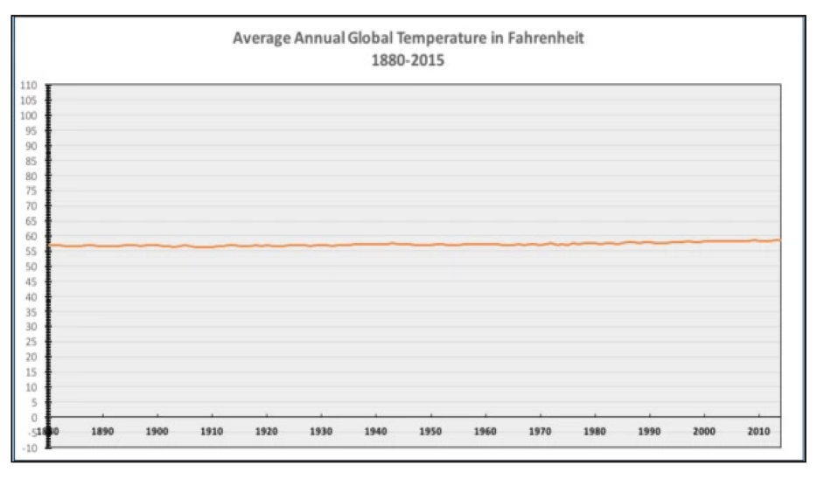
61. The following graph shows change in average global temperature from 1880-2014.

This graph has been used as “irrefutable evidence” that global warming is not real by climate change deniers. Explain what is wrong with this graph and the conclusion.
62. What is science?
63. Draw a neatly labelled diagram of a wombat wearing a cowboy hat, dancing a jig.

Unit 1: Practice Questions

Part 1: What is Science?

1. Give three examples of scientific ideas that were determined to be incorrect. Explain the problem with each theory.

Answers will vary. Some examples could include: miasma theory, phlogiston theory, Lamarckian evolution, phrenology, preformation theory, geocentrism the list goes on and on and on…

2. Explain why these examples of incorrect science ideas do not show a weakness in the scientific method, but rather show a strength in the scientific method.

The fact that incorrect or incomplete ideas are discredited implies that as time moves on our scientific understanding continually improves. If a scientific belief is completely wrong, it likely will not last for long.

3. Consider the following observations made about a cat (named Steamy Gene). Identify each observation as Qualitative, Quantitative or Neither

- The cat has short fur Qualitative
- The cat has four legs Quantitative
- The cat is very large Qualitative
- Cats are better than dogs Neither
- The cat is 108cm long Quantitative
- The cat is 8.0kg Quantitative
- The breed of that cat is a Maine Coon Qualitative
- The cat is friendly Qualitative
- The cat is grey Qualitative
- Cats are mammals Qualitative

4. Why do you think that the fact that an experiment can be repeated is so important?

Repeatability provided improved evidence and protects against experimental flaws and errors. Repeatability also protects against intentional (or non-intentional) “fudging” of the data.

5. I observe a man walking with an umbrella. I observe that it is raining. I conclude that when this man opened his umbrella it caused the rain. I make a hypothesis that whenever anyone opens an umbrella it rains. Explain how we can use the scientific method to test my hypothesis.

Design an experiment in which someone opens their umbrella and see if it rains as a result. Repeat if necessary. You only need a single event in which someone opens an umbrella and it doesn’t rain to disprove the hypothesis.

6. Explain why in the “Flat-Earth” example above the scientist cannot conclude that “The Earth must be a sphere”

Many other shapes could result in the same observations. The Earth could be cylindrical, for example.

7. I observe that when more people are wearing sweaters it is colder outside. I hypothesize that as people put on sweaters it causes the Earth to cool. I make very detailed measurements of the number of people in sweaters and the temperature by getting a team of top-notch scientists to sit on busy corners in cities all over the world and count the number of people wearing sweaters and measure the temperature every day for one year. I collect all the data and I analyze it. The measurements seem to confirm my hypothesis! The more people in sweaters, the lower the temperature. I am very excited as I predict that I can solve Global Warming and Climate Change by getting more and more people to put on sweaters! Explain the flaw in my reasoning.

If I define A as people putting on sweaters and B as decrease in temperature, then I have assumed that A causes B. In reality B causes A.

8. Give 2 new examples (not given in the notes) of how things are classified in daily life.

In the supermarket each aisle or section is a classification: meat, dairy, bread, frozen, produce…

9. Give an example of an observation that is not an estimate.

My toe hurts.

10. Explain the difference between an estimate and a measurement.

An estimate is an approximation based on prior knowledge and prior measurements. Estimates often do not involve the use of any tools.
A measurement is an approximation gathered by using a specific measurement tool, like a thermometer or a rules or a scale. It is still an approximation as no measuring device is perfect.

11. Give an example of a quantitative observation that does not require units.

There are 28 apples in this basket.

12. In 1747 Benjamin Franklin published a paper explaining electricity as the flow of a liquid through certain materials. If an object had an increased amount, or too much, of this fluid it would have a positive charge, if the object had a decreased amount, or too little, of this fluid it would have a negative charge. Franklin outlined several experiments that were consistent with his ideas.
Is this an example of a law or a theory? Explain

This is a theory. It is a theory as it attempts to explain how positive and negative charge arises and how electric charge moves between objects.

13. For each of the following experiments identify the Independent Variable, the Dependent Variable and a list of Controlled Variables. Where possible identify the Experimental Control.

A. What type of insulation will best keep the coffee in an insulated cup hot?

Independent Variable: type of insulation

Dependent Variable: Temperature of coffee

Controlled Variables: size of cup, amount of insulation, initial temperature of coffee, volume of coffee…

Experimental Control: Coffee in a non-insulated cup

B. How does the amount of salt in water affect the freezing point of the water?

Independent Variable: amount of salt

Dependent Variable: temperature at which water freezes

Controlled Variables: volume of water, other water additives

Experimental Control: water with no salt

C. How does the length of a pendulum affect the period of its swing?

Independent Variable: Length of the pendulum

Dependent Variable: Period of the pendulum’s swing

Controlled Variables: Mass of pendulum, angle of displacement of swing,

Experimental Control: None

D. The number of flowers on different breeds of bushes in a greenhouse is recorded every week for two months.

Independent Variable: Breed of bush

Dependent Variable: Number of flowers

Controlled Variables: Temperature, humidity, amount of water, time of watering, amount of sunlight…

Experimental Control: None

E. You give forty sunflowers different watering with either pure water or different concentrations of salt solutions. The flowers are split into four groups of ten. After a two-week period, the average height is measured.

Independent Variable: Concentration of salt solution

Dependent Variable: Average height

Controlled Variables: Amount of water, type of soil, amount of sunlight, temperature, humidity, soil type, size of pot…

Experimental Control: Flowers receiving pure water

F. You are asked to perform an experiment to see how the voltage of a battery affects the brightness of a lightbulb.

Independent Variable: Voltage of battery

Dependent Variable: Brightness of bulb

Controlled Variables: Type of bulb, how the circuit is wired,

Experimental Control: None

G. Pea plant clones are given different amounts of water for a three-week period. The first group receives 400 milliliters per day. The second group of pea plant receives 200 milliliters per day. The third group receives 100 milliliters per day. The fourth group of pea plants receives 50 mL of water per day. The height of the pea plants is recorded daily.

Independent Variable: Volume of water

Dependent Variable: Height of pea plants

Controlled Variables: Temp, sunlight, soil, pot size, time of watering, fetilizers…

Experimental Control: None

14. What type of correlation exists between women receiving master’s degrees in STEM subjects and the number of visitors to Disney’s Animal Kingdom?

A. positive B. negative
C. no correlation D. cannot be determined

15. Which of the six explanations of correlations likely explains this data? Coincidence

16. What type of correlation would you expect between speed of a car and braking distance? Positive

Consider the following data that shows the pressure within a container versus the volume of the container. The amount of gas in the container and the temperature are controlled. In the experiment the volume of the container is directly altered by the experimenter and then the resulting pressure is measured.

Pressure (kPa) | 48 | 25 | 15 | 12 | 7 | 5 | 3 | 2 | 1
Volume (mL) | 10 | 20 | 30 | 40 | 60 | 100 | 150 | 200 | 500

17. Plot a scatterplot of the data.
SET ZERO AS THE LOWEST VALUE ON BOTH AXES!

Draw a TREND LINE for your data (if one exists).

18. What type of correlation exists? Circle the best choice from each grouping:

Positive OR Negative Strong OR Moderate OR Weak Linear OR Non-linear

19. A recent study showed that areas with more street lights had higher rates of automobile accidents than areas with few or no street lights. The study concluded that the street lights did NOT negatively impact the vision of drivers, but in fact improved vision. Provide a plausible explanation for this correlation.

Areas with street lights are areas with more people and higher traffic. Areas without streetlights could be low volume rural areas. We cannot be sure without more data (information), however this seems like a plausible explanation.

20. In the Middle Ages, in Europe it was widely believed that lice prevented illness. This was because lice were extremely common but were rarely found on sick people. This was a false belief caused by an incorrect assumed causation. Research this and explain the true explanation for the correlation between the lack of lice and illness.

Lice are extremely sensitive to temperature. When ill a small rise in body temperature causes the lice to relocate and leave the host. So this is a classic case of reverse causation. The assumption was that A: Lack of Lice CAUSES B: Illness, when in fact the actual case is B: Illness causes A: Lack of Lice.

21. A scientist conducts an experiment to see how the flavour of a candy affects how quickly it is eaten by a child.
What is the DEPENDENT VARIABLE in this experiment? How quickly the candy is eaten
22. A scientist conducts an experiment to see how the flavour of a candy affects how quickly it is eaten by a child.
What is the INDEPENDENT VARIABLE in this experiment? Flavour of candy
23. A scientist conducts an experiment to see how the flavour of a candy affects how quickly it is eaten by a child.
List 3 CONTROLLED VARIABLES in this experiment? Same children representing a range of ages, ethnicities, genders etc. The candies would need to be the same size, same colour, same number of each flavour.
24. A car company conducts an experiment to see how the design of the cars front bumper affects fuel economy. What is the INDEPENDENT VARIABLE? Design of the bumper
25. A car company conducts an experiment to see how the design of the cars front bumper affects fuel economy. What is the DEPENDENT VARIABLE? Fuel economy
26. A car company conducts an experiment to see how the design of the cars front bumper affects fuel economy. List 3 variables that need to be CONTROLLED? The rest of the car, the driving conditions (speed, altitude, flat vs hill…), type of fuel used.
27. A scientist conducts an experiment to see how the vastibulation of a bwoog affects its tripipitude. What is the INDEPENDENT VARIABLE? vastibulation of a bwoog
28. A scientist conducts an experiment to see how the vastibulation of a bwoog affects its tripipitude. What is the DEPENDENT VARIABLE? tripipitude of a bwoog
29. Define OBSERVATION. Information gathered about an object or event using our 5 senses and any observational or measurement tools (like a microscope, ruler, scale, radiation detector, microphone…)
30. Define MEASUREMENT. Information gathered about an object using a tool to compare to a predetermined standard. The use of a tool to determine a precise bit of information about an object.
31. Explain the following statement: All measurements are observations, but not all observations are measurements.
In order to take any measurement we must use our senses to gather the information, even if that only means reading the tool. However, many observations do not require any special tool, like observing that is a sunny day.
32. Give an example of a QUALITATIVE observation about a cloud. That cloud is moving quickly. That cloud is very dark. That cloud is a cumulonimbus.
33. Give an example of a QUANTITATIVE observation about a cloud. That cloud has an altitude of 648m.
34. Give an example of a QUALITATIVE observation about a chair. That chair is expensive.
35. Give an example of a QUANTITATIVE observation about a chair. That chair costs $985
36. Give an example of a MEASURMENT of a window. The window 1.67m tall
37. Give an example of a QUALITATIVE observation of a window. The window is dirty
38. Give an example of a MEASUREMENT of a soccer ball. The soccer ball has a speed of 20m/s
39. Explain why repeatability is important for a scientific experiment. Getting the same result when an experiment is repeated is called replication. If research results can be replicated, it means they are more likely to be correct. Replication is important in science so scientists can “check their work. This helps protect against any bias on the part of experimenters and helps prevent any mistakes or flaws in experimental design.
40. Explain why it is important to have only one independent variable for an experiment to be valid. This is necessary for the experiment to be fair. If there are multiple independent variable it can difficult or impossible to determine which variable is responsible for the observed results.
41. Explain why, using a meter stick with the smallest division being millimetres, it would be almost impossible to determine the length of a living cat to the nearest millimeter. A cat moves. Act’s length will change depending on the position of the cat, when the cat breathes etc. Even if the cat is very cooperative and lies very still, the length will change as the cat breathes etc.
42. You are told that a measurement of the mass of a baked potato is 412g $±$ 6g. This means that the mass of the potato could be anywhere between 406g and 418g.
43. You are told that the height of a tree is 24m $±$ 3m. This means that the height is between 21m and 27m
44. A measurement of time for an event is known to be between 12.2s and 12.6s. Write that measurement as 12.4s $±$ 0.2s
45. What is the approximate height of the classroom in meters? 3m
46. Make a sketch of a graph that shows a MODERATE, NEGATIVE, LINEAR relationship between 2 variables.

47. Make a sketch of a graph that shows a STRONG, POSITIVE, NON-LINEAR relationship between 2 variables.
48. Since 1986 +there has been a steady increase in both the number of Starbucks outlets and in average processing speed of laptop computers. What is the likely explanation of this correlation.
Coincidence
49. Do some research and find at least one example (not discussed in class) of a correlation explained by:
A. A causes C, which in turn causes B.
B. A and B have a common cause C.
50. In 1785 Charles-Augustine de Coulomb discovered that if particles with charge were brought close to each other they either attracted or repelled one-another. Through further studies he determined that the strength of this force increased as the charges were brought closer together and decreased if they were moved further apart. Using a very cleverly designed apparatus he found that the attraction or repulsion could be calculated mathematically by the following formula:

$$F=k\frac{Qq}{d^{2}}$$
Is this a scientific theory, or a natural law?
Natural Law. This describes WHAT happens, summarized as a mathematical formuls, there is no attempt to explain WHY or HOW this happens.
51. If you touch a hot piece of copper to a cold piece of copper, the hot copper will cool down and the cold copper will heat up. This can be explained by the molecular model of matter. The molecules of the hotter object are moving quickly, the molecules of the cooler object are moving slowly. When brought into contact the fast moving molecules collide with the slower molecules. These collisions cause the fast molecules to slow down, and the slow molecules to speed up.
Is the description above a natural law or a scientific theory? This is a theory. There is an attempt to explain WHY the energy transfers between objects in terms of collisions between molecules.
56. Write 36520000000 in scientific notation. 3.652 x 10¹⁰
57. Write 0.000000000000000265 in scientific notation. 2.65x10⁻¹⁶
58. Calculate: 2.22x10¹⁹ (7.11x10⁻⁵) 1.57842x10¹⁵
59. Calculate: $\frac{5.99x{10}^{13} }{9.21x{10}^{-6}}$ 6.50x10¹⁷
60. Consider the following graphs:

Explain why the graph on the left could be considered misleading.
The scale on the y-axis makes it appear that there is a large change between 2008 when in fact the change is less than 0.1%.

61. The following graph shows change in average global temperature from 1880-2014.

This graph has been used as “irrefutable evidence” that global warming is not real by climate change deniers. Explain what is wrong with this graph and the conclusion.
This is a case in which the scale chosen for this graph is too large to show the detail necessary. The average annual temperature on Earth has never been as low as -10ºF or as high as 110ºF. Including those values on the scale is misleading.
62. What is science? Science is a process of gathering information about the natural universe. It involves EVIDENCE BASED REASONING, REPEATABLE CONTROLLED EXPERIMENTATION and PEER REVIEW. Science also includes the body of knowledge gained from this process.
63. Draw a neatly labelled diagram of a wombat wearing a cowboy hat, dancing a jig.
Answers may vary.

