Torque and Simple Machines (Levers)

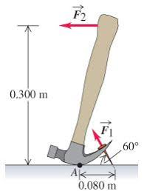

1. Consider the hammer shown in the diagram to the left. If the force required to pull the nail, F₁, is 1600N, find the minimum force that you would need apply on the handle, F₂.

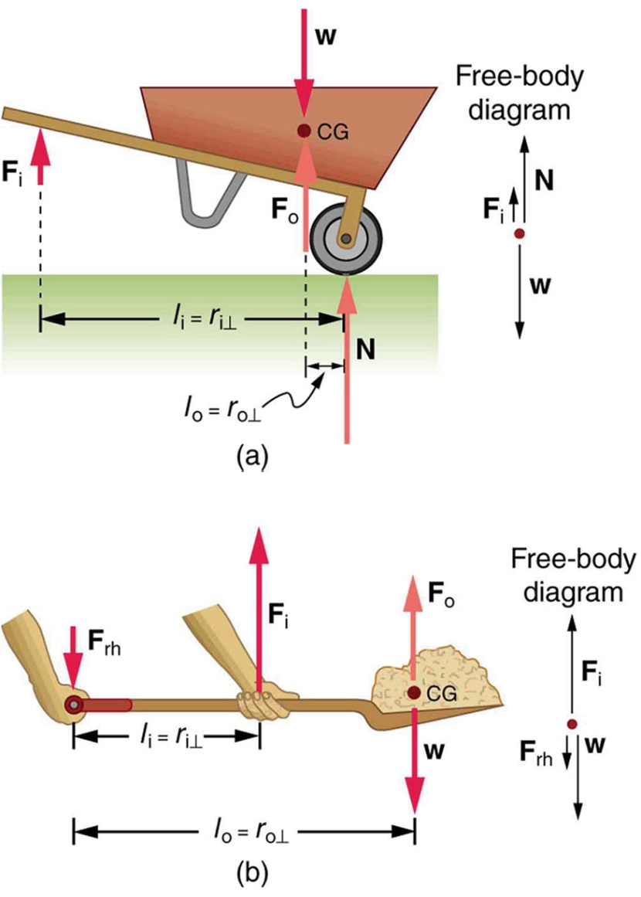
2. Consider the wheel-barrow shown. F_{i} is the input
force needed to hold the load off the ground. W
represents the combined weight of load in the
wheel-barrow and the wheel-barrow itself. N is the
normal force from the ground acting on the tire. If l_{o}
is 45cm and l_{i} is 1.52m, how much weight can be
moved with an input force of 420N?

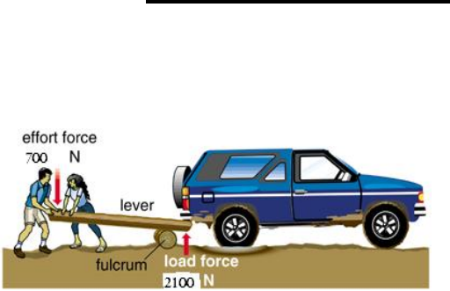
3. A driver has taken her vehicle off road and gotten stuck. In order to get un-stuck she needs to lift the rear of the vehicle out of a hole. She finds a sturdy 3.0m long piece of wood to use as a lever. If the combined mass of her and her passenger is 147kg, and the fulcrum is located as shown, how much force can she apply to the truck?
2.7m

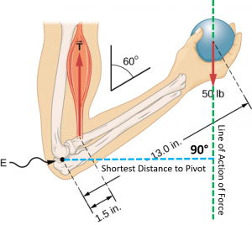
4. Find the force that must be applied by the bicep muscle in order to hold the ball in equilibrium. 1.0lb=4.4N. 1.0in=2.5cm.

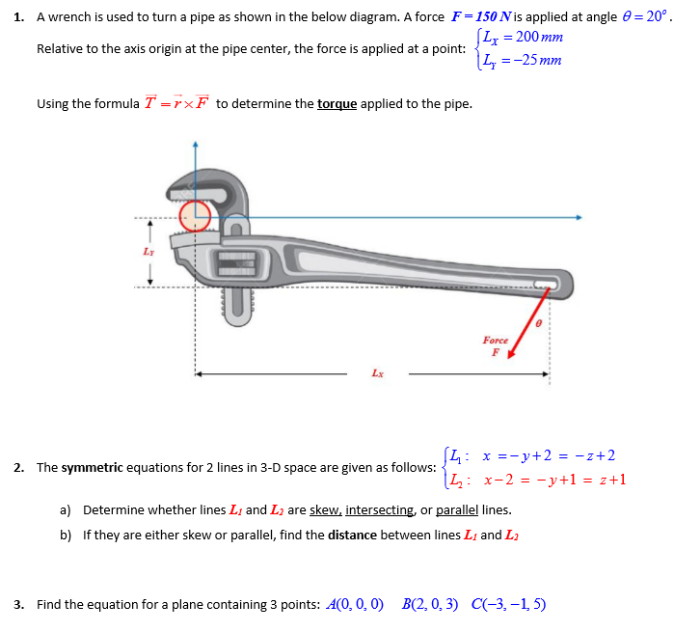
5. Consider the pipe wrench shown below. L_{y}=6.0cm, L_{x}=34.0cm and θ=27º. If the torque required to rotate the pipe is 225Nm, find the magnitude of the applied force, F.

