Thermal Energy Practice:
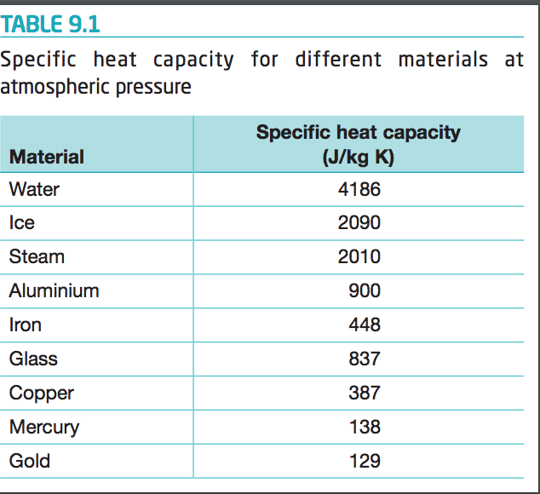
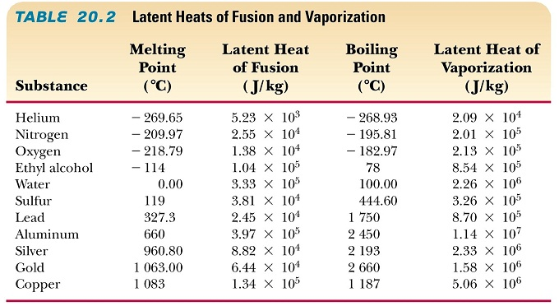

1. How much thermal energy is required to increase the temperature of 2.00kg of gold from 25ºC to 45ºC?
2. How much thermal energy is required to increase the temperature of 2.00kg of copper from 25ºC to 45ºC?
3. How much thermal energy is required to increase the temperature of 2.00kg of aluminum from 25ºC to 45ºC?
4. How much thermal energy is required to increase the temperature of 2.00kg of water from 25ºC to 45ºC?
5. How much thermal energy is required to increase the temperature of 100kg of copper from 16.2ºC to 88.1ºC?
6. How much thermal energy is released by a 222g piece of ice as it changes temperature from -6.0ºC to -24ºC?
7. How much thermal energy must be absorbed from a 4.0kg block of iron to change its temperature from 220ºC to -15ºC?
8. How much thermal energy must be absorbed from the 7.3 million kilogram Eiffel Tower as its temperature changes from a August daytime high temperature of 34ºC to a nighttime low temperature of 22ºC? The Eiffel tower is constructed of iron.
9. A 244g piece of aluminum has its temperature change from 190ºC to 40ºC. Is thermal energy absorbed or released? How much energy?
10. A 6.2Gg piece of gold (worth $418 376 000 000) has its temperature change from 16ºC to 24ºC. Is thermal energy absorbed or released? How much energy?
11. A 60g piece of copper at 80ºC is brought into contact with a 60g piece od aluminum at 40ºC. What is the temperature at equilibrium?
12. A 200g piece of iron at 220ºC is dropped into a 10L jug of water (1L of water is 1kg) at 18ºC. What is the temperature at equilibrium?
13. How much energy is needed to convert a 573g sphere of solid aluminum at 660ºC into liquid aluminum at 660ºC?
14. How much energy is needed to convert 2.0L of water at 100ºC to steam at 100ºC?

