Science 10: Life, Adaptations and Natural Selection

1. Explain the meaning of fitness in terms of ecology.
Fitness is an organism’s ability to survive and reproduce.
2. Explain why variation within a species is necessary for natural selection.
Natural selection means that under certain conditions a particular trait or set of traits will provide individuals with a competitive advantage and those traits may be passed on to their offspring. If all individuals are identical, there is no difference in traits, and thus no change can occur.
3. Explain the difference between a scientific theory and a natural law.
Both theories and laws in science are supported by evidence and experimentation. Both have been repeatedly tested and have been confirmed through peer review. The difference is that A LAW STATES WHAT HAPPENS WITH NO ATTEMP TO EXPLAIN WHY, A THEORY PROVIDED AN EXPLAINATION FOR WHY OR HOW SOMETHING HAPPENS.
4. Which of the following situations would most likely lead to the greatest amount of evolution within a species?
C. A large population with scarce food and many predators.
5. Briefly explain how geographic separation can lead to speciation.
If two populations are separated they cannot inter-breed. Thus as each group faces separate evolutionary pressures, they will evolve in different ways. If enough time passes, it is possible that the two populations will have changed enough that can no longer breed. By definition these are now separate species.
6. A species of bird on a certain island ranges in size from 18cm tall up to 38cm tall. The height differences are consistent across genders. Most birds fall into the range of 20cm-26cm. Describe a situation (an evolutionary pressure) that could lead to the birds evolving into a taller average height.
There are many possible answers. You need to think of a situation in which a taller height would be advantageous to these birds. EXAMPLE: These birds eat insects that live in the bark near the base (from the ground to about 50cm above ground) of a certain type of tree. A fungus develops that damages the bark in the bottom 30cm of the trees. Only individuals that are over 30cm tall can easily obtain food above the 30cm mark. Taller birds have easier access to food, thus are healthier and will be more likely to mate. Shorter birds will have much more difficulty obtaining food and may starve. The tall trait will be passed on more than the short trait and the population will become taller over time.
7. A species of bird on a certain island ranges in size from 18cm tall up to 38cm tall. The height differences are consistent across genders. Most birds fall into the range of 20cm-26cm. Describe a situation (an evolutionary pressure) that could lead to the birds evolving into a shorter average height.
There are many possible answers. You need to think of a situation in which a shorter height would be advantageous to these birds. EXAMPLE: These birds are the prey to a type of small mammal. The birds hide within the leaves of a type a bush. A disease kills off many of these bushed, leaving only low grasses for cover. Shorter birds will be better hidden in the shorter grass and thus will be more likely to survive. Taller birds are more likely to be eaten. The shortness trait will be passed on more than the tallness trait and over time the population will become shorter.

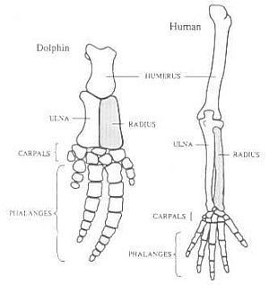

8. Explain how the similar structures between the bones in a dolphin flipper and the bones in a human arm provide evidence for evolution by natural selection.

The similarities in the structure show how a series of small changes could lead to the evolution of an arm from a flipper or a flipper from an arm. If these structures were completely unrelated, there would be no reason for the striking similarities in their form.

9. What are the four factors necessary for evolution by natural selection.
1. Overpopulation
2. INTRA-species competition
3. Variation within the species
4. Reproduction
10. What is the name of the scientist that proposed the theory of natural selection.
Charles Darwin
11. What organisms did the scientist in Q10 use to explain the concept of adaptive radiation?
Galapagos Finches
12. On what archipelago (island group) did Charles Darwin make his most famous observations?
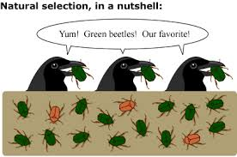
The Galapagos Islands.

13. Use the diagram to the right to explain how the population of beetles may evolve over time. Include the following terms: competition, trait, variation, reproduction, heritable.
There is a variation in the colour of the beetles, this gives the red beetles an advantage in competition with green beetles. As the green bugs are eaten, the red bugs will be more likely to live long enough to reproduce (reproduction). If the trait for colour is heritable the population will become more red over time.

14. Fill in the blanks: Choose from the following: evolution, natural selection, variation, fitness, traits, competition.

Darwin’s theory of natural selection proposed that evolution occurs as beneficial traits are passed from one generation to the next. Within any population there is a certain amount of competition for resources. Differences between individuals, or variation, means that some individuals will be more likely to survive and reproduce. Those who reproduce are said to have higher fitness.
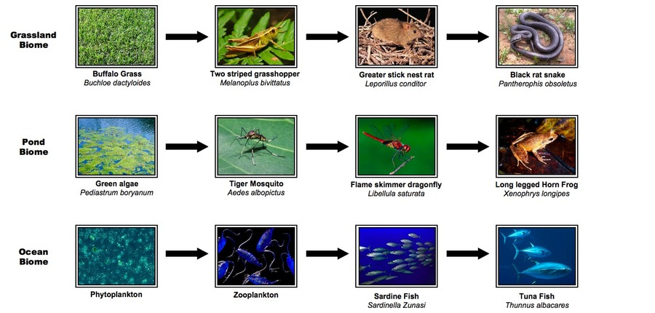

Use the Above Diagram of Food Chains to Answer Questions 15-18 Below:

15. In the ocean biome which organism is the primary consumer? zooplankton
16. In the pond biome which organism is on the first trophic level? green algae
17. In the grassland biome which organism is the tertiary consumer? black rat snake
18. In the pond biome there is 250 000 000J of energy at the producer level. How much energy is there at the secondary consumer level? 2 500 000J

Use the Food Chain Below for Questions 19-22
Grass Grasshopper Mouse Snake Hawk
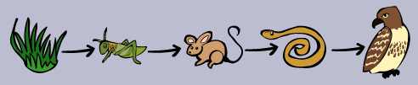

19. In the above food chain which organism is the secondary consumer? mouse
20. At which trophic level is the snake? 4th
21. Which organism is an herbivore? grasshopper
22. Which organism is at the second trophic level? grasshopper

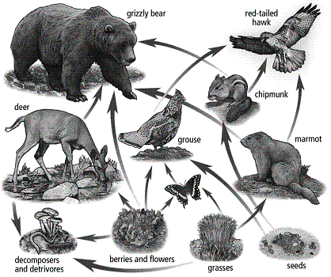
Consider the food chain shown to the left for questions 23-28

23. Which organisms are PRODUCERS? Berries and flowers, grasses, seeds
24. Which organisms are PRIMARY CONSUMERS? butterfly, deer, marmot, chipmunk, grouse, grizzly bear
25. Which organisms are TERTIARY CONSUMERS? red-tailed hawk
26. Which organisms are at more than one level? grouse, grizzly bear, red-tailed hawk
27. Write 2 different food chains that begin at grasses and end at hawk. 1. grasses→marmot→hawk
2. grasses→butterfly→grouse→hawk
28. Which organisms are omnivores? grizzly bear, grouse

29. What are the 7 conditions for life?
1. Reproduction (ability to reproduce)
2. Composed of cells
3. Metabolism. Living things consume energy, produce waste and perform gas-exchange.
4. Respond to stimuli
5. Growth
6. Adapt to changes in environment
7. Homeostasis. Living things maintain internal environment.
30. List the five categories (kingdoms) of living thing, with a brief description of each.
1. Monera: simplest living thing. Unicellular, no internal organelles.
2. Protists: Unicellular. Have internal structures like a nucleus. May perform photosynthesis.
3. Fungi: Multicellular. Do not perform loco-motion. Do not perform photosynthesis. Usually decomposers.
4. Plants: Multicellular. Perform photosynthesis. Do not perform locomotion.
5. Animals: Multicellular. Do not perform photosynthesis. Perform locomotion.
31. What is an adaptation?
Any way that an organism is suited to its own niche. Any change to an organism’s structure or function that increases its fitness.
32. Give five examples of structural adaptations of animals. For each explain its function and how it helps the animal survive (food, protection, reproduction, shelter…)
1. Cat’s claws. Helps cat climb to chase prey and avoid predators.
2. Giraffes neck. Helps reach food on higher branches.
3. peacocks tail fan. Helps to attract a mate.
4. Owls’ eyes. Adapted to see at night to help catch prey.
5. Fish gills. Allow fish to obtain oxygen from water.
6. Elephants large ears. Act as a radiator to allow the elephant to cooldown by radiating heat to the air.
7. Sloths curved toenails/claws. Allow the sloth to hang securely from tree branches to avoid predation.
8. The size of a buffalo. Protects it from predation.
33. Give five examples of structural adaptations of plants. For each explain its function and how it helps the plant survive (food, protection, reproduction, shelter…)
1. Flowers. Attract pollinators (bees) to spread pollen and help in reproduction.
2. Heat activated seed pods. Allow plants to release seeds in the event of a fire, allowing regrowth to occur.
3. Large leaves of the Hosta. Captures a lot of sunlight for photosynthesis.
4. Cone shape of pine trees. Prevents the build-up of snow that could crush the tree.
5. Needles on a cactus. Provides shade and protects against herbivory.
6. Long deep tap root of a cactus. Allows the cactus to reach water held far below the surface in times of drought.
7. Height of an oak tree. Allows the tree to absorb sun while shading the ground below, preventing other plants from obtaining sunlight.
8. Fruit on apple tree. Attracts animals to eat fruie, seeds are not digested and are spread in the animal’s feces.

34. Give three examples of physiological adaptations of animals. For each explain its function and how it helps the animal survive (food, protection, reproduction, shelter…)
answers will vary
35. Give three examples of physiological adaptations of plants. For each explain its function and how it helps the plant survive (food, protection, reproduction, shelter…)
answers will vary
36. Give three examples of behavioural adaptations of animals. For each explain its function and how it helps the animal survive (food, protection, reproduction, shelter…)
answers will vary
37. Give three examples of behavioural adaptations of plants. For each explain its function and how it helps the plant survive (food, protection, reproduction, shelter…)
answers will vary
38. Which of the following symbiotic relationships is considered parasitic?
  - ticks feeding on a dog
39. Humans have hundreds of species of bacteria that live within our digestive tract. Without these bacteria we would not be able to absorb many of the nutrients from our food. What type of relationship is this?
mutualism
40. What does symbiosis mean?
A close life-long relationship between organisms of different species.
41. A bird making a nest in a tree is an example of
D. commensalism
42. Which of the following is a symbiotic relationship where one partner benefits and the other does not benefit or lose from the relationship?
A. commensalism
43. Explain what type of relationship is shown below. Explain how each organism is affected.
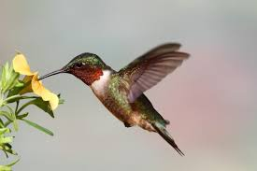
mutualism. The bird benefits by getting food. The flower will benefit by having the bird spread its pollen to other flowers, thus helping it to reproduce.

44. Give two ways in which PREDATION and PARASITISM are similar.
1. It is a lifelong relationship between organisms of different species.
2. One species benefits (predator), the other species is harmed (prey)

Use the reaction below to answer this question:
Energy + CO₂ + H₂O → C₆H₁₂O₆ + O₂
(sugar)
45. Which of the following is true of the reaction above?

A. This is photosynthesis and it is performed by producers

Use the reaction below to answer this question:
C₆H₁₂O₆ + O₂ → Energy + CO₂ + H₂O
(sugar)
46. Which of the following is true of the reaction above?
C. This is cellular respiration and it is performed by producers and consumers

