Science 10: Ecology

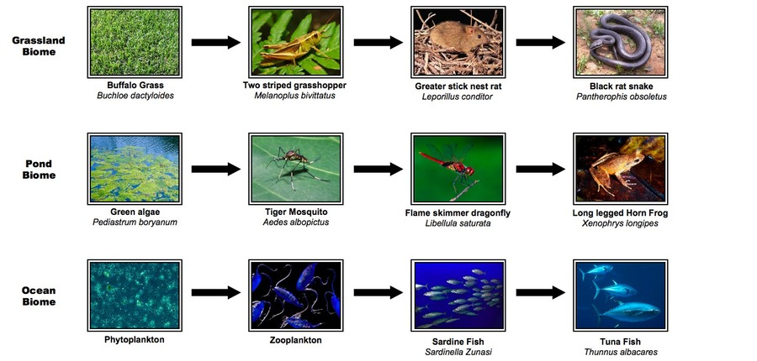

Use the Above Diagram of Food Chains to Answer Questions 1-6 Below:

1. In the ocean biome which organism is the primary consumer?
2. In the pond biome which organism is on the first trophic level?
3. In the grassland biome which organism is on the third trophic level?
4. In the grassland biome which organism is the tertiary consumer?
5. In the ocean biome which organism is the producer?
6. In the pond biome there is 250 000 000J of energy at the producer level. How much energy is there at the secondary consumer level?

Use the Food Chain Below for Questions 7-11
Grass Grasshopper Mouse Snake Hawk
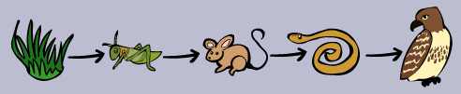

7. In the above food chain which organism is the secondary consumer?
8. At which trophic level is the snake?
9. Which organism is an herbivore?
10. Which organism is a top predator?
11. Which organism is at the second trophic level?

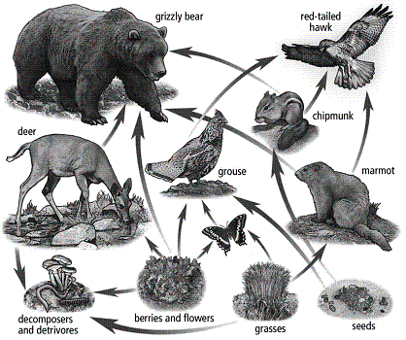
Consider the food chain shown to the left for questions 12-21

12. Which organisms are PRODUCERS?
13. Which organisms are PRIMARY CONSUMERS?
14. Which organisms are SECONDARY CONSUMERS?
15. Which organisms are TERTIARY CONSUMERS?
16. Which organisms are QUATERNIARY CONSUMERS?
17. Which organisms are at more than one level?
18. Write 2 different food chains that begin at grasses and end at hawk.
19. Which organisms are omnivores?
20. Which organisms are herbivores?
21. Which organisms are carnivores?

22. What are the 6 conditions for life?
23. List the five categories (kingdoms) of living thing, with a brief description of each.
24. What is an adaptation?
25. Give five examples of structural adaptations of animals. For each explain its function and how it helps the animal survive (food, protection, reproduction, shelter…)
26. Give five examples of structural adaptations of plants. For each explain its function and how it helps the plant survive (food, protection, reproduction, shelter…)
27. Give three examples of physiological adaptations of animals. For each explain its function and how it helps the animal survive (food, protection, reproduction, shelter…)
28. Give three examples of physiological adaptations of plants. For each explain its function and how it helps the plant survive (food, protection, reproduction, shelter…)
29. Give three examples of behavioural adaptations of animals. For each explain its function and how it helps the animal survive (food, protection, reproduction, shelter…)
30. Give three examples of behavioural adaptations of plants. For each explain its function and how it helps the plant survive (food, protection, reproduction, shelter…)
31. Which of the following symbiotic relationships is considered parasitic?
  - ticks feeding on a dog
  - bees transporting pollen from flowers
  - pilot fish swimming under sharks
  - birds eating the insects from the back of a hippopotamus
32.

33. What does symbiosis mean?
34. What type of relationship is mutualism?
A. One species benefits and the other is not affected at all.
B. Both species involved benefit from the relationship.
C. One Species benefits and the other is harmed.
D. Both Species involved are harmed from the relationship.
E. One species is harmed the other is not affected.
35. What type of relationship is parasitism?
A. One species benefits and the other is not affected at all.
B. Both species involved benefit from the relationship.
C. One Species benefits and the other is harmed.
D. Both Species involved are harmed from the relationship.
E. One species is harmed the other is not affected.
36. What type of relationship is commensalism?
A. One species benefits and the other is not affected at all.
B. Both species involved benefit from the relationship.
C. One Species benefits and the other is harmed.
D. Both Species involved are harmed from the relationship.
E. One species is harmed the other is not affected.
37. A bird making a nest in a tree is an example of
A. predation B. mutualism C. parasitism D. commensalism E. competition
38. Which of the following is a symbiotic relationship where one partner benefits and the other does not benefit or lose from the relationship?
A. commensalism B. mutualism C. parasitism D. decomposition
39. Explain what type of relationship is shown below. Explain why.
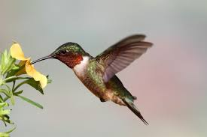

40. Explain why PREDATION is not considered to be PARASITISM.
41. Give two ways in which PREDATION and PARASITISM are similar.
42. Give four examples of keystone species, and briefly explain their roles in their ecosystems.
43. In Robert Payne’s experiment with the starfish in Washington State:
A. What was the INDEPENDENT VARIABLE?
B. What was the DEPENDENT VARIABLE?

Use the reaction below to answer this question:
Energy + CO₂ + H₂O → C₆H₁₂O₆ + O₂
(sugar)
42. Which of the following is true of the reaction above?

A. This is photosynthesis and it is performed by producers
B. This is photosynthesis and it is performed by consumers
C. This is cellular respiration and it is performed by producers and consumers
D. This is cellular respiration and it is performed by consumers only
E. This is nitrification and it is performed by decomposers
43. Which of the following is the best description of a TROPHIC CASCADE?
A. The upward flow of energy from the producer level to the top predator level of a food web.
B. The control of herbivore populations by predators resulting in the abundance of green plants on Earth
C. The downward effects (from top of the food chain to bottom) that occur when a keystone species, or top predator, is removed from an ecosystem.
D. A species that has a large effect on an ecosystem although there are relatively few of them.
E. A relationship between two different species in which both are showered by water from a nearby waterfall
44. Which of the following is the best description of a KEYSTONE SPECIES?
A. The upward flow of energy from the producer level to the top predator level of a food web.
B. The control of herbivore populations by predators resulting in the abundance of green plants on Earth
C. The downward effects (from top of the food chain to bottom) that occur when a keystone species, or top predator, is removed from an ecosystem.
D. A species that has a large effect on an ecosystem although there are relatively few of them.
E. A relationship between two different species in which both are showered by water from a nearby waterfall
45. Which of the following is the best description of the GREEN WORLD HYPOTHESIS?
A. The upward flow of energy from the producer level to the top predator level of a food web.
B. The control of herbivore populations by predators resulting in the abundance of green plants on Earth
C. The downward effects (from top of the food chain to bottom) that occur when a keystone species, or top predator, is removed from an ecosystem.
D. A species that has a large effect on an ecosystem although there are relatively few of them.
E. A relationship between two different species in which both are showered by water from a nearby waterfall
46. A type of spider walks on 6 of its legs and uses the front 2 like antennae in order to trick ants. The ants allow the spider into their nest where the spider prey upon them. Use the terminology learned in this unit to describe this relationship.
47. A Bonuba frog is bright green with red feet. It is a non-poisonous frog. The Ginga from is bright green with red feet. It produces a powerful poison through its skin. Both frogs live in the same ecosystem. Use the terminology learned in this unit to describe this relationship.
48. The alligator snapping turtle is very well camouflaged. Except for its tongue. Its tongue is bright pink and looks very much like a worm. The turtle wiggles its tongue near the ground and attracts small birds. When the bird bites the turtles tongue, the turtle bites back. It then kills and eats the bird. Use the terminology from this unit to describe this interaction.

