Science 10: Life, Adaptations and Natural Selection

1. Explain the meaning of fitness in terms of ecology.
2. Explain why variation within a species is necessary for natural selection.
3. Explain the difference between a scientific theory and a natural law.
4. Which of the following situations would most likely lead to the greatest amount of evolution within a species?
A. A small population in with abundant food and few predators.
B. A large population with abundant food and few predators.
C. A large population with scarce food and many predators.
D. A large population with scarce food and few predators.
5. Briefly explain how geographic separation can lead to speciation.
6. A species of bird on a certain island ranges in size from 18cm tall up to 38cm tall. The height differences are consistent across genders. Most birds fall into the range of 20cm-26cm. Describe a situation (an evolutionary pressure) that could lead to the birds evolving into a taller average height.
7. A species of bird on a certain island ranges in size from 18cm tall up to 38cm tall. The height differences are consistent across genders. Most birds fall into the range of 20cm-26cm. Describe a situation (an evolutionary pressure) that could lead to the birds evolving into a shorter average height.
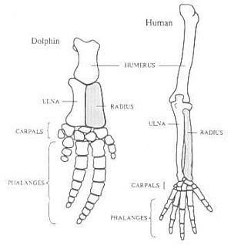

8. Explain how the similar structures between the bones in a dolphin flipper and the bones in a human arm provide evidence for evolution by natural selection.

9. What are the four factors necessary for evolution by natural selection.
10. What is the name of the scientist that proposed the theory of natural selection.
11. What organisms did the scientist in Q10 use to explain the concept of adaptive radiation?
12. On what archipelago (island group) did Charles Darwin make his most famous observations?
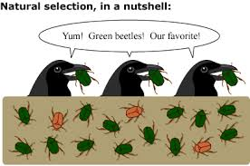

13. Use the diagram to the right to explain how the population of beetles may evolve over time. Include the following terms: competition, trait, variation, reproduction, heritable.

14. Fill in the blanks: Choose from the following: evolution, natural selection, variation, fitness, traits, competition.

Darwin’s theory of _______________________ proposed that _______________ occurs as beneficial ___________________ are passed from one generation to the next. Within any population there is a certain amount of ______________________ for resources. Differences between individuals, or _______________________ means that some individuals will be more likely to survive and reproduce. Those who reproduce are said to have higher _________________________.
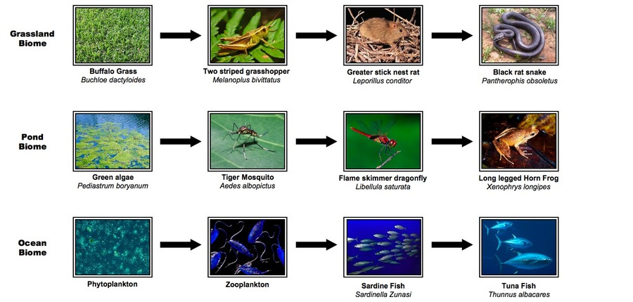

Use the Above Diagram of Food Chains to Answer Questions 15-18 Below:

15. In the ocean biome which organism is the primary consumer?
16. In the pond biome which organism is on the first trophic level?
17. In the grassland biome which organism is the tertiary consumer?
18. In the pond biome there is 250 000 000J of energy at the producer level. How much energy is there at the secondary consumer level?

Use the Food Chain Below for Questions 19-22
Grass Grasshopper Mouse Snake Hawk
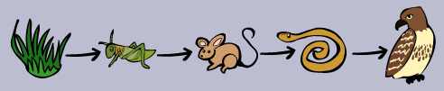

19. In the above food chain which organism is the secondary consumer?
20. At which trophic level is the snake?
21. Which organism is an herbivore?
22. Which organism is at the second trophic level?

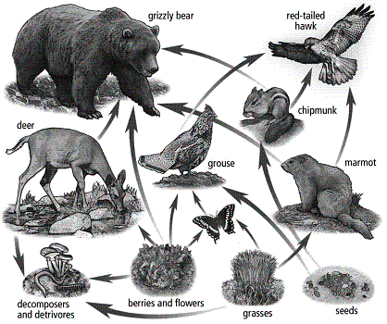
Consider the food chain shown to the left for questions 23-28

23. Which organisms are PRODUCERS?
24. Which organisms are PRIMARY CONSUMERS?
25. Which organisms are TERTIARY CONSUMERS?
26. Which organisms are at more than one level?
27. Write 2 different food chains that begin at grasses and end at hawk.
28. Which organisms are omnivores?

29. What are the 7 conditions for life?
30. List the five categories (kingdoms) of living thing, with a brief description of each.
31. What is an adaptation?
32. Give five examples of structural adaptations of animals. For each explain its function and how it helps the animal survive (food, protection, reproduction, shelter…)
33. Give five examples of structural adaptations of plants. For each explain its function and how it helps the plant survive (food, protection, reproduction, shelter…)
34. Give three examples of physiological adaptations of animals. For each explain its function and how it helps the animal survive (food, protection, reproduction, shelter…)
35. Give three examples of physiological adaptations of plants. For each explain its function and how it helps the plant survive (food, protection, reproduction, shelter…)
36. Give three examples of behavioural adaptations of animals. For each explain its function and how it helps the animal survive (food, protection, reproduction, shelter…)
37. Give three examples of behavioural adaptations of plants. For each explain its function and how it helps the plant survive (food, protection, reproduction, shelter…)
38. Which of the following symbiotic relationships is considered parasitic?
  - ticks feeding on a dog
  - bees transporting pollen from flowers
  - pilot fish swimming under sharks
  - birds eating the insects from the back of a hippopotamus
39. Humans have hundreds of bacteria that live within our digestive tract. Without these bacteria we would not be able to absorb many of the nutrients from our food. What type of relationship is this?
40. What does symbiosis mean?

41. A bird making a nest in a tree is an example of
A. predation B. mutualism C. parasitism D. commensalism E. competition
42. Which of the following is a symbiotic relationship where one partner benefits and the other does not benefit or lose from the relationship?
A. commensalism B. mutualism C. parasitism D. decomposition
43. Explain what type of relationship is shown below. Explain how each organism is affected.
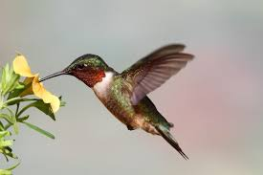

44. Give two ways in which PREDATION and PARASITISM are similar.
Use the reaction below to answer this question:
Energy + CO₂ + H₂O → C₆H₁₂O₆ + O₂
(sugar)
45. Which of the following is true of the reaction above?

A. This is photosynthesis and it is performed by producers
B. This is photosynthesis and it is performed by consumers
C. This is cellular respiration and it is performed by producers and consumers
D. This is cellular respiration and it is performed by consumers only
E. This is nitrification and it is performed by decomposers
Use the reaction below to answer this question:
C₆H₁₂O₆ + O₂ → Energy + CO₂ + H₂O
(sugar)
46. Which of the following is true of the reaction above?

A. This is photosynthesis and it is performed by producers
B. This is photosynthesis and it is performed by consumers
C. This is cellular respiration and it is performed by producers and consumers
D. This is cellular respiration and it is performed by consumers only
E. This is nitrification and it is performed by decomposers

