Nuclear Reactor Video Notes:
https://www.youtube.com/watch?v=1U6Nzcv9Vws

A nuclear reactor has 3 main components (parts)

1.

2.

3.

The ___________________ are usually in the shape of thin rods, about ___________ thick.

They are made of fissionable material like ________________________.

The part of the reactor that contains the fuel elements is called the ___________________________.

The fuel elements are usually immersed in _________________ that acts as the ___________________.

The purpose of the moderator is to _______________________ the energy neutrons in the reactor core.

The control rods are usually made of ________________________________. The function of the control rods

is to ___________________________ excess _________________________. A steady rate of nuclear reaction

can be maintained by ___________________ or ___________________ the control rods in the

__________________.

The reactor core is usually enclosed in thick walls of ________________________ (Why?). The reactor core is

connected to a __________________ ___________________.

The steam that is produced is used to turn a ____________________ to generate __________________.

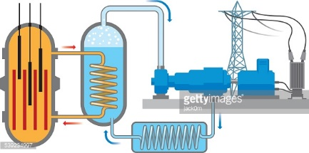

Label the diagram above with the following terms: fuel elements, heat exchanger, turbine, moderator, steam, control rods, reactor core, electrical power lines.

Questions:
1. What is a fissionable material? Give one example.

2. What is heavy water?

3. Explain how the moderator slows down the neutrons.

