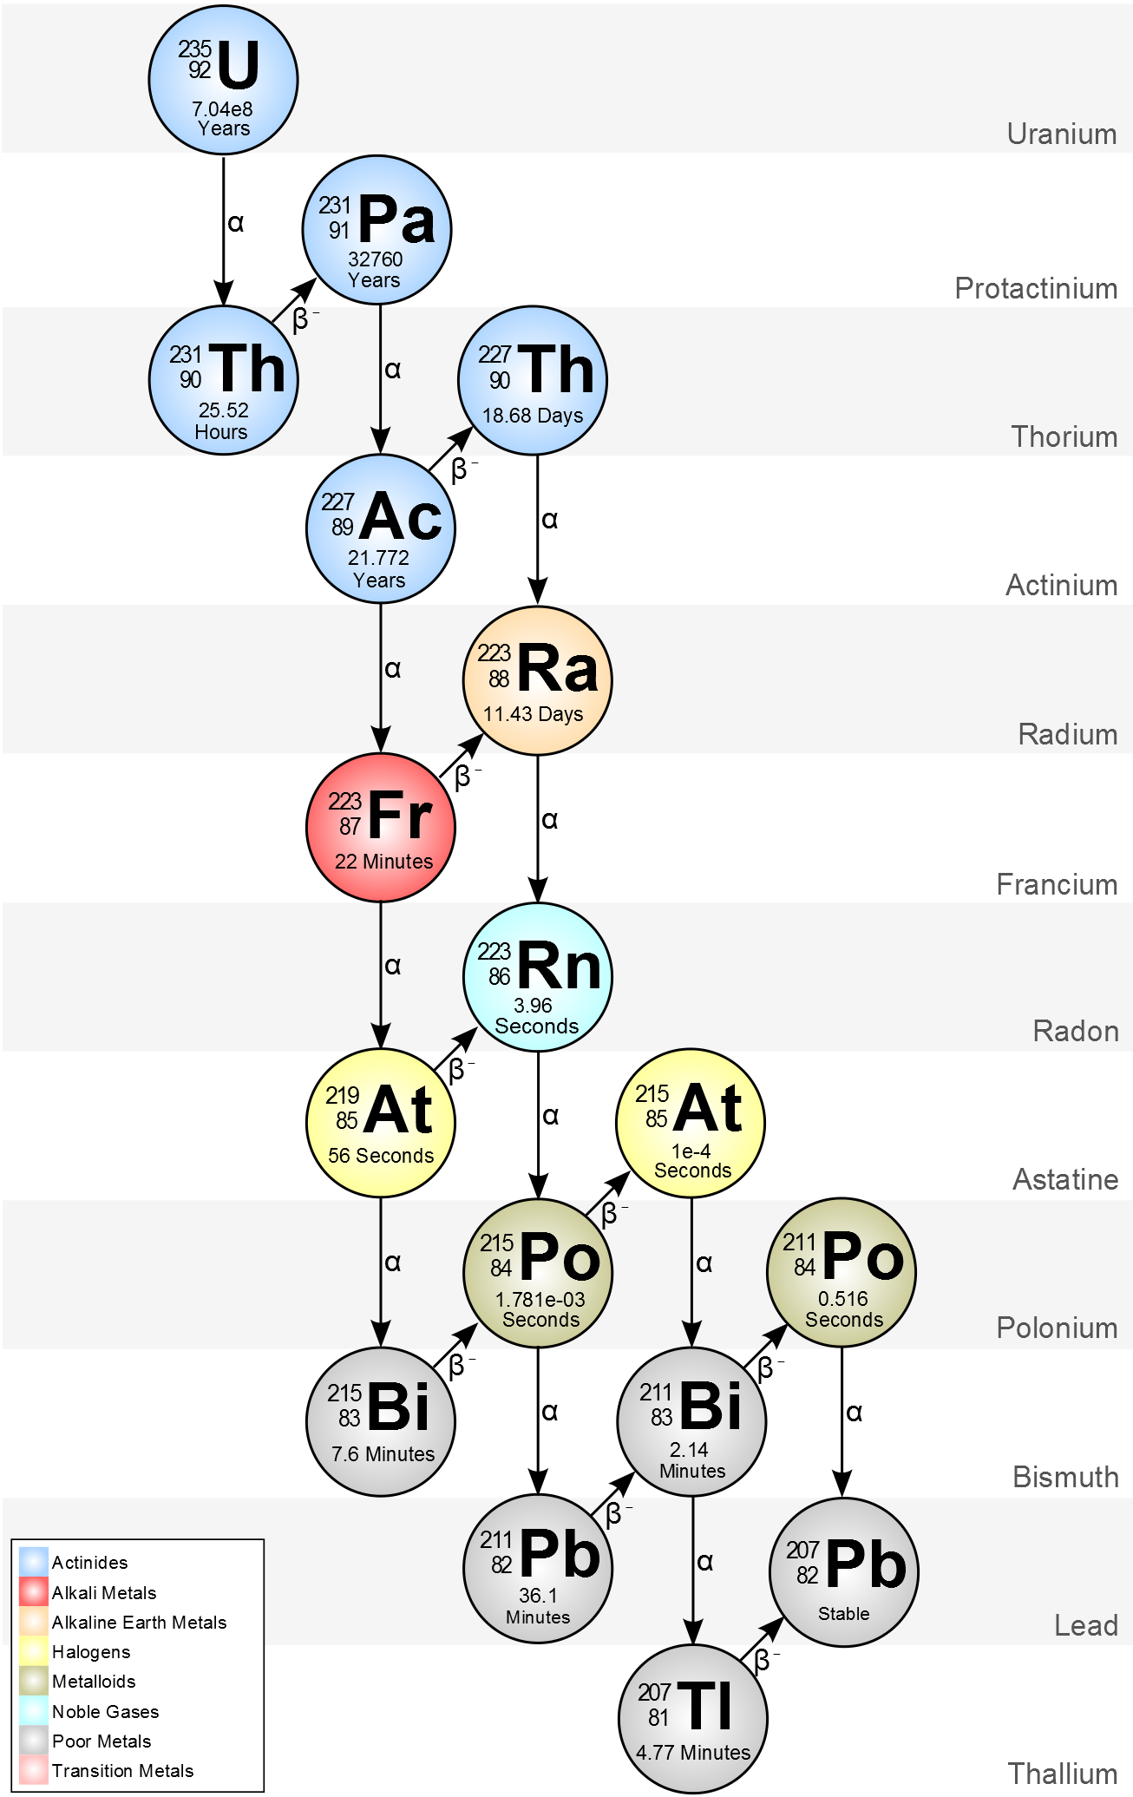
Nuclear Decay Chain

1. Start at the top of the chart at Uranium-235.
2. Follow the arrows, writing the nuclear decay equation for each step.
3. If a certain isotope has more than one arrow pointing arrow pointing away from it, you can choose whatever path you wish. The world is your oyster!
4. Continue until you reach an isotope that is stable.
5. Count the total number of alpha decays and beta decays in your chain. Record.

Number of Alpha Decays: _______

Number of Beta Decays: _______

