Covalent Compounds: Names and Formulas
1. Given the formulas of the following covalent compounds write their names:

Si₄P₅ ____________________________

Br₂Cl₂ ____________________________

NO₂ ____________________________

N₂O₂ ____________________________

P₅Cl₇ ____________________________

Se₂I₆ ____________________________

SO₂ ____________________________

S₂O₄ ____________________________

2. Given the names of the following covalent compounds write their formulas:

nitrogen triiodide ____________________________

pentaphosphorous nonoxide ____________________________

carbon dioxide ____________________________

carbon monoxide ____________________________

tricarbon tetrahydride ____________________________

difluorine tetroxide ` ____________________________

trisulfur petiodide ____________________________

heptabromine octachloride ____________________________

3. Look at the following Lewis diagrams then write the formula and name the compound.

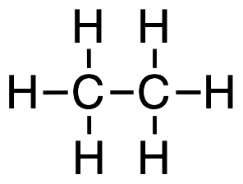

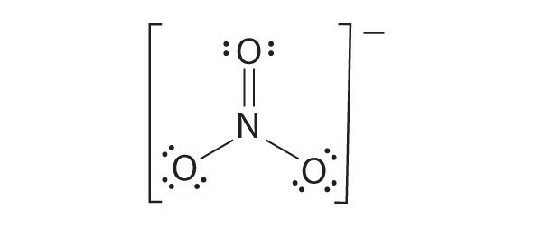

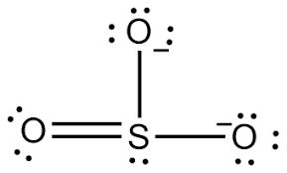

4. Try to draw the Lewis structures for the following covalent compounds:

ClF

oxygen dichloride

silicon tetrachloride

I₂

dicarbon hexabromide

Covalent Compounds: Names and Formulas
1. Given the formulas of the following covalent compounds write their names:

Si₄P₅ tetrasilicon pentaphosphide

Br₂Cl₂ dibromine dichloride

NO₂ nitrogen dioxide

N₂O₂ dinitrogen dioxide

P₅Cl₇ pentaphosphorous heptachloride

Se₂I₆ diselenium hexiodide

SO₂ sulfur dioxide

S₂O₄ disulfur tetroxide

2. Given the names of the following covalent compounds write their formulas:

nitrogen triiodide NI₃

pentaphosphorous nonoxide P₅O₉

carbon dioxide CO₂

carbon monoxide CO

tricarbon tetrahydride C₃H₄

difluorine tetroxide ` F₂O₄

trisulfur pentiodide S₃I₅

heptabromine octachloride Br₇Cl₈

3. Look at the following Lewis diagrams then write the formula and name the compound.

C₂H₆ dicarbon hexahydride

CF₄ carbon tetrafluoride

NO₃⁻ nitrogen trioxide (nitrate anion)

SO₃⁻² Sulfur trioxide (sulfite anion)

4. Try to draw the Lewis structures for the following covalent compounds:

ClF

oxygen dichloride

silicon tetrachloride

I₂

dicarbon hexabromide

