Graphs, Equations and Normalizations:

1. Consider the following equation:

i. What is the form of the graph of g vs F?

A. linear B. quadratic C. reciprocal D. square root E. sinusoidal

ii. What is the slope of the graph of g vs F?

iii. What is the k-value of the function that relates g to F?

iv. What is the y intercept of the graph of g vs F?

2. Consider the following equation:

i. What is the form of the graph of g vs F?

A. linear B. quadratic C. reciprocal D. square root E. sinusoidal

ii. What is the slope of the graph of g vs F?

iii. What is the k-value of the function that relates g to F?

iv. What is the y intercept of the graph of g vs F?

3. Consider the following equation:

i. Which of the following graphs are linear (more than one may apply)?

A. p vs R B. p vs u C. p vs d D. R vs d E. R vs u F. p vs u2

ii. What is the form of the graph of p vs u?

A. linear B. quadratic C. reciprocal D. square root E. sinusoidal

iii. What is the slope of the graph of p vs u2?

iii. What is the k-value of the function that relates p to u?

iv. What is the y intercept of the graph of p vs u2?

v. What is the y intercept of the graph of p vs u?

vi. What is the initial value of p?

4. Consider the following equation:

i. Which of the following graphs are linear (more than one may apply)?

A. C vs H B. H vs e C. C vs e2 D. H vs e2 E. CH vs e2 F. C vs

ii. What is the slope of a graph of H vs ?

iii. What is the k value of a graph of H vs Z?

5. Consider the following equation:

$$\frac{T}{2π}=\sqrt{\frac{m}{k}}$$

This equation shows the relationship between period of a mass oscillating on a spring and the mass of the spring and the spring constant, k. T is in seconds, m is in kilograms and k is in N/m.

A student does a lab with various masses attached to a spring and produces the following data:

|  |  |  |  |  |  |  |
| --- | --- | --- | --- | --- | --- | --- |
| Mass (kg) | 0.100 | 0.150 | 0.175 | 0.300 | 0.500 | 0.800 |
| Time(s)  for 10 oscillations | 2.0 | 2.5 | 2.6 | 3.4 | 4.4 | 5.6 |
|  |  |  |  |  |  |  |

i. Sketch a graph of the data.

ii. Normalize the graph.

iii. Determine the slope of the normalized function.\

iv. Use the slope from iii. with the equation given to determine the spring constant.

6. Consider the following equation:

i. What form will a graph of M vs R have?

A. linear B. quadratic C. reciprocal D. square root E. sinusoidal

ii. What form will a graph of M vs d have?

A. linear B. quadratic C. reciprocal D. square root E. sinusoidal

iii. What form will a graph of c vs d have?

A. linear B. quadratic C. reciprocal D. square root E. sinusoidal

iv. What would you plot on the x-axis to normalize a graph of M vs R?

A. R2 B. C. D. 2Rcd

v. What is the k-value of a graph of M vs. R?

Graphs, Equations and Normalizations: ANSWER KEY

1. Consider the following equation:

i. What is the form of the graph of g vs F?

A. linear B. quadratic C. reciprocal D. square root E. sinusoidal

ii. What is the slope of the graph of g vs F? -12

iii. What is the k-value of the function that relates g to F? -12

iv. What is the y intercept of the graph of g vs F? 3

2. Consider the following equation:

i. What is the form of the graph of g vs F?

A. linear B. quadratic C. reciprocal D. square root E. sinusoidal

ii. What is the slope of the graph of g vs F? W

iii. What is the k-value of the function that relates g to F? W

iv. What is the y intercept of the graph of g vs F? -z

3. Consider the following equation:

i. Which of the following graphs are linear (more than one may apply)?

A. p vs R B. p vs u C. p vs d D. R vs d E. R vs u F. p vs u2

ii. What is the form of the graph of p vs u?

A. linear B. quadratic C. reciprocal D. square root E. sinusoidal

iii. What is the slope of the graph of p vs u2? R

iii. What is the k-value of the function that relates p to u? R

iv. What is the y intercept of the graph of p vs u2? d

v. What is the y intercept of the graph of p vs u? d

vi. What is the initial value of p? d

4. Consider the following equation:

i. Which of the following graphs are linear (more than one may apply)?

A. C vs H B. H vs e C. C vs e2 D. H vs e2 E. CH vs e2 F. C vs

ii. What is the slope of a graph of H vs ?

iii. What is the k value of a graph of H vs Z?

5. Consider the following equation:

$$\frac{T}{2π}=\sqrt{\frac{m}{k}}$$

This equation shows the relationship between period of a mass oscillating on a spring and the mass on the spring and the spring constant, k. T is in seconds, m is in kilograms and k is in N/m.

A student does a lab with various masses attached to a spring and produces the following data:

|  |  |  |  |  |  |  |  |  |
| --- | --- | --- | --- | --- | --- | --- | --- | --- |
| Mass (kg) | 0.020 | 0.050 | 0.100 | 0.150 | 0.175 | 0.300 | 0.500 | 0.800 |
| Time(s)  for 10 oscillations | 0.9 | 1.4 | 2.0 | 2.5 | 2.6 | 3.4 | 4.4 | 5.6 |
| $\sqrt{Mass} (\sqrt{kg}$) | 0.14 | 0.22 | 0.32 | 0.39 | 0.42 | 0.55 | 0.71 | 0.89 |

i. Sketch a graph of the data.

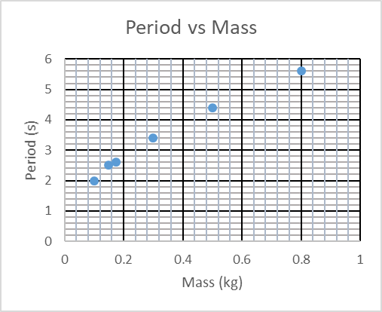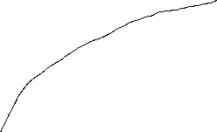

ii. Normalize the graph. iii. Determine the slope of the normalized function.

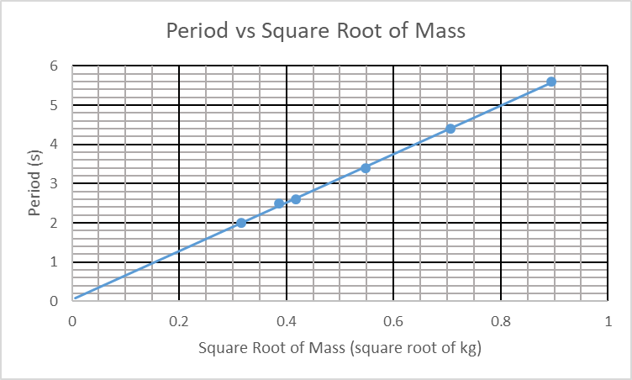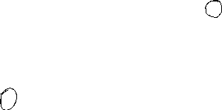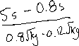

iv. Use the slope from iii. with the equation given to determine the spring constant.

T=k $\sqrt{m}$ = $\frac{2π}{\sqrt{k}} \sqrt{m}$ → k = $\frac{2π}{\sqrt{k}}$ Having two ks meaning two things is a no no. I will use S for slope.

S = → k = = = 1.0 = 1.0

6. Consider the following equation:

i. What form will a graph of M vs R have?

A. linear B. quadratic C. reciprocal D. square root E. sinusoidal

ii. What form will a graph of M vs d have?

A. linear B. quadratic C. reciprocal D. square root E. sinusoidal

iii. What form will a graph of c vs d have?

A. linear B. quadratic C. reciprocal D. square root E. sinusoidal

iv. What would you plot on the x-axis to normalize a graph of M vs R?

A. R2 B. C. D. 2Rcd

v. What is the k-value of a graph of M vs. R?