AP Physics B Circuits
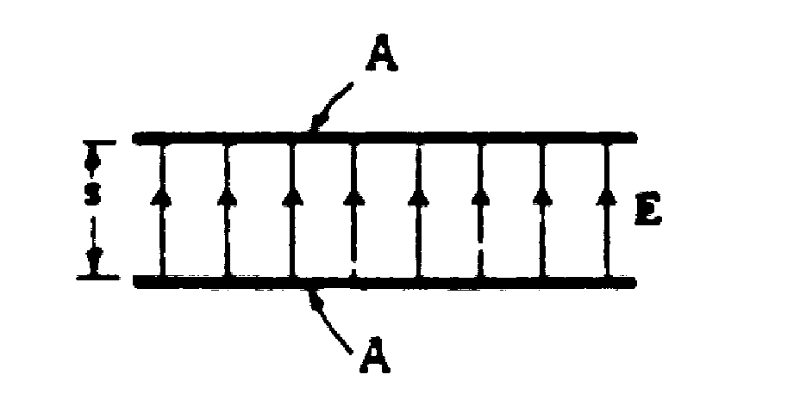

1. A uniform electric field E is established between two capacitor plates, each of area A, which are separated by a distance s as shown above. Give answers in terms of E, A and s.
- What is the electric potential difference V between the plates?
- Specify the sign of the charge on each plate.

The capacitor shown is then connected electrically through a resistor to a second parallel-plate capacitor, initially uncharged, whose plates have the same area A but a separation of only s/2.
- Indicate on the diagram below the direction of the current in each wire, and explain why the current will eventually cease.
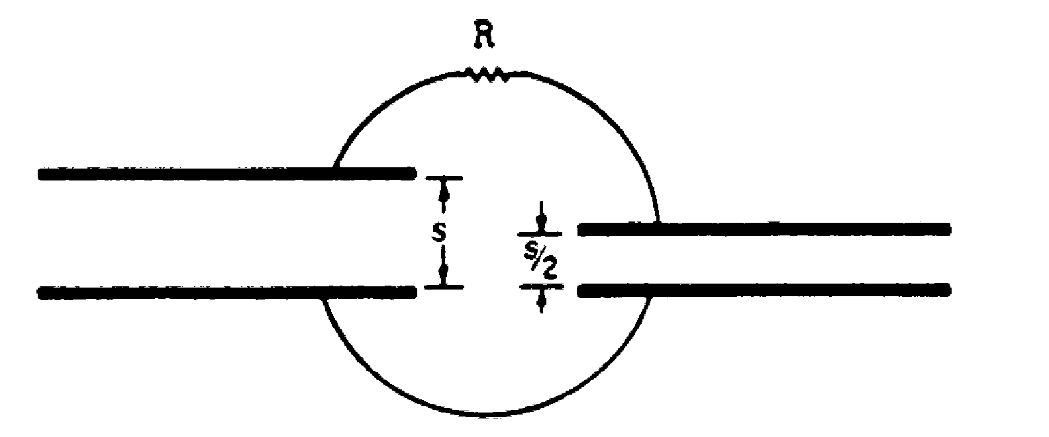

- After the current has ceased, which capacitor has the greater charge? Explain you reasoning.

The total energy stored in the two capacitors after the current has ceased is less then the initial stored energy. Explain qualitatively what has become of this "lost" energy.

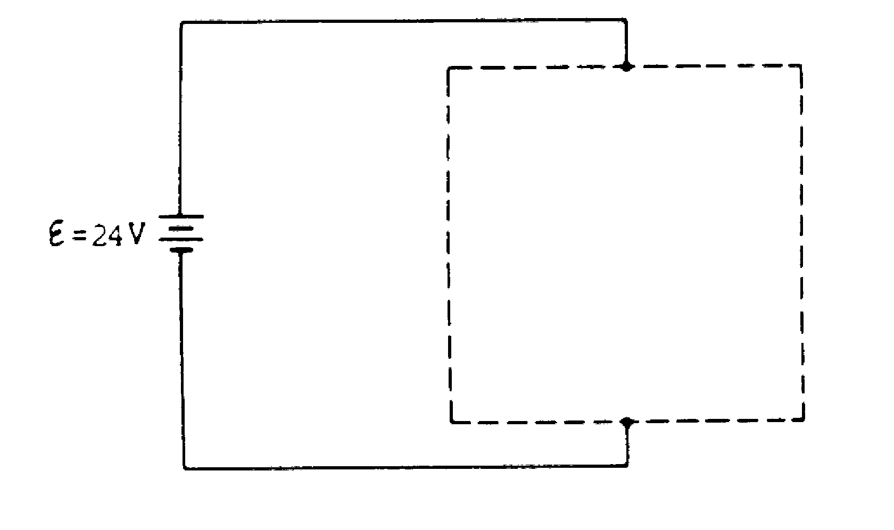
2. The electrical device whose symbol is shown below left requires a terminal voltage of 12 volts and a current of 2.0 amperes for proper operation. Using only this device and one or more 3.0-ohm resistors, design a circuit so that the device will operate properly when the circuit is connected across a battery of emf 24 volts and negligible internal resistance. Within the dashed-line box in the diagram below, draw the circuit using the symbol for the device and the appropriate symbol for each 3.0-ohm resistor.

Mystery Device

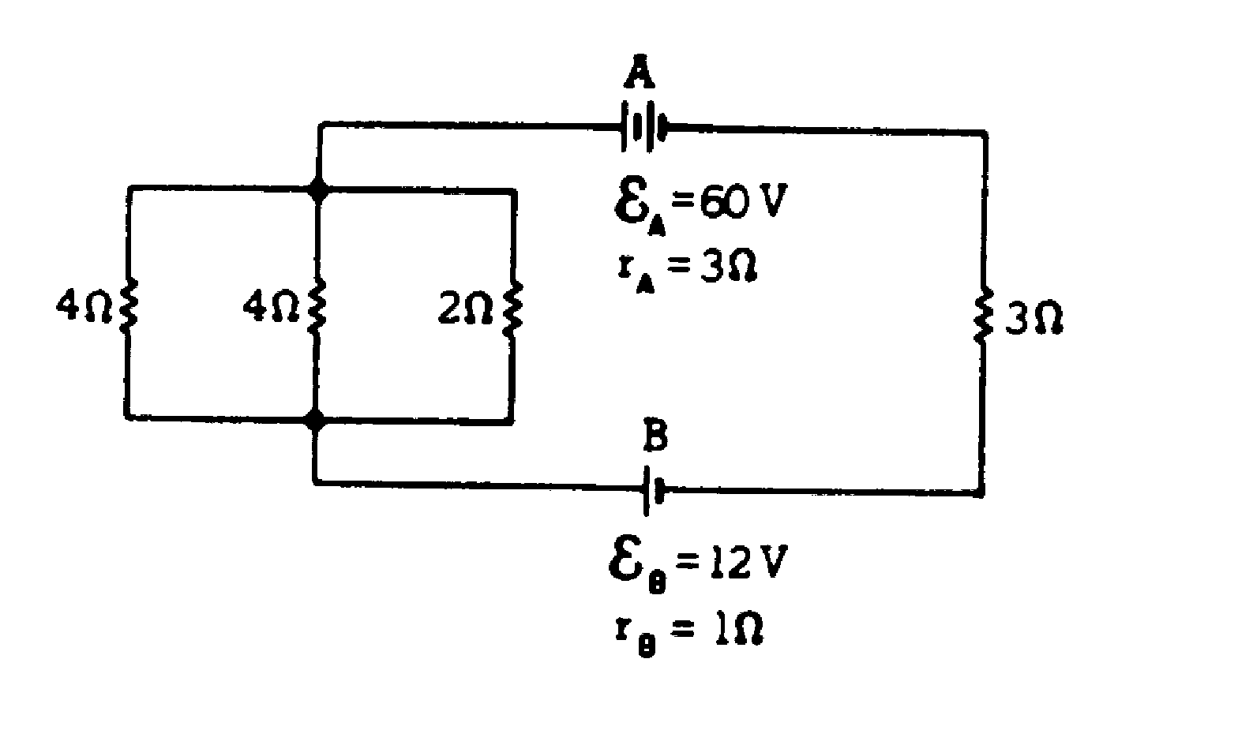

.

3. A circuit consists of battery A of emf ξ_{A} = 60.0 volts and internal resistance r_{A} =3 ohms; battery B of emf ξ_{B} = 12 volts and internal resistance r_{B} = 1.0 ohm; and four resistors connected as shown in the diagram above.
- Calculate the current in the 2.0-ohm resistor.
- Calculate the power dissipated in the 3-ohm resistor.
- Calculate the terminal voltage of battery B.

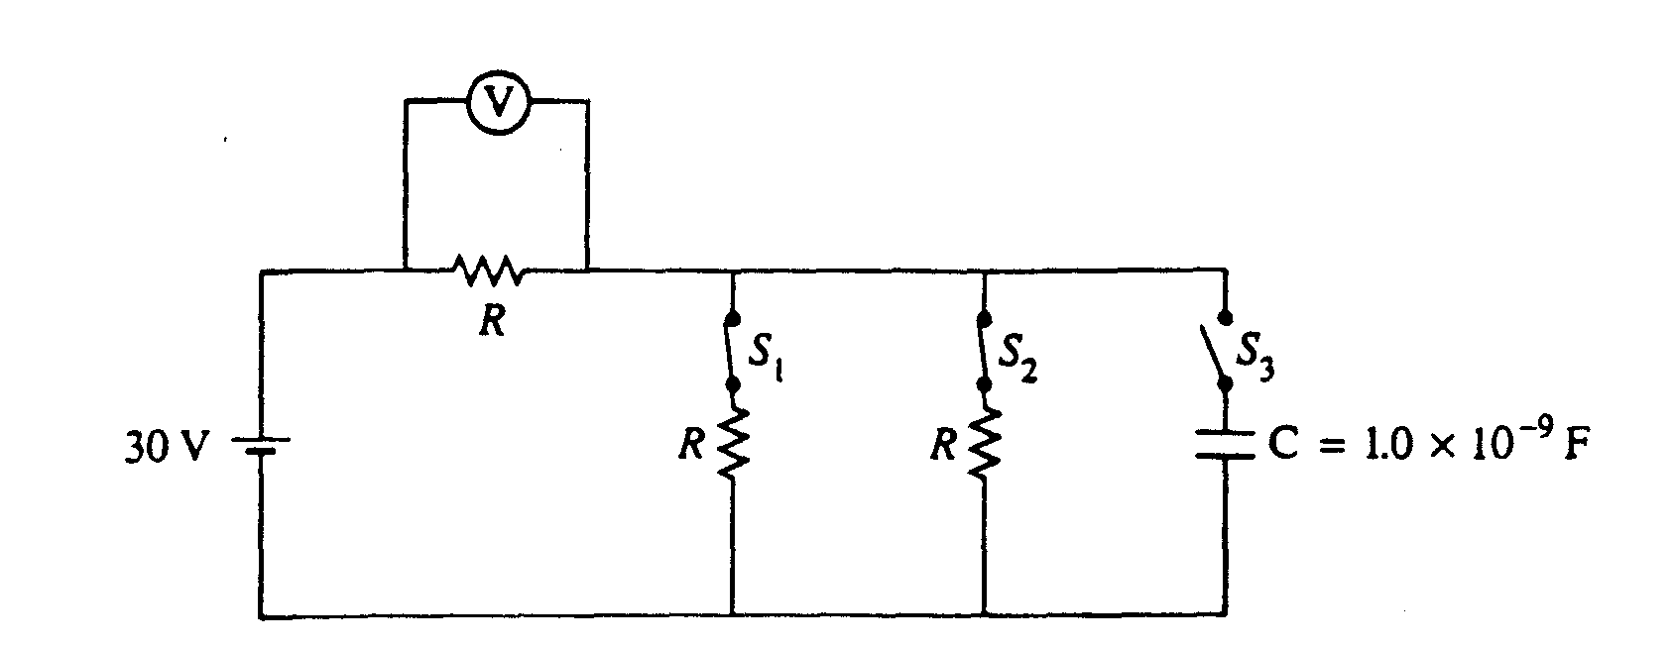
4. Three identical resistors, each with resistance R, and a capacitor of 1.0 x 10⁻⁹ F are connected to a 30 V battery with negligible internal resistance, as shown in the circuit diagram above. Switches S1, and S2 are initially closed, and switch S3 is initially open. A voltmeter is connected as shown.
- Determine the reading on the voltmeter.
(b) Switches S1, and S2 are now opened, and then switch S3 is closed. Determine the charge Q on the capacitor after S3 has been closed for a very long time.

After the capacitor is fully charged, switches S1, and S2 remain open, switch S3 remains closed, the plates are held fixed and a conducting copper block is inserted midway between the plates, as shown below. The plates of the capacitor are separated by a distance of 1.0mm, and the copper block has a thickness of 0.50mm.

(c) What is the potential difference between the plates?
(d) What is the electric field inside the copper block?
(e) On the diagram above, draw arrows to clearly indicate the direction of the electric field between the plates.
(f) Determine the magnitude of the electric field in each of the spaces between the plates and the copper block.

