Energy in Chemical Reactions WS

1. Draw the potential energy (PE) diagram showing the successful collision of the exothermic reaction:

H₂ + I₂ → 2 HI + 250 KJ

The PE of the reactants = 400 KJ
The activation energy of the forward reaction = 200 KJ

2. Draw the PE diagram showing the successful collision of the endothermic reaction:

A + B + 200 KJ → C

The PE of the reactants = 200 KJ
The Activation Energy in the forward direction = 250 KJ

3. Write the following reaction in ΔH notation.

A + B + 200 kJ → C

4. Write the following reaction in Standard Notation.

H₂ + I₂ → 2 HI ΔH = -250 kJ

5. Write in Standard Notation.

2NI₃ + 3BaCl₂ → 2NCl₃ + 3BaI₂ ΔH = 175 kJ

6. Write in ΔH notation.

2AlBr₃ + 3BaF₂ → 2AlF₃ + 3BaBr₂ + 276 kJ

Draw the potential energy diagram for reactions 7-10.

7. Potential energy of reactants = 250 kJ
Potential Energy of activated complex = 350 kJ
Potential Energy of the products = 300 kJ

a) How does the potential energy change as the reaction proceeds?
b) How does the kinetic energy change as the reaction proceeds?
c) Is the reaction exothermic or endothermic?
d) What is the value of ΔH?

If a catalyst was added, what would happen to the energies of the:
e) Reactants?
f) Products?
g) Activated Complex?
h) If a catalyst was added what would happen to the rate?

8. Potential energy of reactants = 350 kJ
Activation Energy = 100 kJ
Potential Energy of the products = 250 kJ

a) How does the potential energy change as the reaction proceeds?
b) How does the kinetic energy change as the reaction proceeds?
c) Is the reaction exothermic or endothermic?
d) What is the value of ΔH?

If the concentration of the reactants was increased, what would happen to the energies of the:

e) Reactants?
f) Products?
g) Activated Complex?
h) What would happen to the rate?

9. Potential energy of reactants = 200 kJ
Potential Energy of activated complex = 400 kJ
ΔH = 150 kJ

a) How does the potential energy change as the reaction proceeds?
b) How does the kinetic energy change as the reaction proceeds?
c) Is the reaction exothermic or endothermic?
d) What is the value of ΔH?

If the temperature was increased, what would happen to the energies of the:
e) Reactants?
f) Products?
g) Activated Complex?
h) What would happen to the rate?

10. Potential energy of products = 50 kJ
Potential Energy of activated complex = 400 kJ
ΔH= -50 kJ

a) How does the potential energy change as the reaction proceeds?
b) How does the kinetic energy change as the reaction proceeds?
c) Is the reaction exothermic or endothermic?
d) What is the value of ΔH?

If the surface area of the reactants was increased, what would happen to the energies of the:

e) Reactants?
f) Products?
g) Activated Complex?
h) What would happen to the rate?
11. What is the only thing, other than changing the reaction that will change the potential energy diagram? Describe how it will affect the diagram and the rate.

12. Use the energy diagram below and identify each of the following. Choose from:

ΔH, E_{a} (forward, uncatalyzed), E_{a} (reverse, uncatalyzed), E_{a} (forward catalyzed),
E_{a} (reverse, catalyzed), Energy of products, Energy of reactants,
Energy of activated complex (catalyzed), Energy of activated complex (uncatalyzed)

a
Energy
Reaction Progress

b

i
f
e
h
c

g
d

Ws # 4 Potential Energy Diagrams Worksheet Answer Key

1. Draw the PE diagram showing the PE changes that occur during a successful collision of the exothermic reaction:

H₂ + I₂ → 2 HI + 250 KJ

The PE of the reactants = 400 KJ
The activation energy of the forward reaction = 200 KJ

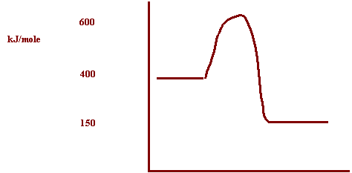
Reaction path

2. Draw the PE diagram showing the PE changes that occur during a successful collision of the endothermic reaction:

A + B + 200 KJ → C

The PE of the reactants = 200 KJ
The Activation Energy in the forward direction = 250 KJ

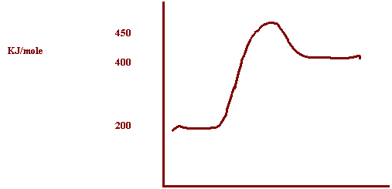

Reaction path
3. Write the following reaction in ΔH notation.

A + B + 200 kJ → C

A + B -----> C ΔH= +200kJ

4. Write the following reaction in Standard Notation.

H₂ + I₂ → 2 HI ΔH = -250 kJ

H₂ + I₂ → 2HI + 250 kJ

5. Write in Standard Notation.

2NI₃ + 3BaCl₂ → 2NCl₃ + 3BaI₂ ΔH = 175 kJ

2NI₃ + 3BaCl₂ + 175 kJ → 2NCl₃ + 3BaI₂

6. Write in ΔH notation.

2AlBr₃ + 3BaF₂ → 2AlF₃ + 3BaBr₂ + 276 kJ

2AlBr₃ + 3BaF₂ → 2AlF₃ + 3BaBr₂ ΔH= -267 kJ

Draw the potential energy diagram for the following reactions.

7. Potential energy of reactants = 250 kJ
Potential Energy of activated complex = 350 kJ
Potential Energy of the products = 300 kJ

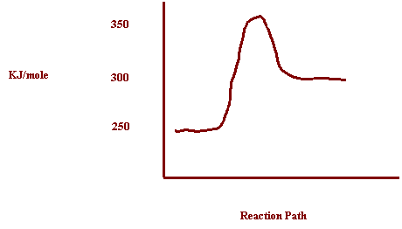

a) How does the potential energy change as the reaction proceeds? Increases
b) How does the kinetic energy change as the reaction proceeds? Decreases
c) Is the reaction exothermic or endothermic? Endothermic
d) What is the value of ΔH? ΔH= +50kJ

If a catalyst was added, what would happen to the energies of the:
e) Reactants? Nothing
f) Products? Nothing
g) Activated Complex? Decrease
h) If a catalyst was added what would happen to the rate? Increase

Draw the potential energy diagram for the following reactions.

8. Potential energy of reactants = 350 kJ
Activation Energy = 100 kJ
Potential Energy of the products = 250 kJ
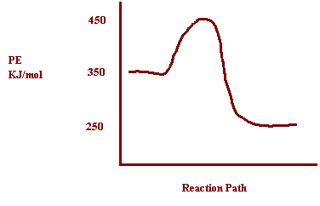

a) How does the potential energy change as the reaction proceeds? Decreases
b) How does the kinetic energy change as the reaction proceeds? Increases
c) Is the reaction exothermic or endothermic? Exothermic
d) What is the value of ΔH? ΔH= -100kJ

If the concentration of the reactants was increased, what would happen to the energies of the:

e) Reactants? Nothing
f) Products? Nothing
g) Activated Complex? Nothing
h) What would happen to the rate? Increase

9. Potential energy of reactants = 200 kJ
Potential Energy of activated complex = 400 kJ
ΔH = 150 kJ
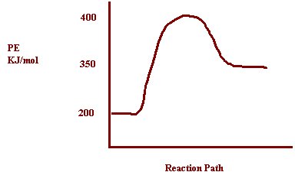

a) How does the potential energy change as the reaction proceeds? Increases
b) How does the kinetic energy change as the reaction proceeds? Decreases
c) Is the reaction exothermic or endothermic? Endothermic
d) What is the value of ΔH? ΔH= 150 kJ
If the temperature was increased, what would happen to the energies of the:
e) Reactants? Nothing
f) Products? Nothing
g) Activated Complex? Nothing
h) What would happen to the rate? Increase

10. Potential energy of products = 50 kJ
Potential Energy of activated complex = 400 kJ
ΔH= -50 kJ
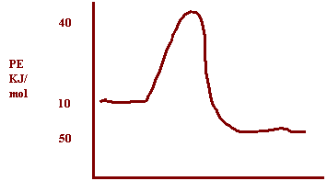

Reaction Path

a) How does the potential energy change as the reaction proceeds? Decreases
b) How does the kinetic energy change as the reaction proceeds? Increases
c) Is the reaction exothermic or endothermic? Exothermic
d) What is the value of ΔH? ΔH= -50kJ
If the surface area of the reactants was increased, what would happen to the energies of the:

e) Reactants? Nothing
f) Products? Nothing
g) Activated Complex? Nothing
h) What would happen to the rate? Increase

11. What is the only thing, other than changing the reaction that will change the potential energy diagram? Describe how it will effect the diagram and the rate.

Catalyst Lowers Ea alloys more low energy collisions to be successful and increase
12. Use the energy diagram below and identify each of the following. Choose from:

ΔH, E_{a} (forward, uncatalyzed), E_{a} (reverse, uncatalyzed), E_{a} (forward catalyzed),
E_{a} (reverse, catalyzed), Energy of products, Energy of reactants,
Energy of activated complex (catalyzed), Energy of activated complex (uncatalyzed)
a
Energy
Reaction Progress

b

i
f
e
h
c

g
d

a. Energy of activated complex, uncatalyzed
b. Energy of activated complex, catalyzed
c. Energy of products
d. Energy of reactants
e. Activation energy (forward, uncatalyzed)
f. Activation energy (reverse, uncatalyzed)
g. ΔH
h. Activation Energy (forward, catalyzed)
i. Activation Energy (reverse, catalyzed)

