Activation Energy

Introduction
Most chemical reactions need an input of energy in order to proceed. This is true even of exothermic reactions. The molecules must have enough kinetic energy when they collide to break the bonds of the reactant molecules. In other words the molecules must have enough speed. This extra energy is called the activation energy, and is required to initiate the reaction.

In the reaction below, you see the energy of the reactants increases at first. This is likely due to the reactants being heated or electrified or stirred. Once the activation energy is reached, the reaction begins. This continues until the products have formed.

In this example, the products have less energy than the reactants did when we started. This means that energy was released, and we have an exothermic reaction. The ΔH for this reaction will be negative.
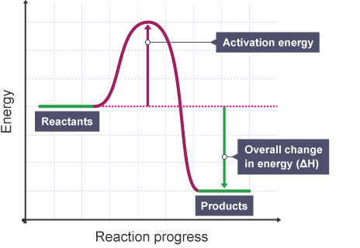

Practice
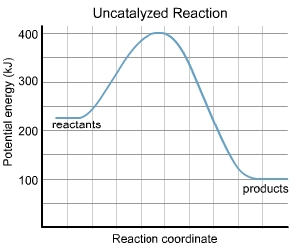
- This graph shows the change in potential energy as a reaction takes place. Label the activation energy and overall change in energy (ΔH) as shown on the example on the previous page.

  - What is the activation energy of this reaction?

  - What is the enthalpy change (ΔH) of this reaction?

  - Would this reaction be classified as exothermic or endothermic?

  - If this reaction were to be reversed, what would the activation energy be?

  - If this reaction were to be reversed, what would the overall change in energy (ΔH) be?

  - If this reaction were to be reversed, would it be endothermic or exothermic?

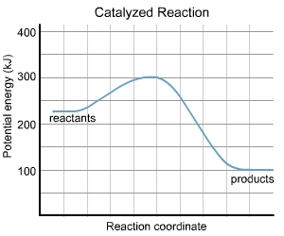
- This graph shows the same reaction, but with a catalyst added. Label the activation energy and overall change in energy (ΔH).

  - What is the activation energy of this reaction?

  - What is the enthalpy change (ΔH) of this reaction?

  - Would this reaction be classified as exothermic or endothermic?

  - Based on this graph, will the catalyst make the reaction proceed more slowly or quickly?

3. Draw a graph showing an endothermic reaction with the following characteristics:

Potential energy of reactants: 80 MJ
ΔH for reaction: 20MJ
Activation energy: 50MJ

4. A chemical reaction has a ΔH of -120J. The activation energy of the reaction is 40J. What is the ΔH and the activation energy of the reverse reaction? Hint: MAKE A SKETCH OF THE ENERGY DIAGRAM.

5. A chemical reaction has the following characteristics:

Potential energy of products: 4.4x10⁶J
Energy of the activated complex: 7.3x10⁶J
Potential energy of the reactants: 6.1x10⁶J

a. Find the activation energy for this reaction.

b. Find the ΔH of the reaction.
Activation Energy KEY
- This graph shows the change in potential energy as a reaction takes place. Label the activation energy and overall change in energy (ΔH) as shown on the example on the previous page.
E_{a}
  - What is the activation energy of this reaction?
E_{a} = E_{ac} – E_{r}
400J-225J= 175J
ΔH

  - What is the enthalpy change (ΔH) of this reaction?

ΔH= H_{final} – H_{initial} = 100J – 225J = -125J

  - Would this reaction be classified as exothermic or endothermic?

EXOTHERMIC

  - If this reaction were to be reversed, what would the activation energy be?

Reversing Reaction means the products become the reactants, so…
E_{a} = E_{ac} – E_{r} = 400J – 100J = 300J

  - If this reaction were to be reversed, what would the overall change in energy (ΔH) be?

ΔH=H_{final} – H_{initial} = 225J – 100J = 125J

  - If this reaction were to be reversed, would it be endothermic or exothermic?

ENDOTHERMIC
- This graph shows the same reaction, but with a catalyst added. Label the activation energy and overall change in energy (ΔH).
E_{a}
  - What is the activation energy of this reaction?
ΔH
75J

  - What is the enthalpy change (ΔH) of this reaction?

-125J

  - Would this reaction be classified as exothermic or endothermic?

EXOTHERMIC

  - Based on this graph, will the catalyst make the reaction proceed more slowly or quickly?
More Quickly
3. Draw a graph showing an endothermic reaction with the following characteristics:

Potential energy of reactants: 80 MJ
ΔH for reaction: 20MJ
Activation energy: 50MJ

4. A chemical reaction has a ΔH of -120J. The activation energy of the reaction is 40J. What is the ΔH and the activation energy of the reverse reaction? Hint: MAKE A SKETCH OF THE ENERGY DIAGRAM.

ΔH=120J

E_{a}=160J

5. A chemical reaction has the following characteristics:

Potential energy of products: 4.4x10⁶J
Energy of the activated complex: 7.3x10⁶J
Potential energy of the reactants: 6.1x10⁶J

a. Find the activation energy for this reaction.

E_{a}=1.2x10⁶J

b. Find the ΔH of the reaction.

ΔH=-1.7x10⁶J

