Physical Optics - Filtered by Reverse Osmosis!

1. Which of the following provides the best evidence that light is a wave?

A. Light will reflect off of surfaces

B. Light can be blocked by opaque objects

C. Light carries energy

D. Light can be refracted

E. We asked light very nicely and although, at first, light was being a little vague and distant, after time, light really opened up to us and made a tearful confession that it had, in fact, decided - after a lot of consideration and soul searching – to be a wave.

F. Light interferes

G. Light can travel through a vacuum

H. Light can travel through solid objects.

2. 566nm light is shone through dual slits onto a screen 2.0m away. The distance between second order dark spots is 2.4cm. What is the slit spacing?

3. A diffraction grating consists of 225lines/mm. The diffraction pattern viewed on a shows a 3rd order bright spot located 1.2m from the central bright spot. The light has a wave length of 755nm. What is the screen distance?

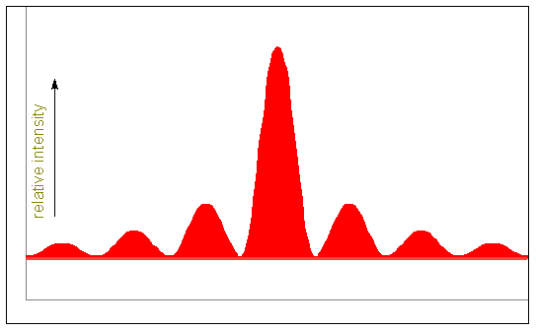4. In a dual slit diffraction pattern (right)

The spot marked by the arrow A results when:

A. Light from the right slit travels 1/2λ further than light from the left slit.

B. Light from the left slit travels 1/2λ further than light from the right slit.

C. Light from the right slit travels λ further than light from the left slit.

D. Light from the left slit travels λ further than light from the right slit A B

5. The spot marked by arrow B results when

A. Light from the right slit travels 3/2λ further than light from the left slit.

B. Light from the left slit travels 3/2λ further than light from the right slit.

C. Light from the right slit travels 5/2λ further than light from the left slit.

D. Light from the left slit travels 5/2λ further than light from the right slit.

6. Two radio transmitters are separated by 2.20km and broadcast the same frequency, in phase with one another. An observer at point A, equidistant from the two towers, receives a maximum strength signal. The observer notices that the signal decreases to zero, increases to a maximum and decreases to zero again at point B. What is the frequency of the signal?

B

511m

A

989m

7. A single slit interference experiment is conducted with 625nm light. On a viewing screen mounted

1.75m from the slit the central bright fringe is found to be 2.00cm wide.

a. How wide is the slit?

b. If the experiment were repeated with a wider slit, would the fringe become wider or narrower?

c. If the experiment were repeated with longer wavelength light, would the fringe become wider or narrower?

8. A ray of light falls with a frequency of 8.40x1014Hz falls on a thin film of liquid, clarified butter (n=1.26) on a slab of congealed (solidified, opaque) bacon fat. What is the thinnest layer of butter that will lead to:

a. constructive interference

b. destructive interference.

9. A piece of paper is placed between two glass plates (n=1.54) creating an air gap as shown. Light with a wavelength of 498nm strikes the plates nearly perpendicularly (Assume any refractive effects are negligible). How many bright fringes will be seen between the edge of the glass and the sheet of paper (4.6x10-5m)?

**(Assume the glass is very thick compared to the paper)**

10. Find the third minimum thickness of a film of ectoplasm (n=2.24) on a pool of oil (n=1.40) that will result in destructive interference of light with a wavelength of 440nm in air.

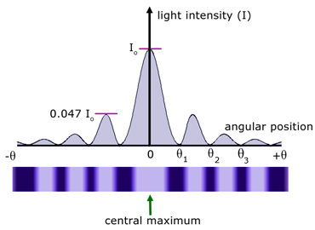

11. Consider the single slit diffraction pattern shown to the right.

Label with an “A” the interference point that results from a light

Ray at the left of the slit travelling ½ λ further than a light ray

Beginning 1/6W to the right (W is the width of the slit).

NOT TO SCALE

12. A Michelson interferometer is used to observe light with a frequency of

6.86x1014Hz. How many bright spots will be detected as the mirror is moved 0.500cm?

13. How much is the fish? How much is the fish? How much is the chips? Does the fish have chips?

14. Which of the following best describes the interference pattern observed on a screen after light passes through a screen with many very narrowly spaced openings?

a. A broad bright central fringe with much smaller secondary and tertiary bright fringes.

b. Fine widely spaced spots of light.

c. Evenly spaced alternating bright and dark spots.

d. An intricate interweaving of dark and light signifying the delicate interplay between diametrically opposed forces at work within each of us.

e. It makes a cookie monster shape.

15. A thin film of ethanol (n=1.16) is sandwiched between two thick sheets of transparent plastic (n=1.63). What is the 3rd minimum thickness of the ethanol at a point where a dark spot appears for light with λp=398nm.