Trigonometry and Right Triangles:

Use this diagram

k θ

q

m
Φ

Φ
for questions 1-13

1. If k=3 and m=4 find q. q=______________

2. If q=15 and m=9.8 find k. k=______________

3. If m=7 and Φ=36º find k, q and θ. k=______________ q=______________ θ=______________

4. If m=14 and q=17 then sinθ=_____________, cosθ=_____________, tanθ=____________________

and sinΦ=_____________, cosΦ=____________, tanΦ=____________________

5. If m=8.2 and q=11.2 then sinθ=_____________, cosθ=_____________, tanθ=____________________

and sinΦ=_____________, cosΦ=____________, tanΦ=____________________

6. If m=5.9 and k=4.8 then sinθ=_____________, cosθ=_____________, tanθ=____________________

and sinΦ=_____________, cosΦ=____________, tanΦ=____________________

7. If q=145 and Φ=19º k=________________________, m=____________________

8. If q=0.665 and θ=54º k=________________________, m=____________________

9. If q=64 and Φ=64º k=________________________, m=____________________

10. If q=35 and Φ=21º k=________________________, m=____________________

11. If q=547 and θ=38º k=________________________, m=____________________

12. If m=71 and Φ=29º k=________________________, q=____________________

13. If k=49 and θ=59º q=_______________________, m=________________

14. Consider the following right triangle:
58º

θ
N
M
88cm
A. Find M.
B. Find N.

15. How tall is the tree?

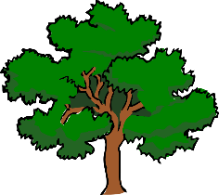

27º

Length of Shadow: 14.7m

