Wave Basics:

A wave is a vibration in some medium (material) that carries energy (propagates) through space. The energy is carries from place to place through vibrations, but the medium (the particles, in most cases) DO NOT TRAVEL. The particles simply oscillate or vibrate around their rest position.

- The motion of the energy through space is called PROPAGATION.
- The motion of the molecules/particles/medium is called VIBRATION or OSCILLATION

Waves, like most things, can be classified in several different ways.

- One way is in term of the medium that is being disturbed, through which the waves travel. There are three main types:

  - MECHANICAL WAVES cause the vibration of matter, and must propagate through matter. This includes sound, waves on strings and springs, earthquake waves and water waves.

  - ELECTROMAGNETIC WAVES can propagate through space and do not require any particles. The wave vibrates and moves through the electromagnetic field. This is light in all of its forms (visible, infra-red, UV, X-rays…).

  - QUANTUM PARTICLE WAVES describe the probabilistic behavior of very small particles. This is a mathematical probability wave, and it’s quite strange and we won’t worry about them now.

- The second way is in terms of how the medium jiggles. There are actually many different types (transverse, longitudinal, surface, Rayleigh, Love..) but we will look at the main two.

  - TRANSVERSE waves are those in which the direction of the oscillation is perpendicular to the propagation.

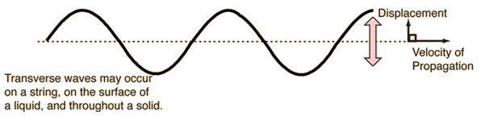
Crest
Crest
Crest
Transverse mechanical waves can only propagate through a solid, or along a string. Transverse waves do not propagate through liquids or gases
Amplitude
Amplitude
Trough
Trough

  - LONGITUDINAL waves are those in which the direction of the oscillation is parallel to the propagation.

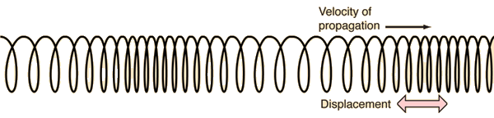
Compression
Compression

Rarefaction
Rarefaction

  - ALL OTHER wave types are some combination of these two, in which the medium displays both transverse and longitudinal oscillations.

Regardless of what kind of wave we have there are some universal truths about waves. All waves have two fundamental aspects to their motion, PROPAGATION and OSCILLATION.

If the wave is a PERIODIC wave the oscillation happens with a regular repeating pattern, each vibration is the same as the one that preceded it and as the one that follows it. In this case the time for each complete vibration is called the period, and the number of vibrations per unit time is the frequency.

$$T=\frac{t}{N} f=\frac{N}{t} T=\frac{1}{f} f=\frac{1}{T}$$

The units for period are units of time (seconds, minutes, hours…)
The units of frequency are units of $\frac{1}{time}$ ($\frac{1}{seconds}≡Hertz\left(Hz\right), \frac{1}{min}≡repetitions per minute \left(RPM\right)…)$

The maximum displacement from the rest position is called the amplitude of the oscillation. If you observe a particle, its motion from one extreme to the other (top to bottom, side to side) will be 2A (two times the amplitude). In one period each particle will oscillate through 4 amplitudes.

As each particle vibrates it causes its neighbour to oscillate (the actual mechanism for this can be quite complex) and the wave propagates forward at CONSTANT SPEED, provided the medium is consistent. The distance the wave propagates forward in each period is defined as a wavelength (λ).

Wavelength can also be measured as the distance between successive crests (or compressions) or troughs (or rarefactions).

The basic equations that describe wave motion are equations of motion with constant speed, that is:

$$v=\frac{d}{t}$$

where v is the speed of PROPAGATION. As defined above if we set time to one period (T), the wave will have propagated
one wavelength, λ. So the above equation can be re-written as:

$$v=\frac{λ}{T}= λf$$

so,

$$v=λf$$

is the main equation for the motion of waves, all waves, and is known as the UNIVERSAL WAVE EQUATION.

SOUND:

Sound is a longitudinal, mechanical wave that propagates through air (usually) but can also move through liquids and solids.

A vibrating source of some sort, be it a speaker, a vibrating string (guitar, violin…) a vibrating membrane (drum, larynx…) or anything else, vibrates which causes the air (or water, or wood, or…) molecules next to it to vibrate. This molecule vibrates its neighbours which vibrate their neighbours and so on.

As these molecules jiggle about they create regions in which the molecules become more tightly packed, or COMPRESSIONS, and regions where the molecules are more spread apart, or RAREFACTIONS. Sound is created by the alternation between these compressions and rarefactions in space.

With sound it is very common to measure these variations in particle density (especially in air) in terms of PRESSURE. The greater the pressure difference the greater the AMPLITUDE of the wave (This is a vast over-simplification, but it will serve our purposes.

The frequency of a sound wave can be perceived as pitch and the amplitude as volume or loudness.

A sound does not need to be heard or even hearable to be sound. If we can hear it is called audible sound.

The normal range of audible sounds for a human being is 20Hz to 20 000Hz, although our hearing at higher frequencies tends to degrade with age as our eardrums, and all tissues lose flexibility and we slowly, but inevitably decline to become wrinkly, stiff, brittle, decrepit husks of our formally glorious selves.

Drawing longitudinal waves can be difficult and annoying and time consuming, as well as inaccurate (how do you ensure the density of the dots accurately and consistently show the pressure).
Drawing transverse waves is relatively easy, not to mention fun.

So we can use a clever little trick to represent a longitudinal wave with a diagram that looks like a transverse wave. The key is to be aware that you are using a trick and that the diagram is showing how the pressure is varying in space as opposed to how the molecules are vibrating.

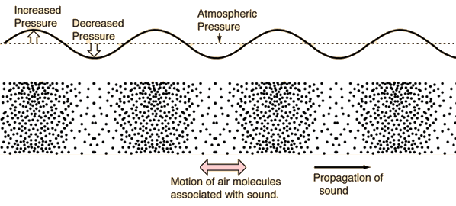

When we draw diagrams of standing sound waves it is important to remember that we are showing how the pressure is changing at various places in the tubes, NOT how the molecules are moving!

BEATS

As we have discussed waves can interfere in which case the amplitude of the resultant wave is the sum of amplitudes of the interfering waves. This can result in standing waves, as we have seen, and also shows up in a phenomenon called beats.
