Energy Transformations

Kinetic Energy

**Kinetic energy** is the purest and simplest form of energy to understand. If an object is moving it has kinetic energy. The faster it goes and the more mass it has, the more kinetic energy it will have. In fact we can calculate kinetic energy from the following formula:

$$Kinetic Energy=\frac{1}{2}mass ×speed^{2}$$

$$E_{k}=\frac{1}{2}mv^{2}$$

Here mass must be measured in kilograms (kg) and speed must be measured in meters per second (m/s)

The S.I.(Systéme International) unit for energy is the Joule (J).

Examples:

1. Find the kinetic energy of a 1200kg car driving at 20m/s (72km/h).

$$E_{k}=\frac{1}{2}mv^{2}$$

$$E_{k}=\frac{1}{2}1200kg({20m/s)}^{2}$$

$$E_{k}=240 000J=240kJ$$

*The car has 240kJ of kinetic energy.*

2. Find the kinetic energy of a 0.0075kg bullet leaving a gun at 380m/s (1370km/h).

$$E_{k}=\frac{1}{2}mv^{2}$$

$$E_{k}=\frac{1}{2}0.0075kg({380m/s)}^{2}$$

$$E_{k}=541.5J$$

*The bullet has 541.5J of kinetic energy.*

3. A hockey puck has a mass of 170g and is shot at 25m/s. Find the kinetic energy of the puck.

*For this question we need to notice that the mass is given in grams and needs to be converted to kilograms.*

*170 $g$ $×\frac{1.0kg}{1000g}$ =0.170kg*

*Now solve as usual.*

$$E_{k}=\frac{1}{2}mv^{2}$$

$$E_{k}=\frac{1}{2}0.170kg({25m/s)}^{2}$$

$$E_{k}=53.125J$$

*The puck has 53J of kinetic energy.*

4. A golf ball has a mass of 0.050kg and is flying at a speed of 120km/h. What is its kinetic energy?

*For this question we need to notice that the speed is given in km/h and needs to be converted to m/s.*

*120 $\frac{km}{h}$ $×\frac{1000m}{1km} × \frac{1h}{60min}×\frac{1min}{60s}$ =33.3333333m/s*

*Now solve as usual.*

$$E_{k}=\frac{1}{2}mv^{2}$$

$$E_{k}=\frac{1}{2}0.050kg({33.3333333m/s)}^{2}$$

$$E_{k}=27.\overline{7}J$$

*The golf ball has 28J of kinetic energy.*

Potential Energy

**Potential energy** is a bit more abstract. Potential energy is the *potential* of a group of objects to get kinetic energy. Potential energy is the energy of position.

**Gravitational Potential Energy (Epg)** is the energy that exists when 2 massive objects are separated by some distance. The masses will attract and move toward each other, gaining kinetic energy.

For now we will consider a mass lifted up, away from the surface of the Earth (or any other planet). If the mass is dropped, it will fall and gain kinetic energy. The higher the object is lifted and the more massive it is, the more energy it will have. The energy also depends on the strength of the *gravitational field* or *acceleration due to gravity*. On Earth, where we spend most of our time, the gravitational field is nearly constant and is equal to 9.8m/s2.

*Gravitation Energy = mass $×$ gravitational field $×$ height*

$$E_{pg}=mgh$$

mass in *kilograms (kg)*,

height in *meters (m).* Height is measured from a conveniently chosen zero point.

gravitational field in *meters per second squared (m/s2)* . Remember that ***on Earth, g=9.8m/s2***

Examples:

1. Find the gravitational energy when a 5.0kg mass is lifted 2.0m above the ground.

$$E_{pg}=mgh$$

$$E_{pg}=5.0kg\left(9.8\frac{m}{s^{2}}\right)2.0m$$

*Epg=98J*

*The mass has 98J of gravitational energy*

2. Find the gravitational energy when a 100kg mass is lifted 30cm above the desk.

*We need to first convert cm to m.*

*30 $cm$ $×\frac{1.0m}{100cm}$ =0.30m*

*Now solve as usual.*

$$E_{pg}=mgh$$

$$E_{pg}=100kg\left(9.8\frac{m}{s^{2}}\right)0.30m$$

*Epg=294J*

*The mass has 294J of gravitational energy.*

Conservation of Mechanical Energy

In many situations the motion of an object can be explained in terms of an exchange between kinetic and potential energy. Remember from last unit we know:

***Energy can neither be created nor destroyed, but can only change form.***

So in many simple situations where there is no chemical reactions, nuclear reactions or heat-producing friction, we will have a simple exchange of kinetic and potential energies.

Example 1: Consider a ball falling from the top of a building. At the top all of the energy is potential and the kinetic is zero (the ball is not yet moving). As the ball falls it *LOSES POTENTIAL ENERGY* (h gets smaller)as it *GAINS KINETIC ENERGY* (it goes faster and faster), but the *TOTAL ENERGY REMAINS CONSTANT.*

|  |  |  |  |
| --- | --- | --- | --- |
|  | **Ek** | **Epg** | **Etotal** |
| A | 0 | 1000 | 1000 |
| B | 200 | 800 | 1000 |
| C | 400 | 600 | 1000 |
| D |  | 400 |  |
| E |  | 200 |  |
| F | 1000 |  |  |

A

B

C

D

E

F

The results here can be summarized in a simple formula. The total energy is constant so…

$$Total Final Energy=Total Initial Energy$$

$$E_{t}=E_{t0}$$

$$E_{k}+E_{pg}={E_{k0}+E}_{pg0}$$

Example 2: A ball is thrown off of a cliff as shown below. Complete the table for Ek and Epg at each point shown.





|  |  |  |  |
| --- | --- | --- | --- |
|  | Ek | Epg | ET |
| A | 23J | 29J |  |
| B | 19J |  |  |
| C | 12J |  |  |
| D |  | 23J |  |
| E |  | 4J |  |



Example 3. A roller-coaster cart crests a hill with 6000J of gravitational energy and 700J of kinetic energy. The cart then rolls down the hill. At the bottom of the hill it has 5000J of kinetic energy. Assuming no energy lost to heat or sound, what is the potential energy at the bottom of the hill.

***Solution:*** *First I sketch the situation, and list the knowns on the diagram.*



$$E_{k}+E_{pg}={E_{k0}+E}_{pg0}$$

$$5000J+E_{pg}=6000J+700J$$

$$E_{pg}=1700J$$

*I could also have solved by using a table, as I did in the previous examples. However by using a formula I will be able to better solve more complicated problems later on.*

Example 4: A car rolls along level ground. The car has 70kJ of kinetic energy. The car then rolls up a hill. By the time it reaches the top of the hill the car has lost 45kJ of kinetic energy. How much gravitational potential energy has it gained?

***Solution:***

*First I will sketch the situation, with the given info.*



*Ek=70kJ – 45kJ = 25kJ*



*Ek0 =70kJ*



*Epg0 = 0kJ*



*Although I was not directly given the final Ek, I can easily deduce it from the given information.*

*Remember that height can be zero wherever is convenient, so I set the initial Epgto zero.*



$$E_{k}+E_{pg}={E_{k0}+E}_{pg0}$$

$$25kJ+E_{pg}=70kJ+0kJ$$

*Epg = 45kJ*

*So the car gained 45kJ of gravitational potential energy.*



*Notice that the gained potential energy is the same as the lost kinetic energy. This is always the case when energy is conserved. We are not losing or gaining energy, only exchanging energy from one form to the other.*

Example 5: A 1400kg car rolls along level ground at 10m/s. The car then rolls up a hill. By the time it reaches the top of the hill gained 25200J of gravitational energy. What is the Ek of the car at the top of the hill?

*This is a more challenging question that requires us to use the formulas we already learned before we can proceed.*

*First I will sketch the situation, with the given info.*

*Epg=0J + 25200J = 25200J*

*v0 =10m/s*

*Epg0 = 0J*

*Again, remember that height can be zero wherever is convenient, so I set the initial Epgto zero.*

*I can use the information given to determine the final Epg.*

*Also, before you start think “Should the final Ek be more or less than Ek0?”*

*In this case I need to* ***calculate*** *the Ek first:*

*Calculate the initial Ek: Ek0= ½mv02 = ½1400kg(10m/s)2=70000J*

*Then we can just use the same idea we used in the first 4 examples. Final energy is equal to initial energy.*

$$E_{k}+E_{pg}={E_{k0}+E}_{pg0}$$

$$E_{k}+25200J=70000J+0J$$

*Ek = 44800J*

*The final kinetic energy of the car is 44800J.*

Example 6: A 1400kg car rolls along level ground at 10m/s. The car then rolls up a hill. By the time it reaches the top of the hill gained 25200J of gravitational energy. What is the speed of the car at the top of the hill?

*Obviously this is very similar to the previous question. Just one additional step. This is going to be a very important skill for you in science and elsewhere: being able to break a problem down into smaller, manageable chunks.*

*First I will sketch the situation, with the given info.*

*In this case I need to* ***calculate*** *the Ek first.*

*Epg=0J + 25200J = 25200J*

*v0 =10m/s*

*Epg0 = 0J*

*Again, remember that height can be zero wherever is convenient, so I set the initial Epgto zero.*

*I can use the information given to determine the final Epg.*

*Also, before you start think “Should the final speed be more or less than 10m/s?”*

*Calculate the initial Ek: Ek0= ½mv02 = ½1400kg(10m/s)2=70000J*

*Then we can just use the same idea we used in the first 5 examples. Final energy is equal to initial energy.*

$$E_{k}+E_{pg}={E_{k0}+E}_{pg0}$$

$$E_{k}+25200J=70000J+0J$$

*Ek = 44800J*

*Here is the extra piece.*

*Now find the final speed: Ek= ½mv2*

*The final speed is 8m/s.*

Thermal Energy

**Thermal energy** is the energy of the motion of the atoms of a substance. In actuality it is really just kinetic energy, but because atoms are so tiny and there are so many of them we usually take a sort of average of the energy of the molecules. There are some important terms to define and keep clear:

* **Thermal Energy**: The total kinetic energy of ALL OF THE MOLECULES of a substance. Technically this definition (and that of temperature) only applies to an *ideal gas*, but it is a close enough approximation for us to use it for any state of matter.
* **Temperature:** A measure of the *average kinetic energy* of the molecules of a substance. Temperature, in science, may be measured in degrees Celsius (oC) or in Kelvin (K). Another common scale you may be aware of is the Fahrenheit scale (oF) although this is not commonly used in science.

Temperature is a relative scale that describes how hot or cold an object is.

Temperature can be thought of as the “concentration of thermal energy”.

* **Heat:** The transfer of thermal energy within an object or between objects. Thermal energy naturally flows from hotter objects to colder objects. Hot and cold are relative, not absolute terms, so what we mean here is that the direction of heat is naturally from higher temperature to lower temperature. Heat can be made to flow in the opposite direction, as in a refrigerator, but that will require the input of energy.

**Methods of Thermal Energy Transfer:** Heating occurs by three main ways; *conduction, convection* and *radiation*.

* **Conduction:** Heat by contact. When objects are in contact, the molecules of the objects will collide at the interface. By definition, the molecules of the hotter object have more Ek than the molecules of the colder object. Thus as they collide the molecules of the hotter object lose Ek and it cools. Likewise the molecules of the colder object gain Ek and it warms. This transfer of energy continues between objects and within objects until the average kinetic energy of the molecules is the same and the objects are at the same temperature.

The rate of conduction depends upon four main factors:

1. The materials involved. Some materials allow thermal energy to move more easily (conductors). Other materials prevent the flow of thermal energy (insulators).

2. The distance. It should be reasonably obvious that it will take more time for thermal energy to transfer through a thick object than through a thinner object. Think of oven mitts compared to regular mittens.

3. The surface area that is in contact. More surface area means more collisions and so the energy can transfer more quickly.

4. The difference in temperature between the hot and cold object.

* **Convection:** Heat by bulk flow of a fluid. Notice the word “fluid”. Convection can only occur in liquids and gases, in which molecules can move from place to place. When any object has its temperature increased, the spaces (which contain nothing) between the molecules grow. Therefore the volume increases, but the mass remains constant. As a result a hotter fluid will float in a colder fluid. As the hotter fluid rises it will transfer energy to the rest of the material by conduction. The colder fluid will be forced down, often toward the heat source, and the fluid will set up a convection current with hooter fluids rising and cooler fluid sinking.
* **Radiation:** Heat by electromagnetic (light) waves. This is very important, as both conduction and convection require molecules to transfer the thermal energy. Without radiation energy could not transfer from the sun to the Earth. That would be bad. Thermal radiation is primarily in the infra-red range of the electromagnetic spectrum. Infra-red is lower frequency, lower energy and longer wavelength than visible red light. Electromagnetic waves can create thermal energy by vibrating charged particles (electrons and protons) and therefore can jiggle the molecule of a substance. All objects emit electromagnetic radiation. You radiate thermal energy. This is why you can feel warmth coming off of a person who has been exercising.

**Specific Heat, Latent Heat, Calorimetry**

**Specific Heat**

How much thermal energy transfer (heat) it takes to raise the temperature of an object depends upon how much of the object there is (it takes a lot more energy to raise the temperature of a swimming pool by 10oC, than to raise the temperature of a cup of coffee by 10oC) and a quantity called the *specific heat*. The specific heat depends upon the material and the state of the material. This can be summarized with a formula:

$$Q=mc∆T$$

Q: Heat in Joules

m: mass in kilograms

ΔT: change in temperature in Kelvin (or oC)

c: specific heat in Joules per kilogram Kelvin

(also called *heat capacity*)

Example 1: How much thermal energy must be transferred to a 435g glass of water (c=4186J/(kgoC)) in order to raise its temperature from 8oC to 88oC?

*Solution:*

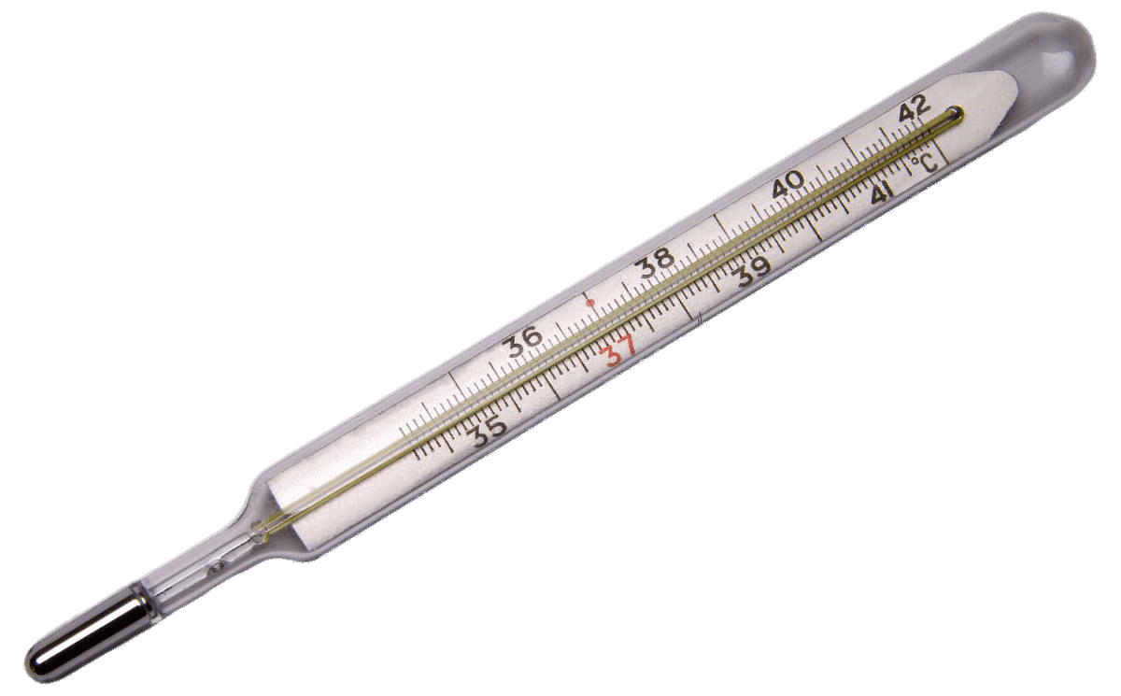

**

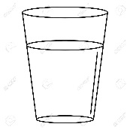

*T0=8oC T=88oC*

*m=0.435kg*

*c=4186J/(kgoC)*

*ΔT=88oC-8oC = 80oC*

*Q = m c ΔT*

*Q = 0.435kg(4186J/(kg oC))(80oC)*

*Q = 145672.8J*

*That is a LOT of ENERGY! In fact that would be the same amount of energy as it would take to lift a 700kg mass up to the top of a 6-story building! Wow.*

Example 2: 60 000J of energy is required to raise the temperature of 600g of an unknown liquid from 5oC to 95oC. What is the specific heat for this liquid?

m=0.6kg

ΔT= 95oC – 5oC = 90oC

*Q = m c ΔT*

$$c=\frac{Q}{m∆T}$$

$$c=\frac{60000J}{0.6kg({90}^{o}C)}=1111.\overline{1} \frac{J}{kg{}_{}^{o}C}$$

*The specific heat of this material is 1111J/(kgoC).*

**Latent Heat:**

If you heat a pot of water on a stove and monitor the temperature, an interesting thing will occur. The temperature will rise steadily until 100oC, then the water begins to boil. What is interesting is that as the water boils the temperature will not rise above 100oC. At the boiling point all added energy goes into breaking the intermolecular bonds in order to change the water from a liquid to a gas.

This behaviour is not unique to water. As any substance changes state (also called a phase change) from solid to liquid or liquid to gas or vice versa, the temperature remains constant during the phase change. During phase change all added energy/absorbed energy goes into to breaking/forming intermolecular bonds. This energy in known as *latent heat*.

Latent Heat of Fusion(Lf) : This is the energy (per unit mass) that must be added to change state from solid to liquid (melt) OR the energy that is released (per unit mass) as a substance changed from liquid to solid (freeze).

Latent Heat of Vaporization (Lv): This is the energy (per unit mass) that must be added to change state from liquid to gas (boil) OR the energy that is released (per unit mass) as a substance changed from gas to a liquid (condense).

The heat of fusion/vaporization depends upon the material. The energy needed to change the state of a certain mass of material can be found with the following formula:

$$Q=mL$$

Q: thermal energy in Joules

m: mass in kilograms

L: latent heat in Joules per kilogram

Example: The latent heat of fusion for ethyl alcohol is Lf=10800J/kg. How much thermal energy will be released as 250g of ethyl alcohol freezes?

*Solution:*

*m= 0.250kg*

*Lf=10800J*

$$Q=mL$$

*Q=0.25kg(10800J/kg)*

*Q= 2700J*

**Calorimetry:**

Calorimetry is the process of determining the amount of heat released or absorbed during a physical process. Calorimetry can also be used to determine the specific heat of an unknown substance.

The basic principle is the ***Law of Conservation of Energy***. This of course states that energy can neither be created nor destroyed, but can only change form. Thus in a thermal process the thermal energy that is released by one object must be absorbed by another.

Example 1: A sample of methane gas (m=2.00g) is burned. The energy released causes the temperature of 1.0kg of water to rise by 24oC. The specific heat of water is 4186J/(kgoC). How much energy was released from the methane?

*Solution: The energy absorbed by the water must be Q=mcΔT. This energy must have been released by the methane.*

*-Qmethane=Qwater=mcΔT*

*\*The negative indicates that the methane is releasing thermal energy, and so LOSING ENERGY.*

*-Qm=Qw=1.0kg(4186J/kgoC)(24oC)*

*-Qm=100464J*

*Qm=-100464J (Again, the negative sign tells us that the methane LOST energy)*

*The methane releases 100464J of energy.*

Example 2: 10mL of gasoline is burned within a calorimeter. A calorimeter is a sealed system in which the energy released from one substance is completely absorbed by another, usually water. The calorimeter contains 1.0L of water (1.0L of water = 1.0kg of water). The water (c=4186J/(kgoC)) temperature is observed to rise from 15oC to 90oC.

A. How much energy was released from the gasoline?

B. What is the *energy density* of the gasoline in units of megajoule per kilogram?

*Solution:*

*A. Energy absorbed by the water is equal to the energy released by the by the gasoline.*

*Qw=mc∆T*

*Qw=1.0kg(4186J/(kgoC)(90oC-15oC)*

*Qw=313950J*

*The gasoline released 313950J of energy*

*B. This is really just a unit conversion problem.*

Example 3: A 65g sample of an unknown material at 240oC is placed in a sealed container and lowered into a beaker containing 2.2kg of water (c=4186J/kgoC) at 20oC. After some time the system reaches equilibrium at 23oC. Find the specific heat of the unknown.

*Solution: Again the energy absorbed by the water is equal to the energy released by the unknown.*

*-Q?=Qw*

*-m?c?ΔT? = mwcwΔTw*

*-0.065kg(c?)(23oC-240oC)=2.2kg(4186J/kgoC)(23oC-20oC)*

*-0.065kg(c?)(-217oC)=9209J/oC(3oC)*

*14.105kgoC (c?)=27627.6J*

*c? =1958.7J/kgoC*