Uniform Circular Motion: Artificial Gravitation

As we have already discussed, for an object to travel in a circular path there must be sufficient force directed radially inward (toward the center of the circle) to cause the object to follow the circular path. If there is not enough force the object’s inertia will carry it on a straight line (or a straighter line) path.

The source of this force may be friction, tension, gravitation or any other force. Complete the activity described below and answer the following questions:

Activity:

- With a partner, or in a group of 3, grab a small paper cup and about 80cm of string.
- Poke two small holes approximately 1.5cm below the rim of the cup on opposite sides, using the tip of a pen or pencil. The holes only need to be large enough for the string to pass through.
- Thread the string through the holes and tie into a handle. See the diagram below, or the model in class.

knot

- Add about 2-3cm of water to the cup.
- Starting slowly, swing the cup of water back and forth, like a pendulum.
- Next, swing the cup in a complete circle, such that it is completely upside down at the top of its path.
- Now try to swing the cup in a complete horizontal circle, so the path is parallel to the ground.
A
D
C

B
vertical circle horizontal circle

- Have each person in your group try.
- Clean up any spills. Wet paper towel can be recycled.

Questions:

1. Draw FBDs for the water in the bucket for positions A, B, C and D from the diagrams.
2. What force is providing the centripetal force in each case?
3. Notice that for the horizontal circle, it is not possible to swing the cup (or any mass) fast enough to make the string completely horizontal, it will ALWAYS dip below horizontal. Explain why using Newton’s Laws.

You may be wondering what any of this has to do with artificial gravity. Well, imagine the activity were conducted in a zero gravity environment, like deep outer-space. Would the water still stay in the cup? Yes it would. The water still has inertia and would need the force from the cup (normal force) to push it into its circular path. Next imagine the bucket were much larger, and instead of water it was filled with astronauts. If those astronauts stood on the bottom of the bucket they would feel the “floor” of the bucket pushing them inward. The floor would push up on their feet, just like the floor pushes up on your feet when you stand on the ground. As long as the bucket keeps swinging quickly enough, the astronauts could stand, walk around, eat, sit on a chair, play guitar, construct origami aardvarks, etc.

If the swinging is done at constant speed, the normal force pushing each person inward will be constant, just like gravity. Moreover, by adjusting the speed of the bucket, the strength of the “gravity” could be increased or decreased to acclimatize the astronauts to different strengths of gravity to prepare for extended missions to different planets.

Of course, the astronauts would not be in a bucket, but rather some sort of cylindrical or toroidal space station which rotates.
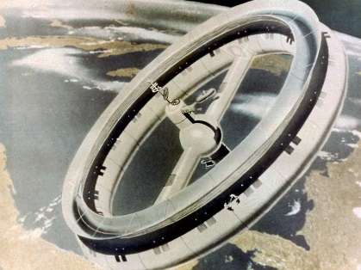
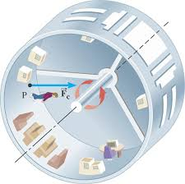

Examples:

1. A circular space station has a radius of 101m. What would be the rotational
speed of the outer edge of this station to simulate Earth’s gravity?

SOLUTION:
To simulate Earth, a=9.80m/s².

$a=\frac{v^{2}}{r} → v=\sqrt{ra}= \sqrt{101m (9.80\frac{m}{s^{2}})}=31.46108708m/s$

v=31.5m/s
2. A circular space station has a radius of 101m. What would be the rotational period of the station to simulate Earth’s gravity at its outer edge?

SOLUTION:
We could use the answer from number 1 and then use $v=\frac{2πr}{T}$ to find period, but I will solve this as though I had not done number 1.

$a=\frac{v^{2}}{r}= \frac{({\frac{2πr}{T})}^{2}}{r}= \frac{4π^{2}r}{T^{2}} → T= \sqrt{\frac{4π^{2}r}{a}}= \sqrt{\frac{4π^{2}101m}{9.80\frac{m}{s^{2}}}} =20.17100409s$

The period of rotation is 20.2s

3. A rotating space station has two levels. Level 1 has a radius of 120m
and level 2 has a radius of 240m. Both levels rotate with the same period.
The artificial gravity in level 2 is 16N/kg (16m/s²). What is the gravity in
level 1?

SOLUTION:
Both levels have the same period.

$a=\frac{4π^{2}r}{T^{2}} → T= \sqrt{\frac{4π^{2}r}{a}} → T_{1}= \sqrt{\frac{4π^{2}r_{1}}{a_{1}}} and T_{2}= \sqrt{\frac{4π^{2}r_{2}}{a_{2}}}$

$T_{1}= T_{2} →\sqrt{\frac{4π^{2}r_{1}}{a_{1}}}=\sqrt{\frac{4π^{2}r_{2}}{a_{2}}} → \frac{4π^{2}r_{1}}{a_{1}}= \frac{4π^{2}r_{2}}{a_{2}} → \frac{4π^{2}120m}{a_{2}}= \frac{4π^{2}240m}{16m/s^{2}}$

$a_{2}=\frac{120m(16m/s^{2})}{240m}=8.0m/s^{2}$ Notice: Half the radius, half the acceleration. Is that a coincidence? Is there a general rule you could write?
Practice:

1. A rotating space station is designed such that the astronauts experience an artificial gravity of 6.8m/s². The outer edge of the space station is moving at a speed of 48m/s. Find the radius of the space station.

2. A rotating space station is designed such that the astronauts experience an artificial gravity of 14m/s². The space station makes one complete rotation every 1.0 minute. Find the radius of the space station.

3. A rotating space station has a radius of 78m and spins at 3.00 RPM (3.00RPM means the station completes 3.00 revolutions per minute). Find the magnitude of the artificial gravity at the outer edge of this space station.

4. A rotating space station consists of two levels, spinning with the same frequency. Level A has a radius of 80.0m and simulates a gravity of 5.0m/s². Level B simulates a gravity of 12m/s². Find the radius of Level B.

