The Nitrogen Cycle:

The Earth’s atmosphere is about ________________ nitrogen gas (N₂).

Although there is so much nitrogen in the atmosphere most organisms ______________________________________.

A big part of the N-Cycle is how organisms have evolved together to _____________________________.

This is a very complicated process, but`s let`s look at some of the basics.

- Almost all nitrogen is removed from the atmosphere by ____________________________________.

- This can happen in a couple of ways.

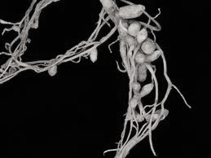
  - One way is a _________________________________________ relationship between nitrogen fixing bacteria and a type of plant called a _________________________. The bacteria live in small lumps on the roots of the legumes, called nodules. The bacteria pull nitrogen from the atmosphere and release it directly into the roots of the plant as NH₄ (____________________________). The legumes in turn, provide the bacteria with _____________________________.

  - Usually however the nitrogen-fixing bacteria live in the ___________________. The NH₄ they produce ________________________________ by most plants. A second type of _____________________ now comes to the rescue! Nitrifying bacteria convert NH₄ to NO₃⁻ (____________________). Plants CAN _______________________________ NO₃⁻ into their roots!

- The plants now make amino acids out of the nitrogen, which can then form _________________________.

- Animals then eat the plants to get their nitrogen.

- When the plants and animals die ___________________________ break them down and release _______________ back into the soil.

- Now to be a full CYCLE the nitrogen needs to ___________________________________________________.

- Some of the NO₃⁻ that is created by the __________________________________ is passed on to yet another type of ________________________ called ______________________________. These denitrifying bacteria convert NO₃⁻ back into ____________ and _________________________________.

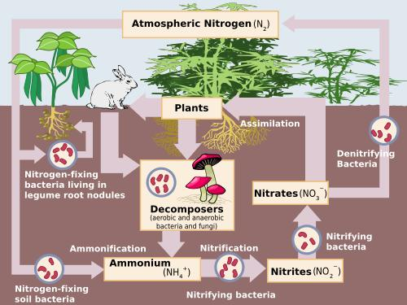

The Nitrogen Cycle:

The Earth’s atmosphere is about 78% nitrogen gas (N₂).

Although there is so much nitrogen in the atmosphere most organisms cannot use N₂ gas directly

A big part of the N-Cycle is how organisms have evolved together to remove N₂ from the atmosphere

This is a very complicated process, but`s let`s look at some of the basics.

- Almost all nitrogen is removed from the atmosphere by bacteria

- This can happen in a couple of ways.

  - One way is a mutualistic symbiotic relationship between nitrogen fixing bacteria and a type of plant called a legume. The bacteria live in small lumps on the roots of the legumes, called nodules. The bacteria pull nitrogen from the atmosphere and release it directly into the roots of the plant as NH₄ (ammonium). The legumes in turn, provide the bacteria with sugar.

  - Usually however the nitrogen-fixing bacteria live in the soil. The NH₄ they produce cannot be absorbed by most plants. A second type of bacteria now comes to the rescue! Nitrifying bacteria convert NH₄ to NO₃⁻ ( nitrate ). Plants CAN absorb NO₃⁻ into their roots!

- The plants now make amino acids out of the nitrogen, which can then form proteins.

- Animals then eat the plants to get their nitrogen.

- When the plants and animals die decomposers break them down and release NH₄ (ammonium) back into the soil.

- Now to be a full CYCLE the nitrogen needs to be returned to the soil.

- Some of the NO₃⁻ that is created by the nitrifying bacteria is passed on to yet another type of bacteria called denitrifying bacteria. These denitrifying bacteria convert NO₃⁻ back into N₂ (nitrogen gas) and release it to the atmosphere.

