The Ecological Niche and Evolution
An ecological niche where and what a species is/does within an ecosystem. Essentially it is the sum of all activities and relationships a species has while obtaining and using the resources needed to survive and reproduce.
A species' niche includes:
a. Habitat - where it lives in the ecosystem
b. Relationships - all interactions with other species in the ecosystem
c. Nutrition – Its energy source and its method of obtaining energy. In other words: What it eats and how it eats it.
Examples of Relationships/Interactions between Species
Relationship | Examples:
Herbivory  A primary consumer feeds on a producer. | a. A fruit bat eats a papaya.  b. The cottontail eats white clover.
Predatory  A consumer kills and eats another consumer. | a. The cougar is a predator of black-tailed deer.  b. The great white shark is a predator of harbor seals.
Mutualism  2 species live together with each providing benefit to the other via the relationship. | a. Aphids provide honey dew for ants, while the ants move the aphids to new leaves and protect them from predators.  b. The Rufous Hummingbird obtains nectar from the Red Columbine while distributing the pollen for the flower.
Commensalism  One species benefits from another without causing any significant negative effect to that species | a. A bird builds its nest high in a tree gaining protection from predators.  b. An egret (bird) follows heards of zebra and eats the insects that are stirred up as the zebra walk through the grass.
Parasitism  A parasite lives on or within a host and obtains food from it. The parasite benefits, the host is always harmed. | a. The fish tapeworm lives in the small intestine of a cat, absorbing digested food provided by the cat.  b. Mistletoe is a plant parasite on Oregon White Oak, obtaining sap from the oak.
Competition  2 species compete for the same resource. If there is not enough to support both one will have to adapt, move or become extinct. The effect is negative for both species | a. Douglas Fir & Western Hemlock grow together in the mixed conifer forests of Oregon, competing for minerals, water, and light.  b. A scrub jay and a gray squirrel compete for nuts and seeds within the oak forest.
Change and adaptation are driving forces for evolution to occur. Darwin’s Theory of Evolution by Natural Selection is based on this concept. A term that is often used to describe Darwin’s theory is
“Survival of the Fittest”
Perhaps it should be rephrased as
“Survival of the Adaptable-est”
Here fitness refers to how well a species can find and fill a niche, how well it can compete for resources, how well it can avoid predation and survive long enough to reproduce.
Pressures that Drive Evolution:
There are many factors that may lead to the evolution of a species. Two major factors are environmental change and competition.
Environmental Change:
If something occurs that creates a stress to an organism’s (or population’s) niche, that population may need to adapt somehow. The something could be the introduction of a new species to the habitat. The something could be a change in the habitat itself, like a forest fire, a flood or climate change. The something could be a disease that kills off a food source. The something could be many things.
The way a population adapts is NOT always going to be evolution. In fact, more commonly a population will find a simpler way to adapt. It may find a different food source (ex: Orcas changing their diet from whales to sea otters) or move to a new location where the pressure is not present.
However, sometimes these changes to the environment favor certain individuals with certain traits or characteristics (ex: dark butterflies vs. light butterflies during the industrial revolution, more passive wolves on the fringes of human settlements vs aggressive wolves…). In these cases, those individuals with the favorable trait will have a better chance to outcompete others and the specific traits may be passed on. If this continues the species will evolve.
Competition:
Intraspecies Competition: Competition between members of the same species for resources (water, food, shelter and mates) in the habitat.
EX: Male bighorn sheep compete for mates by fighting. The sheep run toward one another a ram their heads together. In fact they are called Rams! The last one to give up gets to mate.

EX: After a kill wolves will compete for the best parts of the kill.

Interspecies Competition: Competition between 2 different species for the resources of the habitat.
EX: Hyenas fight a cheetah for a fresh kill.

EX: Oak and hickory trees in eastern North America grow taller faster than most pines, thereby shading smaller species and eventually dominating the forest.

Competition between 2 Different Species for a Niche:
a. 2 Species partially share a niche: both compete in the overlapping parts of the niche for resources, nesting sites, or territory. If the overlap is minimal, both species can coexist. This is known as RESOURCE/NICHE PARTIONING. It can be spatial, temporal or morphological.
b. 2 Species have the same niche: both compete head to head in the niche for resources, nesting sites, or territory. One of the species will be superior to the other in utilizing the niche. The 2nd species disappears from the ecosystem. The 2nd species must either adapt (evolve) or move to a new habitat. Otherwise it will face extinction.
Competitive Exclusion Principle: Only 1 species can occupy a whole niche in an ecosystem at a time.
Extinction: When all individuals of a certain species die off.
Artificial Selection

This is when humans selectively breed, or genetically modify, in order to favor “desirable” traits. This can be seen extensively in agriculture and is well known in dogs.

Key points:
- In interspecies competition, two species use the same limited resource. Competition has a negative effect on both of the species (-/- interaction).
- A species' niche is basically its ecological role, which is defined by the set of conditions, resources, and interactions it needs (or can make use of).
- The competitive exclusion principle says that two species can't coexist if they occupy exactly the same niche (competing for identical resources).
- Two species whose niches overlap may evolve by natural selection to have more distinct niches, resulting in resource partitioning.

Introduction
Humans compete with other humans all the time – for jobs, athletic prizes, dates, you name it. But do we compete with other species? If you've ever gone camping and had you food stolen by an enterprising raccoon, bear, or other critter, you've had a little taste of interspecific competition – competition between members of different species that use overlapping, limited resources.
Resources are often limited in a habitat, and many species may compete to get ahold of them. For instance, plants in a garden may compete with each other for soil nutrients, water, and light. The overall effect of interspecific competition is negative for both species that participate (a -/- interaction). That is, each species would do better if the other species weren't there.
In this article, we'll look at the concept of an ecological niche and see how species having similar niches can lead to competition. We'll also see how species can evolve by natural selection to occupy more different niches, thus divvying up resources and minimizing competition.

The niche concept
A species' niche is its ecological role or "way of life," which is defined by the full set of conditions, resources, and interactions it needs (or can make use of)^1​1​​start superscript, 1, end superscript. Each species fits into an ecological community in its own special way and has its own tolerable ranges for many environmental factors. For example, a fish species' niche might be defined partly by ranges of salinity (saltiness), pH (acidity), and temperature it can tolerate, as well as the types of food it can eat.
[Is that the only way to define a niche?]
As we'll see, two organisms with exactly the same niche can't survive in the same habitat (because they compete for exactly the same resources, so one will drive the other to extinction). However, species whose niches only partly overlap may be able to coexist. Also, over long periods of time, they may evolve to make use of more different, or less overlapping, sets of resources.

Competitive exclusion principle
The competitive exclusion principle tells us that two species can't have exactly the same niche in a habitat and stably coexist. That's because species with identical niches also have identical needs, which means they would compete for precisely the same resources.
A famous example of the competitive exclusion principle is shown in the figure below, which features two types of single-celled microorganisms, Paramecium aurelia and Paramecium caudatum. When grown individually in the lab, both species thrive. But when they are grown in the same test tube (habitat) with a fixed amount of nutrients, both grow more poorly and P. aurelia eventually outcompetes P. caudatum for food, leading to P. caudatum's extinction.
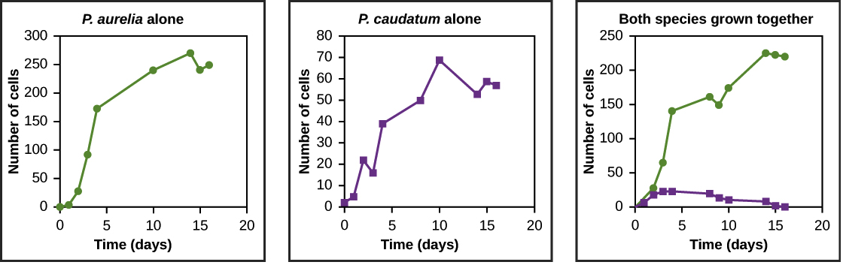
Graphs a, b, and c all plot number of cells versus time in days. In Graph (a), P. aurelia is grown alone. In graph (b), P. caudatum is grown alone. In graph (c), both species are grown together. When grown together, the two species both exhibit logistic growth and grow to a relatively high cell density. When the two species are grown together, P. aurelia shows logistic growth to nearly the same cell density as it exhibited when grown alone, but P. caudatum hardly grows at all, and eventually its population drops to zero.
Image modified from "Community ecology: Figure 7," by OpenStax College, Concepts of Biology, CC BY 4.0.
In nature, it's rarely the case that two species occupy exactly identical niches. However, the greater the extent to which two species' niches overlap, the stronger the competition between them will tend to be^2​2​​start superscript, 2, end superscript.

Resource partitioning
Competitive exclusion may be avoided if one or both of the competing species evolves to use a different resource, occupy a different area of the habitat, or feed during a different time of day. The result of this kind of evolution is that two similar species use largely non-overlapping resources and thus have different niches. This is called resource partitioning, and it helps the species coexist because there is less direct competition between them.
The anole lizards found on the island of Puerto Rico are a good example of resource partitioning. In this group, natural selection has led to the evolution of different species that make use of different resources. The figure below shows resource partitioning among 11 species of anole lizards. Each species lives in its own preferred habitat, which is defined by type and height of vegetation (trees, shrubs, cactus, etc.), sunlight, and moisture, among other factors.

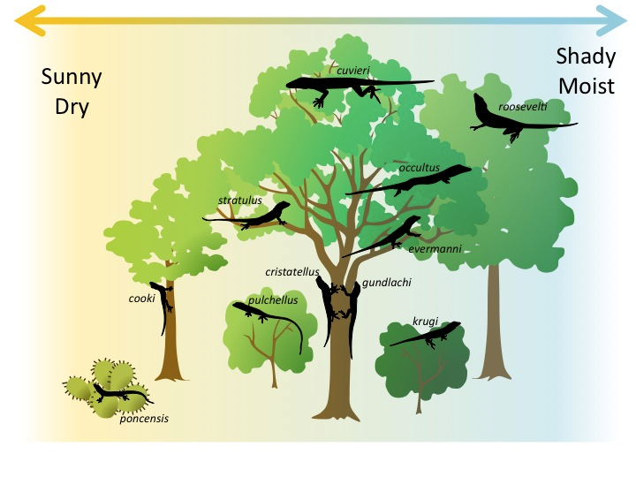
Diagram representing resource partitioning among species of anole lizards. Some live high in a tree, others in the middle, others on the trunk. Other anole species live in bushes or cactuses. Also, some species live in a sunnier, drier environment, while others live in a shadier, moister environment. There are 11 species pictured in all, each with a slightly different type of environment it occupies.
Image credit: "Community ecology: Figure 9, by Eva Horne, modified from Williams et al.^3​3​​start superscript, 3, end superscript, source article is CC BY 4.0.

