The Doppler Effect:

- The Doppler Effect is a perceived change in the frequency of a wave (pitch for sound, colour for light) when there is relative motion between the source and the observer.
- If the source and observer are moving toward one another the observer will detect the wave as having a higher frequency than the frequency of the source.
- If the source and observer are moving away from one another the observer will detect the wave as having a lower frequency than the frequency of the source.

The explanation for this phenomenon is slightly different depending on who is moving, the source or the observer.

Moving Source

From here on we will be looking at the Doppler Effect for sound. The effect is similar for light, but the explanation and the calculations are much more difficult due to relativity.

First we need to recognize that as sound travels away from a source it will move out in all directions like ripples in a pond after a rock is thrown in. We can imagine a diagram in which we note the position of each compression as the waves move away from the source. If the source is stationary the diagram simple looks like:

A B

If the source moves with constant speed to the left or to the right the diagram becomes:

A B A B

The net effect is that the waves in front of the source are compressed while the waves behind the object are stretched. In each case imagine what observers at points A and B would hear.

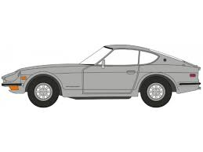

Moving Observer:

In the case of the moving observer the sound waves move out from the source in concentric circles like in the first diagram. The wavelength is consistent in all directions. To simplify let’s just consider the waves moving out to the left and right.

Moving Toward Source Moving Away From Source

