Simple Machines:
Machine:
- Any mechanical device that trades an input for an output.
Simple Machine:
- A machine that converts an input force to an output force. Most commonly F_{o} > F_{i}.
- The input is often called the effort, while the output is often called the load.
- This is done by increasing the distance over which the force must act.
- For an ideal (no energy lost) simple machine
$\sum{F}$_{i}d_{i} = $\sum{F}$_{o}d_{o}
- Machines act on the principle of conservation of energy
- The basic principle is that we trade force for distance. By increasing the distance, we can decrease the force required and still do the SAME AMOUNT OF WORK.

The 6 Simple Machines:
- There are 6 types of simple machines that can be grouped into 2 categories.

Inclined Planes | Levers
Ramp | Lever and Fulcrum
Wedge | Pulley
Screw | Wheel and Axle

1. RAMP:

We have all seen and used a ramp. Rather than lifting and object straight up, we can move it up by using a ramp. By doing so we move the object a greater distance, but we need to use less force.
M
h
h
M
d₁
d₂
F₁
F₂

To move the mass to the top of the table, we must increase its energy by: ΔU_{g}=mgh, so we must do that amount of work.

If we lift straight up we apply a force of mg over a distance d₁=h.
If we use the ramp the distance is increased, but the force will be decreased.
If we ignore friction then we see that:
W_{i} = W_{o}= mgΔh
F₁d₁ = F₂d₂
or: $\frac{d_{i}}{d_{o}}= \frac{F_{o}}{F_{i}}$

So for example to lift a 200N object up 2m, we need to do 400N of work. If we use a 10m long ramp we can do the same work with a 40N force. 5 times the distance, $\frac{1}{5}$ the force!
This basic principle applies to all machines and the ratio
$$\frac{F_{o}}{F_{i}}= \frac{d_{i}}{d_{o}}$$

is called the MECHANICAL ADVANTAGE (M.A.) of the machine.

$$M.A.=\frac{F_{o}}{F_{i}}= \frac{d_{i}}{d_{o}}$$

2. WEDGE:
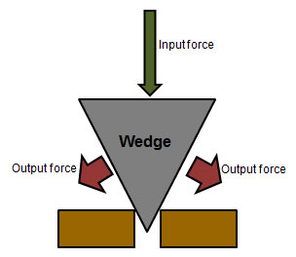
A wedge is simply 2 ramps stuck together. It operates by using a force to move the wedge, while forcing some object apart. Think of an axe:

d_{in}=L

d_{out}=w
The input force causes the wedge to move into the material a distance d_{in} which is the length, L, of the wedge. Thin forces the material to move apart a distance d_{out} which is the width, w, of the wedge.

$$M.A.=\frac{d_{in}}{d_{out}}=\frac{L}{w}$$
SCREW:
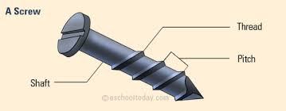
A screw is essentially an inclined plane wrapped around a central shaft. It’s kind of like a spiral staircase without the stairs.

The pitch is the space between threads and it is the distance the screw will sink into the material for one complete rotation.
$$M.A.=\frac{d_{in}}{d_{out}}=\frac{2πr}{p}$$
Here r is the radius of the shaft of the screw, p is the pitch.
4. Lever
A lever is simply a rigid beam with a fulcrum. There are 3 classes of simple lever which are defined by the relative position of the
Class 1 Lever:
The fulcrum is between the load and the effort. Consider a simple rod and pivot:
F_{in}
d_{out}
d_{in}
F_{out}
M
M
L_{in}

L_{out}
$$M.A.=\frac{d_{in}}{d_{out}}= \frac{L_{in}}{L_{out}}$$

Class 2 Lever:
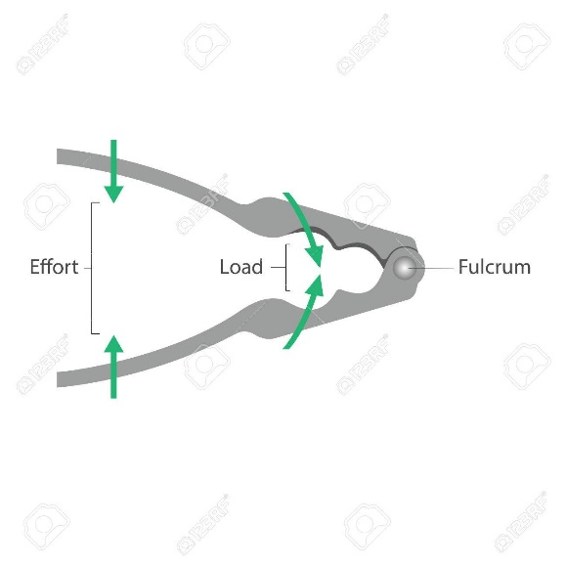
The load is between the fulcrum and the input. Usually the fulcrum is at one end, while the input is at the other. Common examples are a wheelbarrow or a nut-cracker.
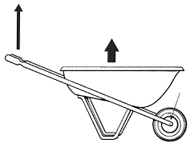

Class 3 Lever:
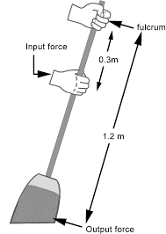
The input is between the fulcrum and the load. Usually the fulcrum is at one end, while the output is at the other. Common examples are tweezers, or stapler or a broom.

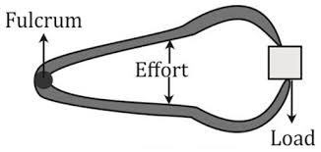

These levers don’t provide a mechanical advantage. In fact the input force is greater than the output! So why do we use them?
5. Pulley
A single pulley on its own does not provide any mechanical advantage, but a collection of pulleys can. The mechanical advantage of the pulley follows the same basic formula:

$$M.A.=\frac{F_{1}}{F_{2}}= \frac{d_{2}}{d_{1}}$$
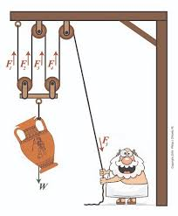
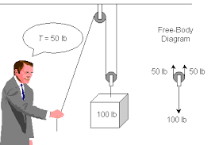
But there is a bit of a shortcut for a pulley system:

You can figure out the mechanical advantage by simply counting how many times the pulley system causes the rope to pull on the object.
Complex machines work in similar ways, combining multiple simple machines. and I leave it to you to work out the mechanical advantage of each.

