Part 2: Types of Compounds Review

Identifying Compounds

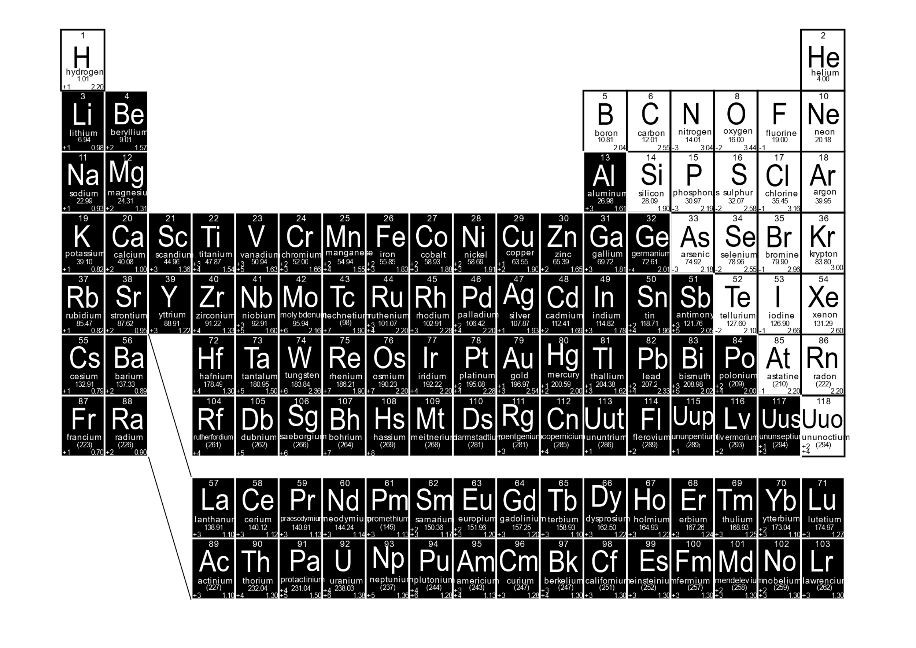
The first step in naming compounds is to recognize an element as a metal or a non-metal. Luckily this is very simple with your periodic table.

Each element that appears as black is a metal, each element shown in white is a non-metal.

Hydrogen is the exception as it can behave as either a metal or a non-metal. We will deal with that a little later!

An ionic compound consists of a metal and a non-metal, bound by an ionic bond. The metal will appear first in the chemical name and formula, while the non-metal will appear second in the name (with the ending “ide”) and formula.

A covalent compound consists of two non-metals, bound by shared electrons; a co-valent bond.

Practice:

Identify each compound below as ionic (I) or covalent (C).

A. NaCl B. CaF₂ C. SiCl₄ D. CuCl₂ E. N₂O₂
F. P₂Cl G. CO₂ H. K₂O I. MgBr₂ J. B₂F₃

Beyond this there are other more complex classifications of compounds like acids, bases and salts. There is also the distinction between organic and inorganic compounds, within organic compounds there are hydrocarbons, alcohols, sugars, proteins, aromatics, benzenes, polymers and more. This will be explored in more detail in Science 10.

Naming Ionic Compounds

Rule 1: a. Write the name of the metal element first.
b. If the metal is a transition metal (group 3-12) include a roman numeral to indicate ion charge.

Rule 2: Write the name of the poly atomic ion or non-metal element next. For non-metal elements
change the ending to “ide”

Practice:

Write the chemical name for each of the following ionic compounds. Don’t forget to write the correct roman numeral for transition metals!

A. NaCl B. Na₂O C. MgO D. MgCl₂ E. KI F. CuCl₂ G. FeBr₃
H. CrN I. K₂S J. Li₂O K. CuF L. FeBr₂ M. CuCl N. MnO₂

Naming Covalent Compounds

Rule 1: The element with the lower group (family) number is written first in the name; the element with
the higher group (family) number is written second in the name.
Exception: when the compound contains oxygen and a halogen, the name of the halogen is the first word in the name.
Rule 2: If both elements are in the same group, the element with the higher period number is written
first in the name.

Rule 3: The second element in the name is named as if it were an anion, i.e., by adding the suffix -ide to
the name of the element.

Rule 4: Greek prefixes (see the table below) are used to indicate the number of atoms of each nonmetal element in the chemical formula for the compound.

Rule 5: The Greek prefix is written before the name of each element. That’s why it’s called a pre-fix!
Exception: if the compound contains one atom of the element that is written first in the name, the prefix "mono-" is not used.

Prefixes:
Number | Prefix | Number | Prefix
1 |  | 6
2 |  | 7
3 |  | 8
4 |  | 9
5 |  | 10
Note: when the addition of the Greek prefix places two vowels adjacent to one another, the "a" (or the"o") at the end of the Greek prefix is usually dropped; e.g., "nonaoxide" would be written as "nonoxide", and "monooxide" would be written as "monoxide". The "i" at the end of the prefixes "di-" and "tri-" are never dropped.

Practice:

A. P₂Cl₄ B. CO₂ C. CO D. N₂O₂ E. Si₂O₃ F. ClF
G. NO H. SeF₂ I. B₂S₃ J. CCl₄ K. AsN L. Si₃N₅

Practice:

Identify each compound below as ionic (I) or covalent (C).

A. NaCl B. CaF₂ C. SiCl₄ D. CuCl₂ E. N₂O₂
F. P₂Cl G. CO₂ H. K₂O I. MgBr₂ J. B₂F₃

A. I B. I C. C D. I E. C
F. C G. C H. I I. I J. C

Practice:

Write the chemical name for each of the following ionic compounds. Don’t forget to write the correct roman numeral for transition metals!

A. NaCl B. Na₂O C. MgO D. MgCl₂ E. KI F. CuCl₂ G. FeBr₃
H. CrN I. K₂S J. Li₂O K. CuF L. FeBr₂ M. CuCl N. MnO₂

A. sodium chloride B. sodium oxide C. magnesium oxide D. magnesium chloride
E. potassium iodide F. copper(II) chloride G. iron(III) bromide H. chromium(III) nitride
I. potassium sulfide J. Lithium oxide K. copper(I) fluoride L. iron(III) bromide
M. copper(I) chloride N. manganese(IV) oxide

Practice:

A. P₂Cl₄ B. CO₂ C. CO D. N₂O₂ E. Si₂O₃ F. ClF
G. NO H. SeF₂ I. B₂S₃ J. CCl₄ K. AsN L. Si₃N₅

A. diphosphorous tetrachloride B. carbon dioxide C. carbon monoxide
D. dinitrogen dioxide E. disilcon trioxide F. chlorine monofluoride
G. nitrogen monoxide H. selenium difluoride I. diboron trisulfide
J. carbon tetrachloride K. arsenic mononitride L. trisilicon pentanitride

