DNA replication

The Basic Replication Process.

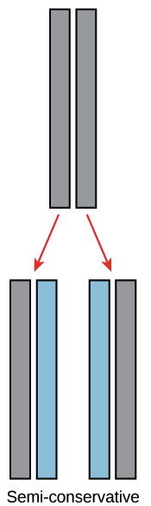

Semi-conservative replication produces two helices that contain one old and one new DNA strand.

DNA replication is semi-conservative. This means that each of the two strands in double-stranded DNA acts as a template to produce two new strands. Each “new” molecule contains one “old” strand that served as the template and one “new” strand that was constructed during the replication process.

Replication relies on complementary base pairing: adenine (A) always bonds with thymine (T) and cytosine (C) always bonds with guanine (G).
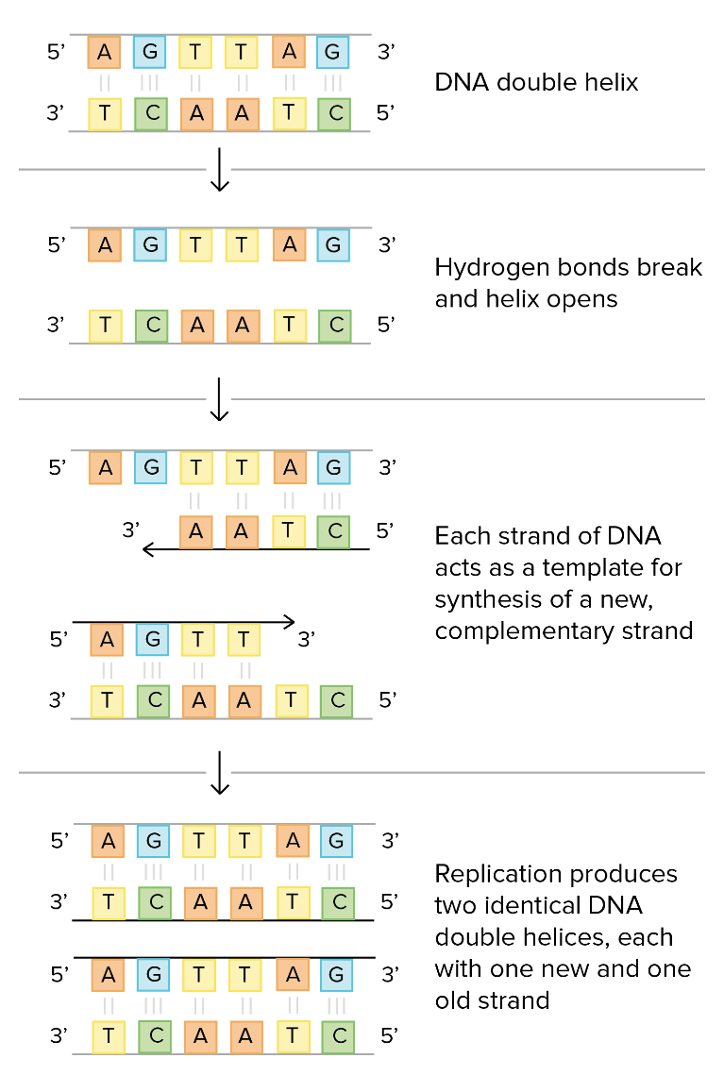

More Detail: Enzymes

The actual process is significantly more complex. We will now look at the process in slightly more detail:

DNA replication occurs through the help of several enzymes. One of those enzymes, called DNA helicase, "unzips" the DNA molecule by breaking the hydrogen bonds that hold the two strands together. Each strand then serves as a template for a new complementary strand to be created. Complementary bases attach to one another (A-T and C-G).

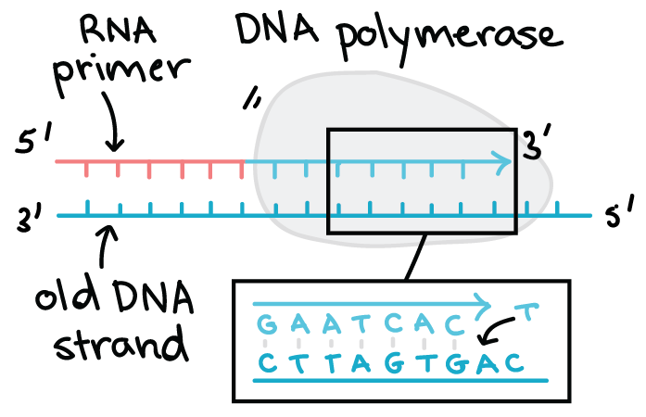

The DNA template is used to create the complementary strand. The primary enzyme involved in this is DNA polymerase which joins nucleotides to synthesize the new complementary strand. DNA polymerase also proofreads each new DNA strand to make sure that there are no errors.

DNA Transcription

Transcription is the first step in gene expression. It involves copying a gene's DNA sequence to make an RNA molecule.

RNA (Ribonucleic Acid) is like DNA, with three key differences:

1. RNA is single stranded, not double stranded.
2. The sugar in the RNA backbone is ribose rather than deoxyribose.
3. Most importantly (to us, at least) is that the thymine base is replaced by uracil. That is to say that RNA has A, C, G and U instead of A, C, G and T. The pairing rules are sill intact:

A with U
C with G

The Basic Transcription Process:

Transcribe means to copy a message into a written form. In biology the goal of transcription is to make an RNA copy of a gene's DNA sequence. The RNA copy, called messenger RNA, or mRNA, or transcript, carries the information needed to build a protein out of the nucleus, into the cytoplasm.
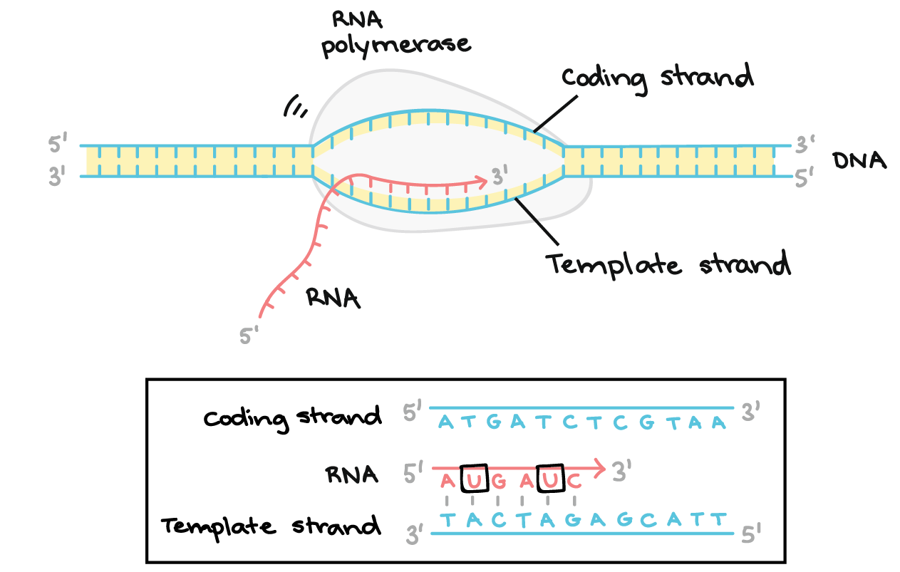

In transcription:

1. A region of DNA in unzipped and un wound. The region of opened-up DNA is called a transcription bubble.
2. One strand, the template strand, serves as a template for synthesis of a complementary mRNA transcript. The other DNA strand is called the coding strand.
3. RNA polymerase adds nucleotides to the strand of RNA, called messenger RNA. Once complete the mRNA moves out of the transcription bubble.
4. The mRNA molecule moves out of the nucleus.
5. The DNA molecule “rezips”. Notice that the DNA molecule is not changed during transcription.

DNA Translation

Translation is the process by which the DNA code is finally “translated” into a final product. That final product is a protein.

During translation, the mRNA sequence is read in groups of three nucleotides. Each three-letter "word" or codon corresponds to an amino acid that's added to a polypeptide (protein or protein subunit).

The amino acids are carries by small segments of RNA, three nucleotides long, called transfer RNA or tRNA. The tRNA temporarily binds to the strand of mRNA while the amino acid it carries is attached to the growing peptide chain. Once the amino acid id attached, the tRNA detaches and goes back to pick up another amino acid.
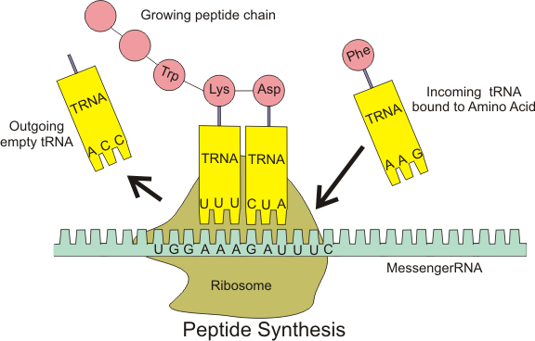

This is the end goal of DNA and of genes. Of course, the real process is much more complex. There are many more enzymes involved and the sequences of DNA for any gene are on the order of 100 000 letters long. Furthermore, many of the letters are actually just gibberish, and the code must be spliced together to make sense. Consider the following simple example:

BQQWTHEDOGRSMKPQARANDAZEPTQMTETHEHAMFAUMNO

Decode the message above. Just like in a DNA sequence, all the words are three letters long. First, remove the "junk" letters. Second, put the remaining letters into groups of three, starting at the beginning.

Practice:

1. For the following DNA template strand segments, write the mRNA code that results from transcription:

A. CGGATTACAGTT

B. AGGTACCGCCA

C. ACCTATATTCCG

2. For the following DNA coding strand segments, write the mRNA code that results from transcription:

A. GTTCACGGA

B. CATGAGTTA

C. AAGCTCGCTG

3. What was the sequence of bases on the template DNA strand that results in the following mRNA sequence?

A. ACGGUGCU

B. GCCAUUAC

C. UUGGCAGC

4. What sequence of amino acids results from the following mRNA sequences?

A. CUUGAGGCUGCGUGAUG

B. AUGUUUUAUCAAUAAAUA

C. AGGCGAUCCAGCUGA

Practice:

1. For the following DNA template strand segments, write the mRNA code that results from transcription:

A. CGGATTACAGTT GCCUAAUGUCAA

B. AGGTACCGCCA UCCAUGGCGGU

C. ACCTATATTCCG UGGAUAUAAGGC

2. For the following DNA coding strand segments, write the mRNA code that results from transcription:

A. GTTCACGGA GUUCACGGA

B. CATGAGTTA CAUGAGUUA

C. AAGCTCGCTG AAGHUCGCUG

3. What was the sequence of bases on the template DNA strand that results in the following mRNA sequence?

A. ACGGUGCU TGCCACGA

B. GCCAUUAC CGGTAATG

C. UUGGCAGC AACCGTCG

4. What sequence of amino acids results from the following mRNA sequences?

A. CUUGAGGCUGCGUGAUG Leucine-Glutamic Acid-Alanine-Alanine-STOP

B. AUGUUUUAUCAAUAAAUA Methionine-Phenylalanine-Tyrosine-Glutamine-STOP

C. AGGCGAUCCAGCUGA Arginine-Arginine-Serine-Serine-STOP

