MITOSIS, MEIOSIS and GAMETE FORMATION
Mitosis is the type of cell division that occurs during normal growth and cell replacement. In mitosis a single parent cell duplicates all its DNA and divides. Each daughter cell has the exact same DNA as the parent.

Summary: One cell divides into two identical cells. Normal growth and repair.

Meiosis is the type of cell division that produces “sex cells” called gametes. These are the sperm and egg cells. In meiosis a parent cell duplicates its DNA, but produces FOUR cells, each has only one half of the DNA from the parent. This is done in a very specific way so that each gamete gets exactly one of each chromosome.

Summary: One cell divides into four cells with ½ of the DNA of the parent. Produces sex cells called gametes.

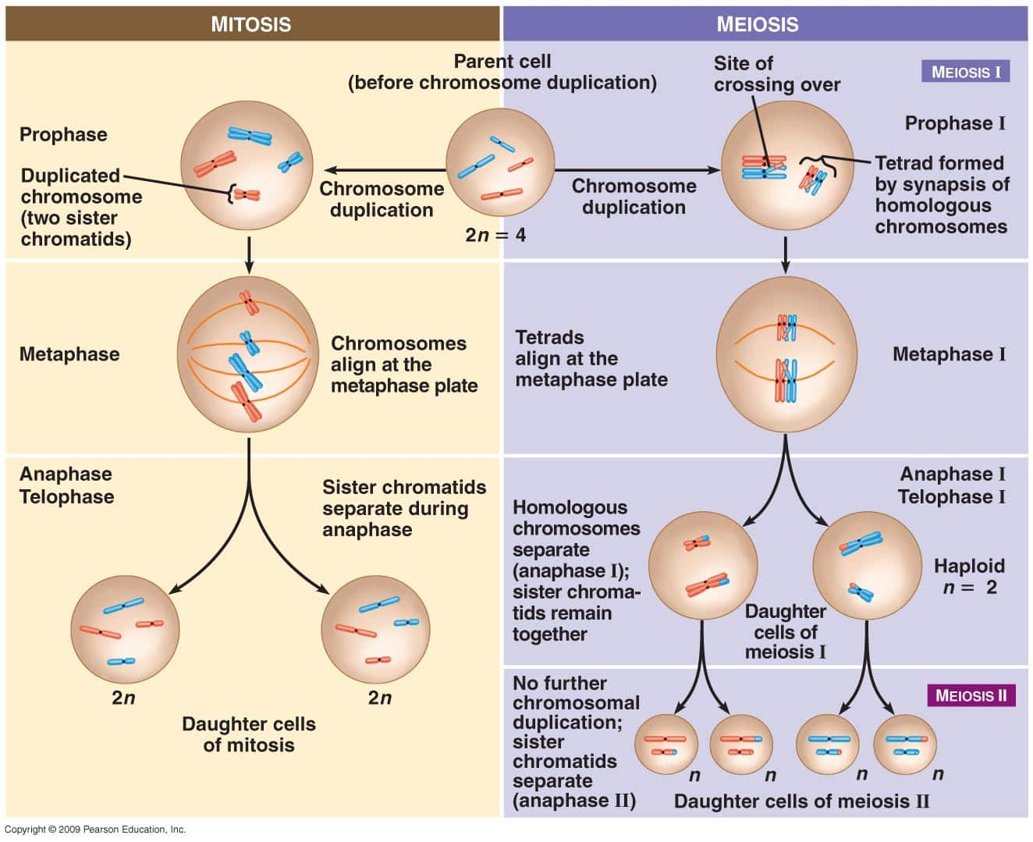

The above diagram shows a simplified version of mitosis and meiosis. The original parent cell has 2 pairs of chromosomes, 4 total. Corresponding pairs are called HOMOLOGOUS chromosomes. The colour coding here is just to help keep track of members of homologous pairs. The colours can be interpreted to represent maternal and paternal DNA. For instance you could imagine that each red chromosome is paternal, each blue chromosome is maternal. The final daughter cells of meiosis II show the possible gametes. In this example we see only half of the possibilities.

Meiosis Chromosome Combinations

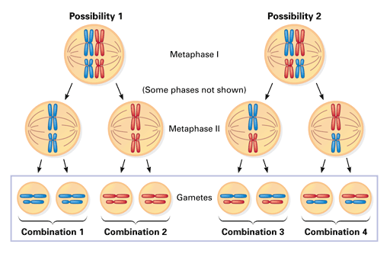

There are 4 unique combinations of genetic material possible. In other words
there are 4 possible gametes.

Crossing Over

Crossing over is a process by which two homologous chromosomes exchange equal segments with each
other. Crossing over occurs in the first division of meiosis. This leads to an even greater amount of genetic variability.

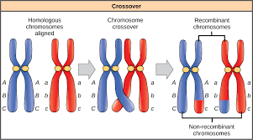

Instead of 4, there are now 8 unique combinations of DNA possible, or 8 unique gametes.

