DNA, Genes and Chromosomes
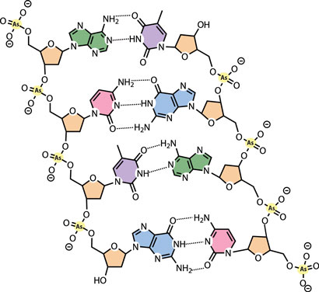
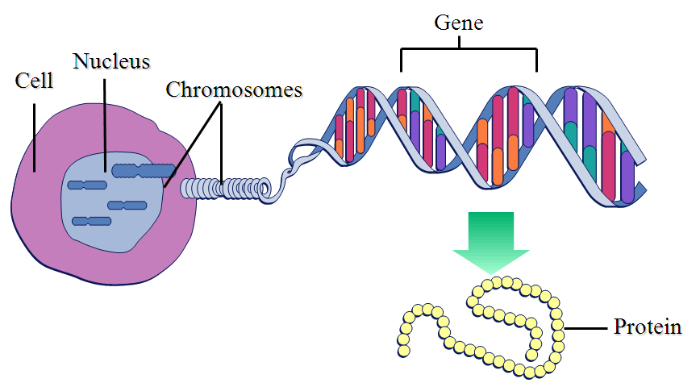

DNA:

- DNA is short for deoxyribonucleic acid. It is a very large molecule found within the cells of every living thing ever observed. Interestingly, DNA is not an acid at all, it is a salt.
- DNA is sometimes called the blueprint for life.
- DNA contains coded information telling our cells how to make proteins, how and when to divide and everything else that our cells do. Your DNA determines your hair colour, your eye colour, your height and all the other traits that make you, you. Your DNA tells your lungs how to breathe and your heart how to beat.
- In monera the DNA is just floating around in the cell, but in all other types of life (protists, fungus, plants and animals) the DNA is found within the nucleus.
- DNA has a shape like a ladder that has been twisted around and around. This shape is called a double helix. The sides of the ladder are made up of sugar (deoxyribose) and phosphates. The rungs of the ladder are each made of two nitrogenous bases.
- There are 4 nitrogenous bases in DNA:
Adenine (A), Cytosine (C), Guanine (G) and Thymine (T)
- The bases attach to each other like puzzle pieces. Adenine only attaches to Thymine (and vice versa), while Cytosine only attaches to Guanine. We will usually just call them A, C, G and T.

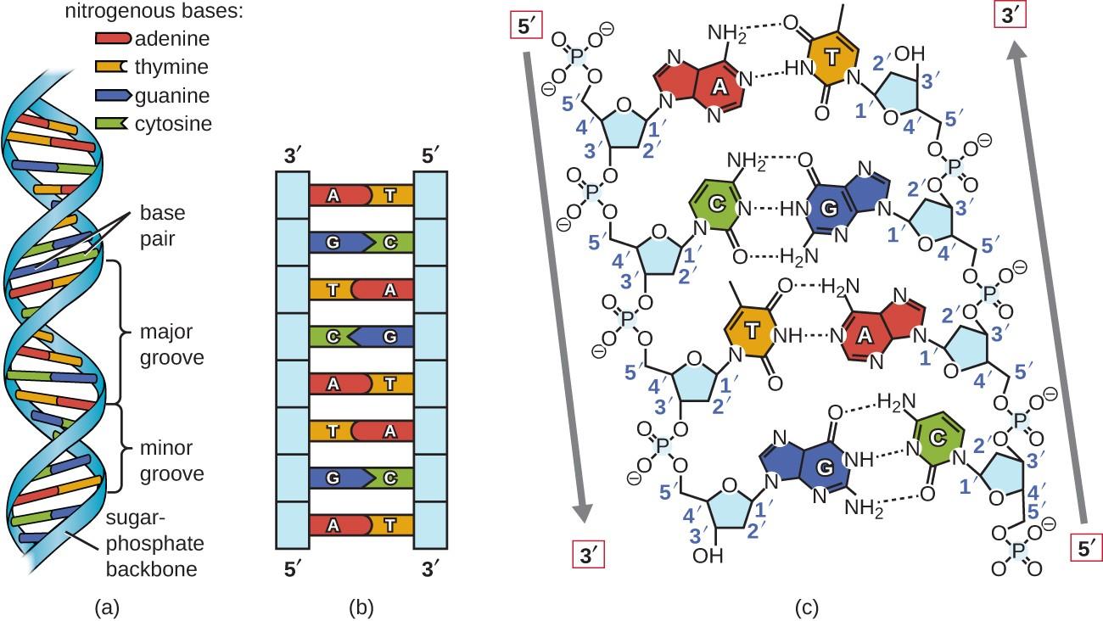

- One grouping of sugar, phosphate, base pair is called a nucleotide.
phosphate
sugar
BASE
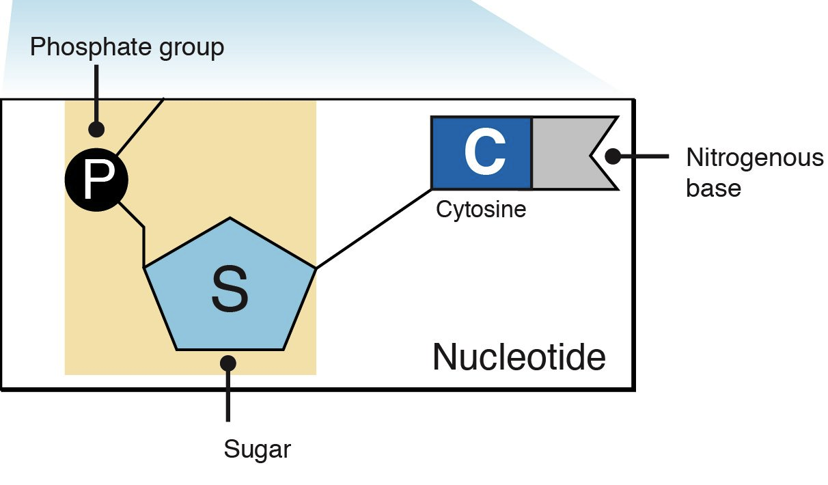

- A single strand of DNA in a human cell can have 200 million base pairs, or 400 million nucleotides!

GENE:

- A gene is one bit of genetic information
- Quite simply a gene is just a “small” section of DNA. Genes vary in size, but on average contain over 100 000 nucleotide pairs.
- Each gene, or bunch of genes together, holds information for individual traits. For example one section of your DNA determines if you can roll your tongue, that section is the gene for tongue rolling.
- Most traits are controlled by multiple genes. The colour of your skin, for instance, is determined by 378 little sections of your DNA, or, in other words, you have 378 genes for skin colour!
- Each gene is a set of instructions that tells your cell how to build a certain protein.

ALLELE:

- Every gene you have has a partner. You get one version of the gene from your mother and one version from your father.
- These different versions of the gene are called alleles.
- So there is one gene for tongue rolling, but you get one version of that gene from your mother and one version from your father. Depending on the combination of these different versions, or alleles, you can either roll your tongue or not.
- So this means that your skin colour is determined by 378 alleles from your mother and 378 alleles from your father. That’s 756 alleles! Imagine that Punnett square!

CHROMOSOME:

- Your DNA is not all in one big long strand, instead it broken up into sections.
- Each section of DNA is bundled up and coiled up into a package called a chromosome.
- Different organisms have different numbers of chromosomes; humans have 23 pairs for a total of 46.
- It is hard to figure how many chromosomes an organism has. A hermit crab has 254 (127 pairs), a potato has 48 (24 pairs) and a pigeon has 80 (40 pairs).

