Plate Tectonics:
Internal Earth Structure:

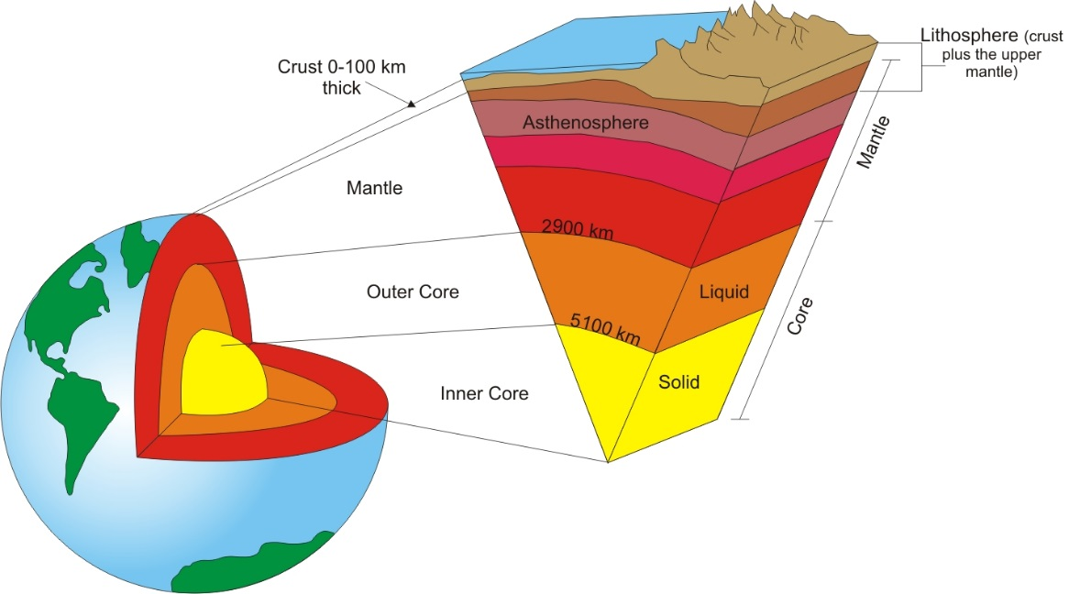

Sea Floor Spreading:
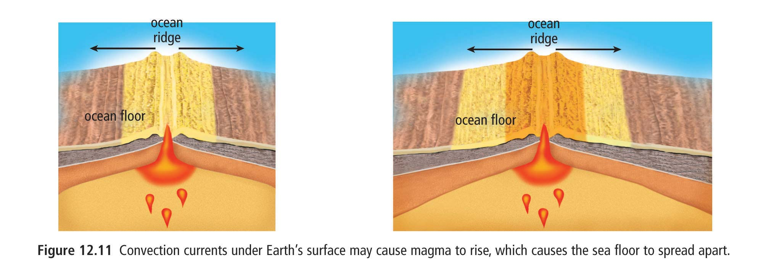

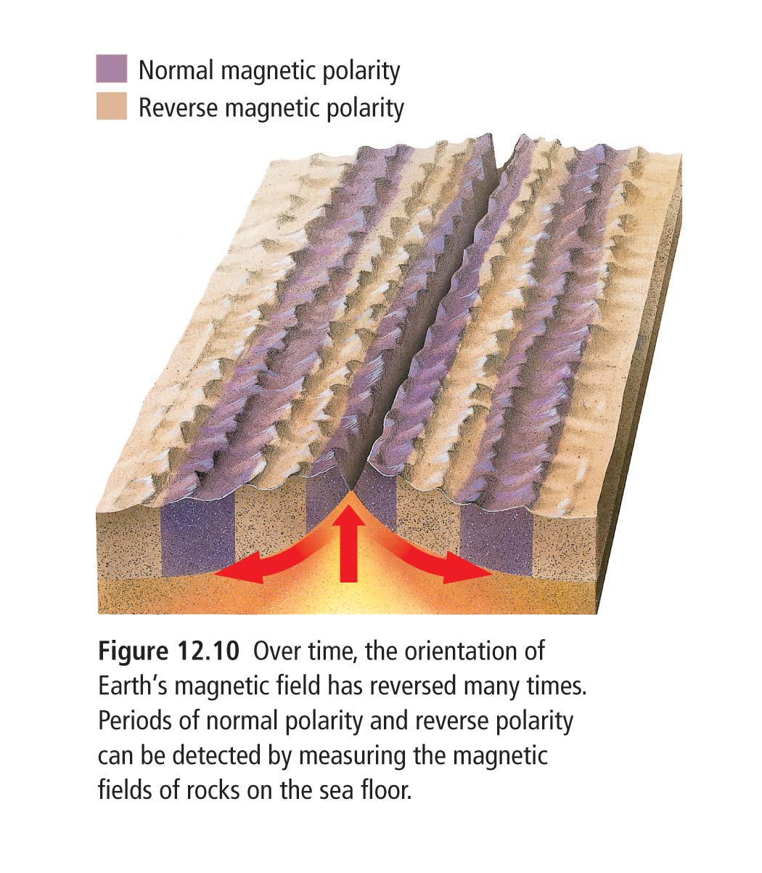
Magnetic Striations:

Convection Currents:
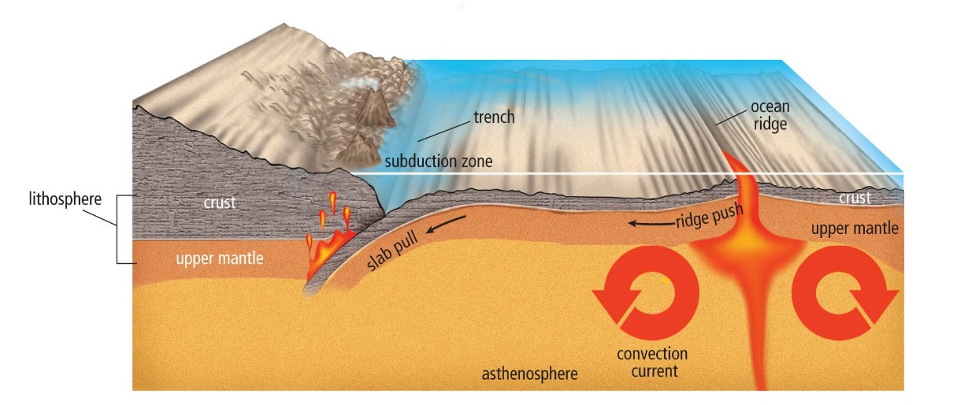

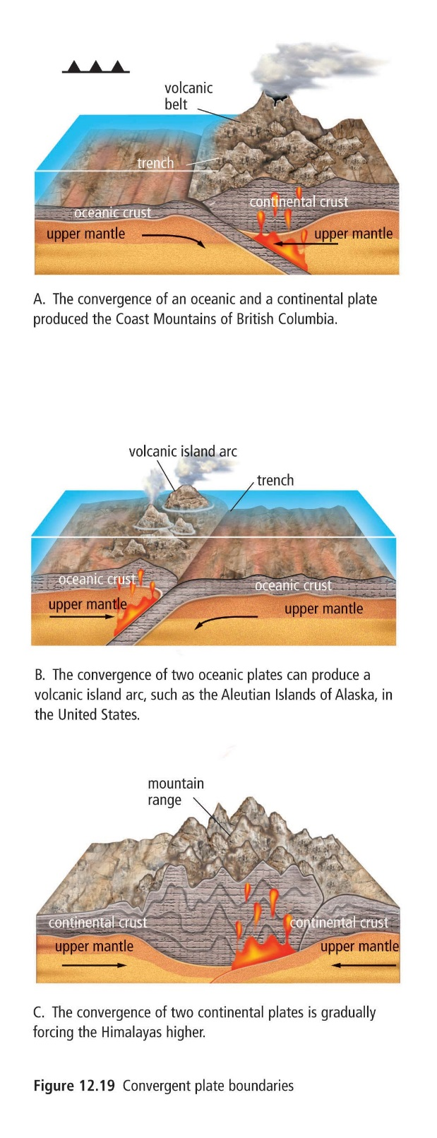
Plate Boundaries:

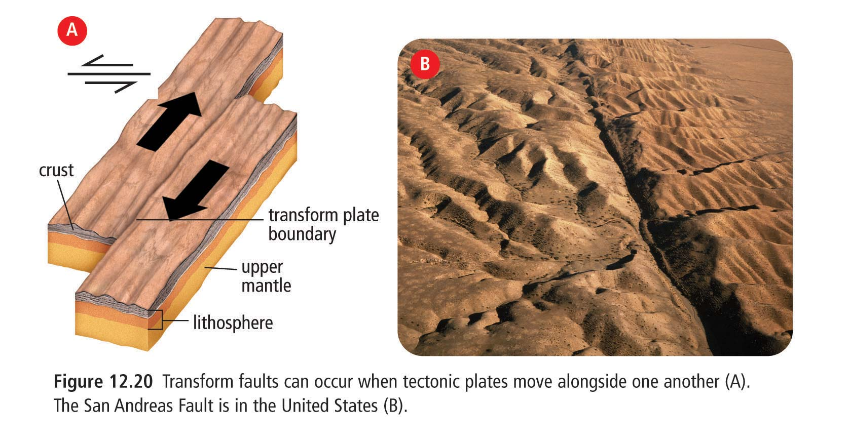

Earthquakes, Volcanoes and Tectonic Plates
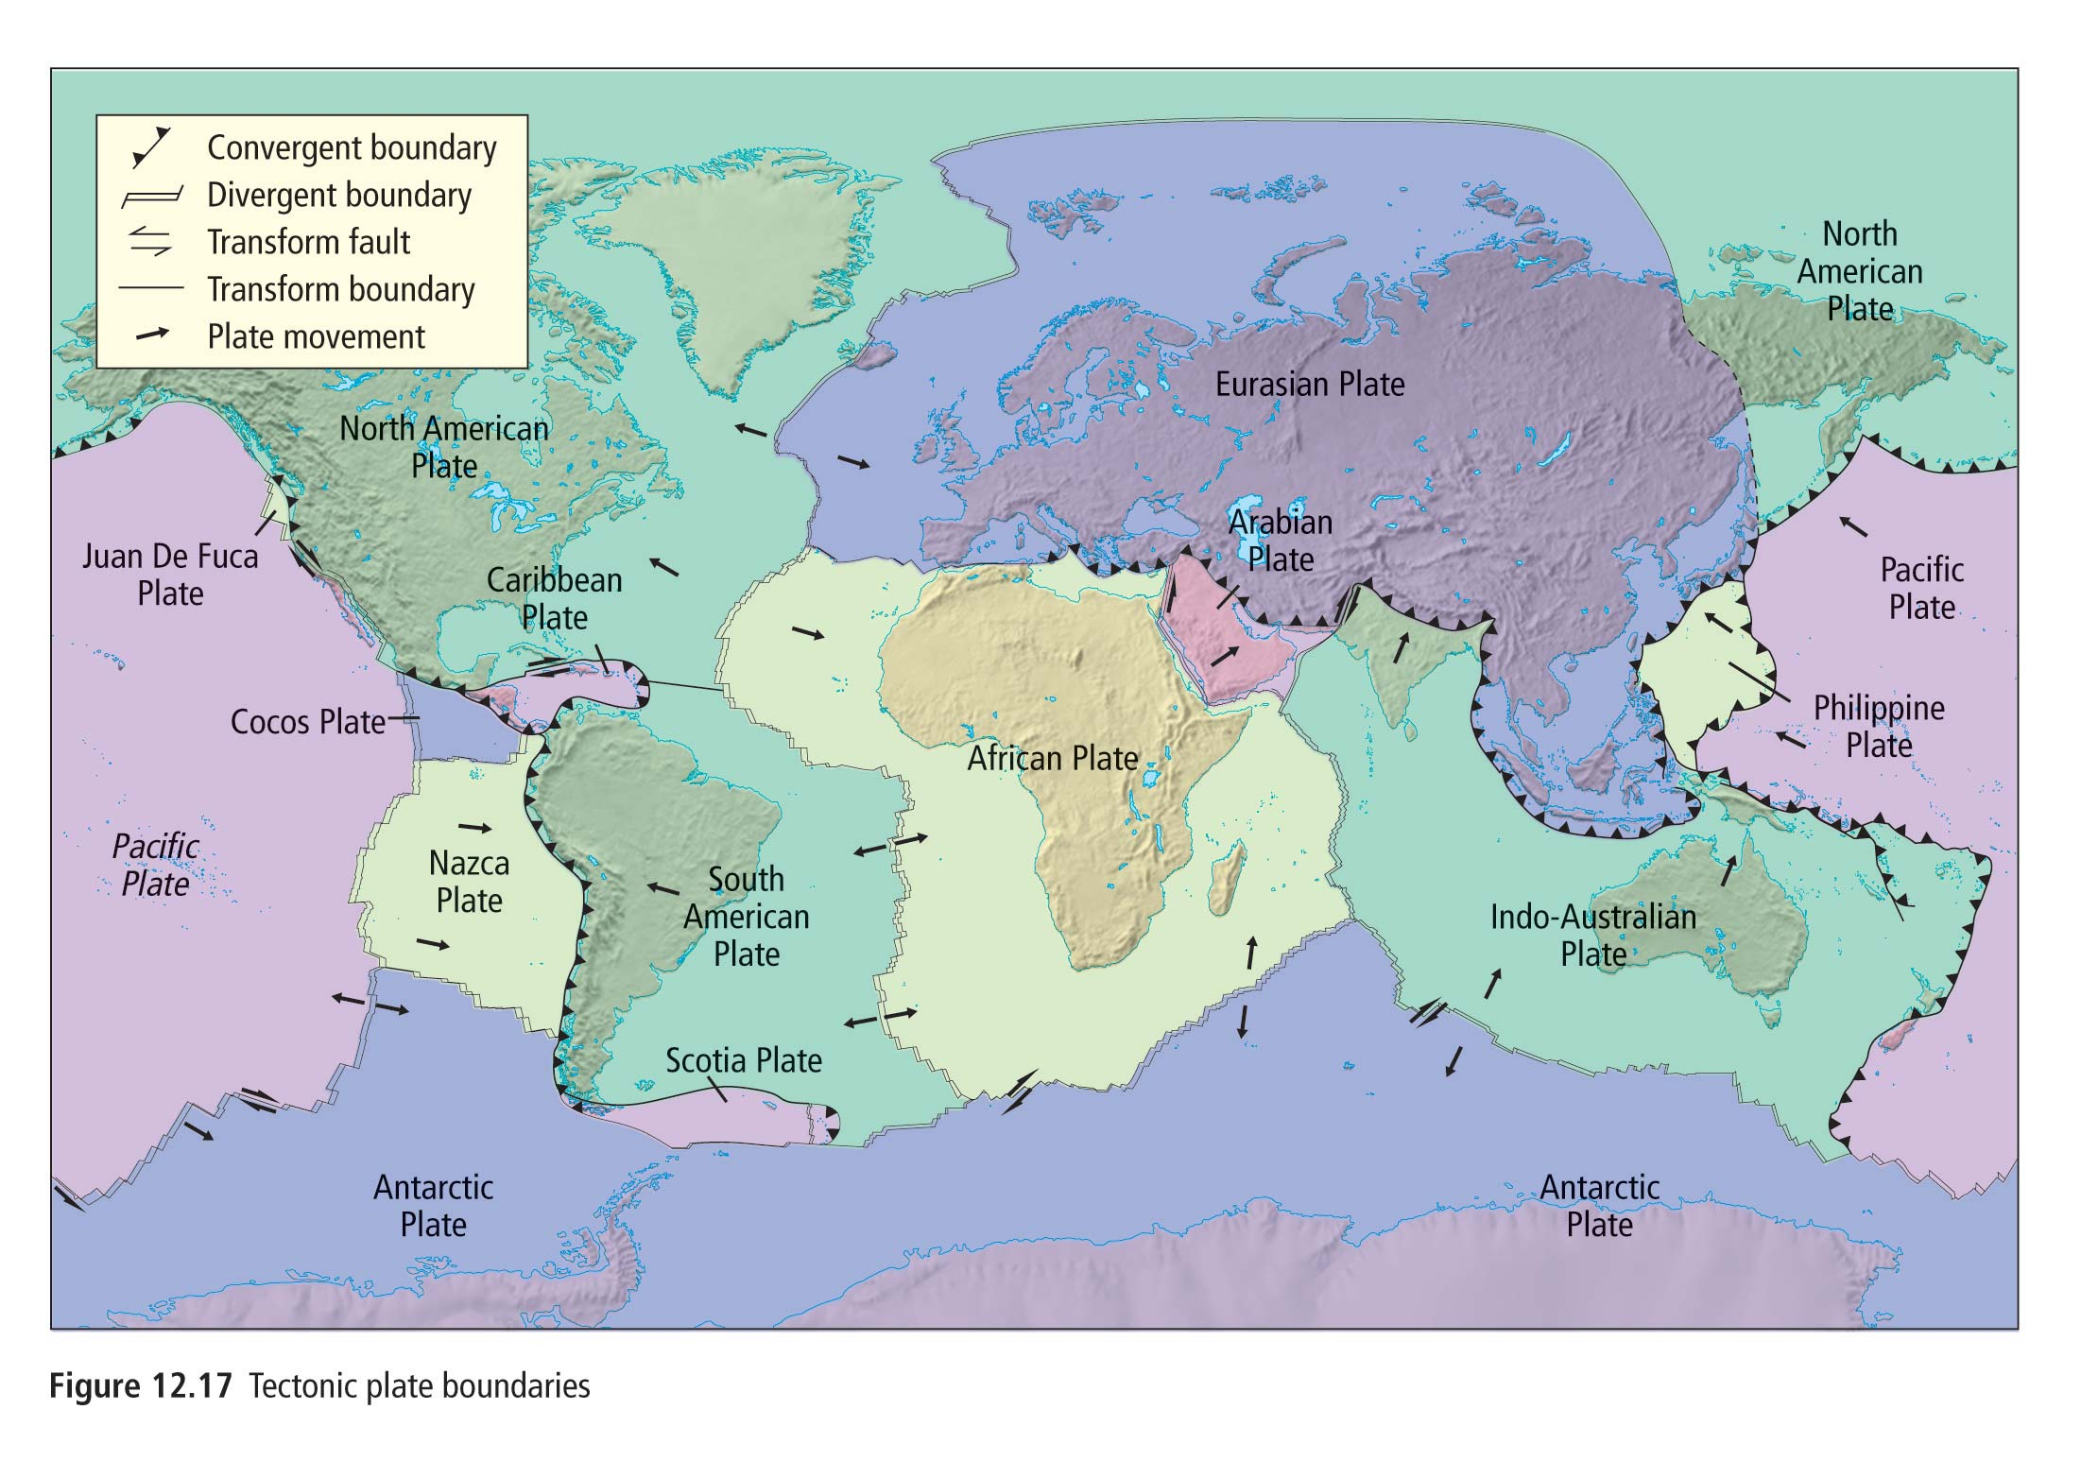
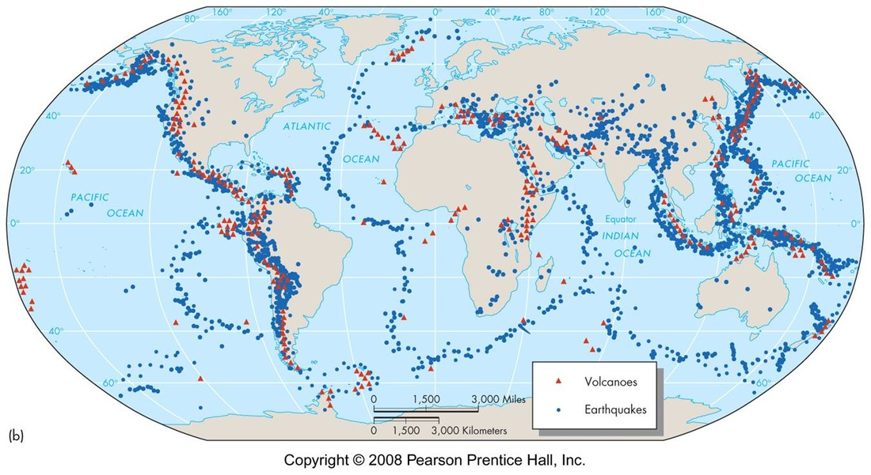

Questions:
1. What is it called when one tectonic plate moves under a second tectonic plate?
2. What type of boundary exists between the Nazca Plate and the Pacific Plate?
3. What kind of boundary exists between the Cocos Plate and the Caribbean Plate?
4. Briefly describe how a divergent boundary occurs. Include the terms magma, convection, tectonic plate.
5. At a convergent boundary between a continental plate and an oceanic plate, which plate is subducted and why?
6. Briefly explain 2 pieces of evidence for seafloor spreading.

