Mass Defect and Energy

What is very interesting (and somewhat counter intuitive) about nuclear reactions is that the mass of the products is different from the mass of the reactants that formed them. The whole is LESS than the sum of its parts in some cases, and GREATER in others. This change of mass was predicted by Albert Einstein and is summarized by the formula:

E=Δmc²

Where E is energy, Δm is the difference of mass between the products and reactants and c is the speed of light in a vacuum. Δm is called the mass defect.

- In exothermic nuclear reactions the products have less mass than the reactants. This “lost” mass (Δm) is released to the surroundings as energy.

- In endothermic nuclear reactions the products have more mass than the reactants. The “gained” mass comes from energy absorbed from the surroundings.

Example:

In a nuclear fusion reaction hydrogen-2 fuses with hydrogen-3 to form helium-4 and a neutron. Every 1.000kg of reactant (hydrogen) yields 0.9937kg of product (helium). How much energy is released in this process?

First, we need to find the mass defect. The convention is to always report this as a positive value.

Δm=1.000kg-0.9937kg=0.0063kg

Next use the formula E=Δmc² to find energy.

E=Δmc²
E=(0.0063kg)(3.00x10⁸m/s)²
E=5.67x10¹⁴J

This is the same amount of energy that would be released by burning 20000 tonnes of coal. This amount of coal would fill a train approximately 1.5-2km in length.

Alternate Units:

When we are dealing with nuclei we are dealing with extremely small objects with extremely small masses. Until now we have said that the mass of a proton is 1. What you should be wondering is 1 what? 1kg? 1 gram? 1 ounce? 1 floostroople?

The answer is 1 atomic mass unit or 1u. This is a convenient mass to use when dealing with atoms or with nuclei. It is also very tiny. The conversion factor between kg and u is:

$$1u=1.66×10^{-27}kg$$
The standard unit for energy is the Joule. 1 Joule is 1 kilogram(meter)² per second². What matters here is that to find energy in joules from E=mc², the mass must be in kg and the speed of light, c, must be in m/s.

A convenient unit for energy when dealing with very small masses is the electron-Volt (eV) or the Mega electron-Volt (MeV). There is a historic significance to this unit and its name, but I won’t get into that here. Let’s just worry about conversions.

$$1ev=1.6×10^{-19}J$$

$$1Mev=1.6×10^{-13}J$$

Finally, we want to know how to convert from mass defect to energy released or absorbed, so let’s go through a little calculation to figure out how much energy in MeV is equivalent to 1u of mass.

$$E=∆mc^{2}$$

$$∆m=1u×\left(\frac{1.66×10^{-27}kg}{1u}\right)=1.66×10^{-27}kg$$

$$E=1.66×10^{-27}kg c^{2}=1.66×10^{-27}kg({3.00×10^{8}m/s)}^{2}$$

$$E=1.49×10^{-10}J$$

Okay, almost there. Now we can just convert Joules to MeV:

$$E=1.49×10^{-10}J ×\left(\frac{1MeV}{1.6×10^{-13}J}\right)=930MeV$$

Every 1u of mass that is lost/gained corresponds to 930MeV of energy. Indeed, this idea is so central to nuclear ant atomic physics that scientists, being a lazy bunch, often take a short cut and refer to the mass of a particle in MeV. This is technically not quite correct as the unit for mass should be MeV/c² as shown below:

$$E=∆mc^{2}$$

$$930MeV=(1u)c^{2}$$

$$\frac{930MeV}{c^{2}}=1u$$

$$1u=930\frac{MeV}{c^{2}}$$

Summary:

Mass: There are three main mass units you will need to be familiar with: kg, u, and MeV/c²

$$1u=1.66×10^{-27}kg$$

$$1u=930\frac{MeV}{c^{2}}$$

Energy: There are two main energy units you will need to be familiar with: J and MeV

$$1Mev=1.6×10^{-13}J$$

And one formula:

E=Δmc²

Example 2: Find the energy in MeV released in the following reaction.

$${}_{49}^{115}{In}→{}_{-1}^{0}β + {}_{50}^{115}{Sn}$$

Given: Mass of 1 indium-115 nucleus: 114.900u
Mass of beta particle: 0.000 6u
Mass of tin-115: 114.899u

First find the mass defect: Δm= 114.900u – (114.899u + 0.0006u) = 0.000 4u

Now convert mass defect to MeV/c²:

$$0.0004u×\frac{(930\frac{MeV}{c^{2}})}{1u}=0.372\frac{MeV}{c^{2}}$$

Finally use E=Δmc²

$$E=0.372\frac{MeV}{c^{2}}×c^{2}=0.372MeV$$

This is a tiny amount of energy, but it is for a single nucleus.

Basic Nuclear Reactor:

A nuclear reactor is just a very fancy device to boil water. The nuclear fission reaction generates heat that boils the water (heavy water) in the reactor and generates steam. The steam is then used to turn a turbine and generate electricity.

The basic design (VASTLY SIMPLIFIED) looks like:

Boiling-Water Reactor (BWR)
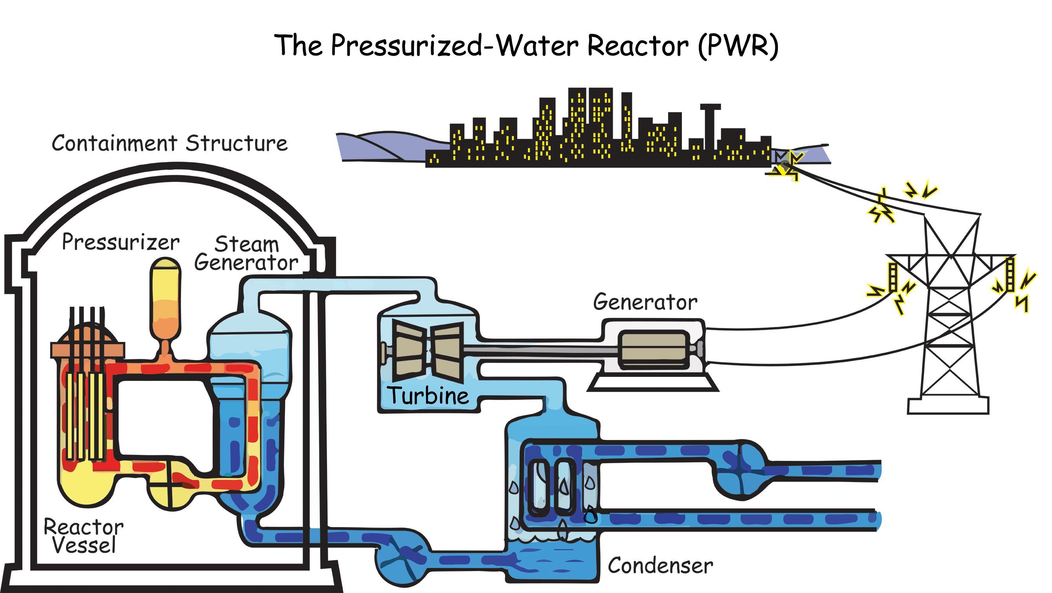

- The fuel elements or fuel rods are made of a fissionable material, usually Uranium-235.

- The control rods are made of boron or cadmium and can absorb neutrons to slow down the chain reaction.

- The moderator slows down the ejected neutrons so they can trigger more reactions.

- The energy released from the reaction is used to heat up water

- The steam produced is used to turn a turbine, generating electricity.

Many nuclear reactors use Uranium-235 as the fuel source. U-235 is called a fissionable material because it will undergo nuclear fission if induced by a neutron.
The most common reaction is as follows:

$${}_{0}^{1}n+{}_{92}^{235}U→ {}_{56}^{141}{Ba}+{}_{36}^{92}{Kr}+3{}_{0}^{1}n$$
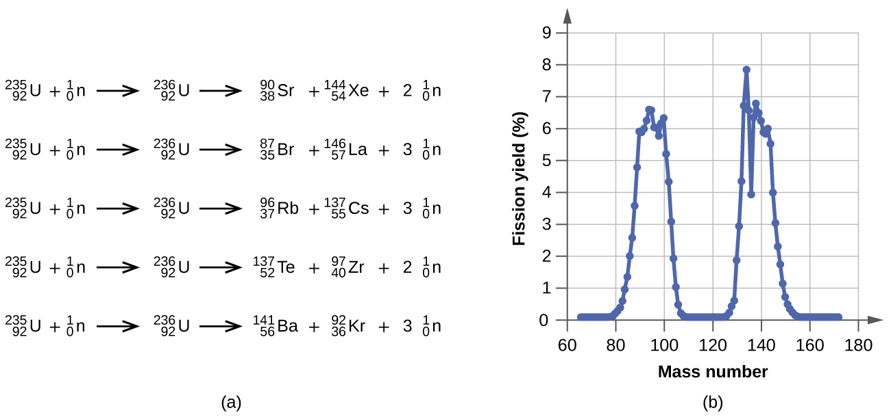
There are other possibilities, as shown below.

*YOU ARE NOT EXPECTED TO MEMORIZE ANY OF THESE REACTIONS. YOU SHOULD BE ABLE TO CONFIRM THAT THEY MEET THE CONDITIONS OF CONSERVATION OF CHARGE AND CONSERVATION OF NUCLEON NUMBER*

What is important to notice is that the reactions all produce energy, and they all produce more neutrons. These neutrons can then collide with other U-235 nuclei and trigger a chain reaction.
The neutrons that are released are high energy, meaning they are travelling very fast, in fact they are travelling too fast to induce a fission reaction.
The moderator, usually water, sometimes heavy water or graphite, functions to slow these neutrons down. This happens simply by collisions between the neutrons and the molecules of the moderator. Once slowed down, the neutrons can then start the chain reaction.
If the chain reaction proceeds too quickly, too much energy can be produced and there can be a nuclear meltdown, which can blow up the reactor and release radioactive material into the environment.
To control the reaction, control rods can be placed into the reactor core to absorb some of the neutrons. By moving the control rods into and out of the core, the reaction rate can be controlled. When the reaction is kept at stable controlled level it is said to be “CRITICAL”.

