Lewis Diagrams of Covalent Molecules:

There is a set of steps for determining the Lewis electron dot diagram of a simple molecule.
- Count the total number of valence electrons. If the molecule is an ion add one extra electron for each negative charge of the anion and remove one electron for every positive charge on the cation.
- Write the central atom(s) and surround it/them with the other atoms.
The central atom is usually the least electronegative element and usually written first in the chemical formula
- Put a pair of electrons between the central atom(s) and each surrounding atom.
- Complete the octets around the surrounding (terminus) atoms (except for H).
In some cases the octet rule will be violated.
- Put the remaining electrons, if any, around the central atom.
- If the central atom still has less than 8 electrons, use any lone pairs form a double or triple bond.
If there is more than one central atom use the lone pairs from the central atoms first. If there are different elements as terminal atoms, take lone pairs from the least electronegative atoms first
- Check that every atom has a full valence shell (8 electrons, except Hydrogen).

EXAMPLE 1:

Let us try these steps to determine the electron dot diagram for BF₄⁻. The B atom is the central atom, and the F atoms are the surrounding atoms. There is a negative sign on the species, so we have an extra electron to consider.

1. Count the total number of valence electrons. B has 3, each F has 7, and there is one extra electron because BF₄⁻ has a charge of negative 1 : 3 + 7 + 7 + 7 + 7 + 1 = 32.

2. Write the central atom surrounded by surrounding atoms.

3. Put a pair of electrons between the central atom and each surrounding atom. This uses up eight electrons, so we have 32 − 8 = 24 electrons left.

4. Complete the octets around the surrounding (terminus) atoms (except for H). This uses up 24 more electrons, leaving 24 − 24 = 0 electrons left.

-

5. Put the remaining electrons, if any, around the central atom. There are no additional electrons to add to the central atom.

6. Not necessary.

7. Check. The B atom has eight electrons around it, as does each F atom. Each atom has a complete octet. This is a good Lewis electron dot diagram for BF₄⁻.

EXAMPLE 2:

In this next example step 6 is necessary:

Draw the Lewis structure of formaldehyde (CH₂O).

1. Count the total number of valence electrons. C has 4, each H has 1 and O has 6. 4+2+6=12.
2. Write the central atom surrounded by surrounding atoms.

3. Put a pair of electrons between the central atom and each surrounding atom. This uses up six electrons, so we have 12-6=6 electrons left.

4. Complete the octets around the surrounding (terminus) atoms (except for H). This uses up 6 more electrons, leaving 6 - 6 = 0 electrons left.

5. Put the remaining electrons, if any, around the central atom. There are no additional electrons to add to the central atom.

6. Move lone pairs to create double or triple bonds. The H and O atoms have the proper number of electrons, but the C atom has only six electrons around it, not the eight electrons for an octet. How do we fix this?
We fix this by recognizing that two atoms can share more than one pair of electrons. Move 2 of the electrons (a lone pair) from the oxygen to between the O and C to make it a bonding pair. This is now a double bond between C and O.

7. Check. The C atom has eight electrons around it, The O has eight electrons around it. Each H atom has 2. This is a good Lewis electron dot diagram for CH₂O.

EXAMPLE 3.
What is the proper Lewis electron dot diagram for CO₂?
Solution
The central atom is a C atom, with O atoms as surrounding atoms. We have a total of 4 + 6 + 6 = 16 valence electrons. Following the rules for Lewis electron dot diagrams for compounds gives us
The O atoms have complete octets around them, but the C atom has only four electrons around it. The way to solve this dilemma is to make a double bond between carbon and each O atom:
Each O atom still has eight electrons around it, but now the C atom also has a complete octet. This is an acceptable Lewis electron dot diagram for CO₂.

Test Yourself

What is the proper Lewis electron dot diagram for carbonyl sulfide (COS)?
Answer

It is also possible to have a triple bond, in which there are three pairs of electrons between two atoms. Good examples of this are elemental nitrogen (N₂) and acetylene (C₂H₂):

Acetylene is an interesting example of a molecule with two central atoms, which are both C atoms.
Polyatomic ions are bonded together with covalent bonds. Because they are ions, however, they participate in ionic bonding with other ions. So both major types of bonding can occur at the same time.

Food and Drink App: Vitamins and Minerals
Vitamins are nutrients that our bodies need in small amounts but cannot synthesize; therefore, they must be obtained from the diet. The word vitamin comes from “vital amine” because it was once thought that all these compounds had an amine group (NH₂) in it. This is not actually true, but the name stuck anyway.
All vitamins are covalently bonded molecules. Most of them are commonly named with a letter, although all of them also have formal chemical names. Thus vitamin A is also called retinol, vitamin C is called ascorbic acid, and vitamin E is called tocopherol. There is no single vitamin B; there is a group of substances called the B complex vitamins that are all water soluble and participate in cell metabolism. If a diet is lacking in a vitamin, diseases such as scurvy or rickets develop. Luckily, all vitamins are available as supplements, so any dietary deficiency in a vitamin can be easily corrected.
A mineral is any chemical element other than carbon, hydrogen, oxygen, or nitrogen that is needed by the body. Minerals that the body needs in quantity include sodium, potassium, magnesium, calcium, phosphorus, sulfur, and chlorine. Essential minerals that the body needs in tiny quantities (so-called trace elements) include manganese, iron, cobalt, nickel, copper, zinc, molybdenum, selenium, and iodine. Minerals are also obtained from the diet. Interestingly, most minerals are consumed in ionic form, rather than as elements or from covalent molecules. Like vitamins, most minerals are available in pill form, so any deficiency can be compensated for by taking supplements.

Vitamin and Mineral Supplements
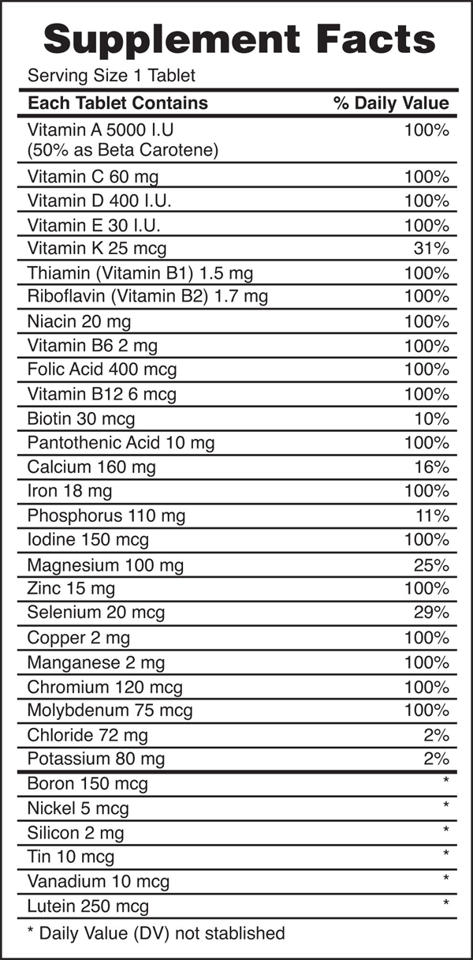
Every entry down through pantothenic acid is a vitamin, and everything from calcium and below is a mineral.

xercises
- How many electrons will be in the valence shell of H atoms when it makes a covalent bond?
- How many electrons will be in the valence shell of non-H atoms when they make covalent bonds?
- What is the Lewis electron dot diagram of I₂? Circle the electrons around each atom to verify that each valence shell is filled.
- What is the Lewis electron dot diagram of H₂S? Circle the electrons around each atom to verify that each valence shell is filled.
- What is the Lewis electron dot diagram of NCl₃? Circle the electrons around each atom to verify that each valence shell is filled.
- What is the Lewis electron dot diagram of SiF₄? Circle the electrons around each atom to verify that each valence shell is filled.
- Draw the Lewis electron dot diagram for each substance.
a) SF₂
b) BH₄⁻

8. Draw the Lewis electron dot diagram for each substance.
a) PI₃
b) OH⁻

9. Draw the Lewis electron dot diagram for each substance.
a) SiH₄
b) ClF

10. Draw the Lewis electron dot diagram for each substance.
a) AsF₃
b) NH₄⁺

11. Draw the Lewis electron dot diagram for each substance. Double or triple bonds may be needed.
a) SiO₂
b) C₂H₄

12. Draw the Lewis electron dot diagram for each substance. Double or triple bonds may be needed.
a) CN⁻
b) C₂Cl₂ (assume two central atoms)

13. Draw the Lewis electron dot diagram for each substance. Double or triple bonds may be needed.
a) CS₂
b) NH₂CONH₂ (assume that the N and C atoms are the central atoms)

14. Draw the Lewis electron dot diagram for each substance. Double or triple bonds may be needed.
a) POCl
b) HCOOH (assume that the C atom and one O atom are the central atoms)

Selected Answers
1. two

2. eight

3.

5.

7.
a) b)

9.
a) b)
Si

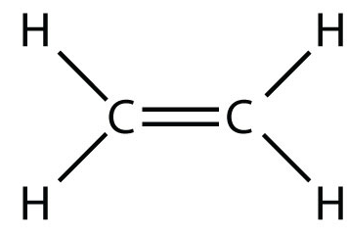
11.
a) b)

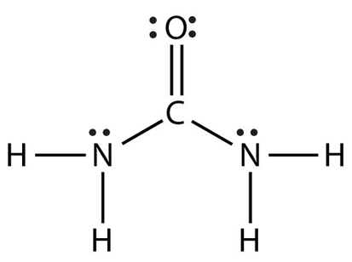
13.a) b)

