Physics 12: Introduction to Magnetism

Basics:

I will assume you are at least aware of the concept of magnetism. Most of us have played with magnets at some time, and the topic should have arisen at some point during your science education before now. If not that’s okay, we’ll start pretty much at the beginning.

Magnets have the ability to attract or repel other magnets. Magnets can also attract certain objects that are not magnets themselves. A common misconception is that magnets will attract (or be attracted to) any metal object; THIS IS FALSE. There are relatively few materials that will react noticeably to a magnet, these include: Iron (Fe), Nickel (Ni), Cobalt (Co), Gadolinium (Gd), Dysprosium (Dy) along with many alloys and compounds. These materials are known as ferromagnetic, but most commonly we would simply say magnetic. Most magnetic objects, like paperclips or nails or refrigerator doors contain nickel. Notice that while these materials will be attracted to a magnet they themselves are not magnets.

All magnets have at least two poles, most have only two, we will discuss multi-pole magnets later. The poles are named North and South because of how they react to the Earths own magnetism. The north pole of a magnet will tend to point North, while the south pole of a magnet will tend to point South (in the absence of other forces that prevent that from happening, like you holding it.). There are no known magnetic mono-poles (isolated norths or souths) although according to modern particle theory and superstring theory such particles should exist.

Common types of magnets are BAR, HORSESHOE and DISK magnets, named for their shapes. The poles on these magnets are usually arranged like this:

N
N
S
S
S
N

Guess which is which!

Now, Opposite poles will attract

Like poles will repel

Either pole will attract a magnetic object (where have we seen that before?).
Magnetic Field

Just like with the electrostatic and gravitational force, the magnetic force (F_{B}) is an action at a distance force in that the objects do not need to touch one another in order to apply the magnetic force. When we have action at a distance forces it is convenient to think of the force being carried by a field. You will of course recall the Electric Field, E and the Gravitational Field, g. Well now I would like to introduce you to a new friend, the Magnetic Field, B.

The magnetic field is a vector quantity (as are all fields) that points AWAY FROM MAGNETIC NORTH and TOWARD MAGNETIC SOUTH (for now, we will see it is a little more complex than that.). The direction of the field lines indicates the direction of the magnetic force on the north pole of a magnet.

B Near a Bar Magnet E Near Opposite Electric Charges (Dipole)

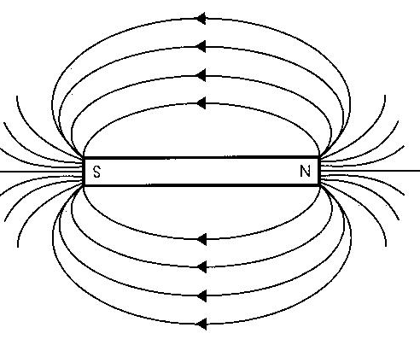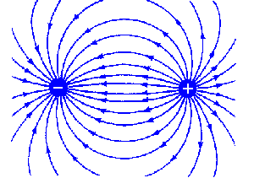
I hope you can see the similarities!

They are certainly similar, but they are not the same. Do not make the common mistake of equating a north pole to a positive charge, or a south pole to a negative charge. Magnets do not have a positive end or a negative end, they have a NORTH POLE and a SOUTH POLE.

Directional Compasses

A directional compass is a simple device used to detect magnetic fields. Most commonly they are used for navigation by detecting the Earth’s magnetic field. A compass simply consists of a small magnet, supported at its centre of mass so that it is free to rotate. Conventionally the magnet is shaped like an arrow, with the point being its north pole, and the opposite end being its south.
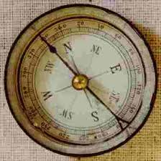

So a directional compass will point toward the south pole of a magnet, and away from the north. In general The pointer in a directional compass will align itself with magnetic field lines.
Sketch the magnetic field near the following:

S
N
N
S

N
S

S N

Magnetic Domains and Induced Magnetism:

Magnetic materials contain regions called magnetic domains. The simplest way to think about it is that a magnetic material is made up of billions and billions of tiny magnets, all aligned randomly.

(look, there’s billions of ‘em!)

Now, because they are arranged randomly there is no overall magnetic field around the object and it is not a magnet. If, however we bring a strong magnet near the object (or place the object within a magnetic field) the domains can align (more or less) in the field (think of each domain being like a tiny compass.).

S N

While the magnet is in place the magnetic material can act like a magnet itself. This is known as induced magnetism.
A magnet (permanent magnet) is a material in which the domains are naturally aligned for unknown reasons.

The real fun begins when we look at how magnetic fields affect charged objects.
S N
N S
S N
N S

CRT

S
N
S
N

