Human Activities and the Global Ecosystem:

1. Overpopulation:
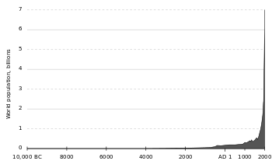
- Although our ancestors (Hominin Ancestor) appeared 6 million years ago, human beings (homo sapiens) have only been around for about 200 000years.
- Human population was relatively stable at about 100-500million people for the first 198 000years.
- Starting at about the year 0 on the modern calendar (2016 years ago) the population began to rise rapidly, reaching 1 billion in about 1800. This means the global population essentially doubled in 1800years.
- In the 216 following the population has exploded to 7.4 billion!
- Current estimates have that number increasing to 11.2billion by 2100 (84 years from now).

Why is this a problem?

Are there possible solutions?

What can YOU do as an individual?

2. Consumerism:
- Consumerism is an economic theory that continually increasing levels of consumption is good for the economy, and for consumers.
- Consumerism began in the 1880s following the industrial revolution. Industrialization allowed for much higher rates of production at much lower costs. Cheap and slave labour also ensured that products could be produced at very low cost. More people could now afford to consume more things.
- In fact production became so efficient, and manufacturing became so important to the economy that in 1955, economist Victor Lebow would epitomize the new status quo, writing in the Journal of Retailing:

“Our enormously productive economy demands that we make consumption our way of life, that we convert the buying and use of goods into rituals, that we seek our spiritual satisfaction and our ego satisfaction in consumption. We need things consumed, burned up, worn out, replaced and discarded at an ever-increasing rate.”

- What could possibly go wrong?

Environmental effects:

Possible Solutions:

What can YOU do as an individual?

3. Agriculture/Food:
- In general agriculture is seen a huge benefit to humans. The shift from hunter/gatherer to farmer has had a huge effect on the development of human civilization.
- It allowed for the development of towns and cities as people no longer needed to be nomadic to follow animals or natural vegetation.
- However starting in the 1920s, but really taking off in the 1970s was a shift to industrialized or factory farming. Other terms for this type of agriculture include: Intensive farming, CAFOs (concentrated animal feeding operations).
- These farms have a very different impact on the environment.

Environmental effects:

Possible solutions:

What can YOU do as an individual?

4. Fossil Fuel Consumption:
- Since the development and mass adoption of the internal combustion engine around 1900 (the first ICE was invented way back in 1791, but it was not made practical or affordable until much later) the demand for, and use of fossil fuels has grown dramatically.
- In 1930 global oil consumption was ~1.6 billion barrels.
- In 2010 global oil consumption was ~26.4 billion barrels (16.5 times as much).
- Coal use has had a similar growth largely due to increased demands for electricity.
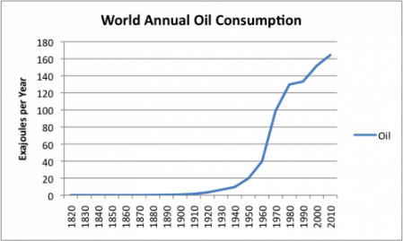
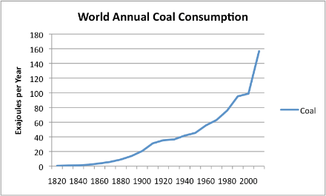

Environmental effects:

Possible solutions:

What can YOU do as an individual?

5. Mining, Manufacturing and Waste:
- Since the industrial revolution (1760~1840) the demand for mined materials has steadily increased.
- This includes the minerals and ores needed to manufacture all metals (steel, aluminum, copper, brass, nickel, lead….), coal, nuclear material (uranium)
- Electronics make extensive use of mined materials (gold, silver, cadmium, rare earth metals…)
- Producing 1 gram of gold generates 2560 kilograms of waste

Environmental effects:

Possible solutions:

What can YOU as an individual do?

6. Forestry/Lumber and Paper:
- Forestry in the harvesting of trees in order to make lumber and wood products. This is different that deforestation.
- Wood is used in construction, as fire wood, charcoal and paper (among other uses).
- The average person in the developed world uses between 300kg and 400kg of paper per year!
- Paper production requires the use of ~200 different chemicals including bleach, chlorine gas and hypochlorous acid

Environmental effects:

Possible solutions:

What can YOU as an individual do?

Commercial Fishing:
- Global fish consumption is over 140 BILLION kg. That is enough fish to stretch to the moon and back 55 times!
- Nearly 40% of all fish currently being caught is being caught at an unsustainable rate.
- Unless the current situation improves, stocks of all species currently fished for food are predicted to collapse by 2048
- An estimated 300 000 whales and dolphins are killed in commercial fishing each year.

Environmental effects:

Possible solutions:

What can YOU as an individual do?

