Continental Drift Theory:
- By the 1600s it had been noticed by cartographers (map makers) and by geographers that the east coast of South America and the west coast of Africa seemed to fit together like puzzle pieces.
- However it was not until 1915 that Alfred Wegener used this and 5 other key pieces of evidence to propose an idea called Continental Drift Theory.
- Continental Drift Theory proposed that all of the continents were at one point all joined in one super-continent called Pangaea. Around 200 million years ago Pangaea broke apart and the continents drifted to their present places.

6 Pieces of Evidence:
The 6 pieces of evidence provided by Wegener in 1915 were: the jigsaw fit of continents, rocks and geological formations, glaciation, fossils, coal and mineral belts and climate evidence.

- Jigsaw Fit

- Rocks and Geological Formations

- Glaciation

- Fossils

- Coal and Mineral Belts

- Climate

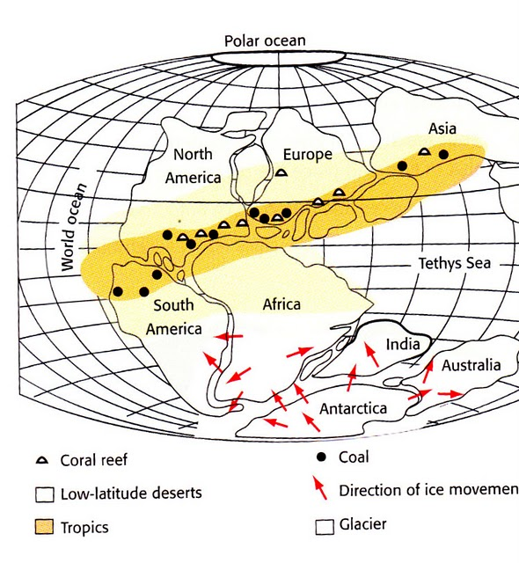
Fossil Evidence Coal Deposits
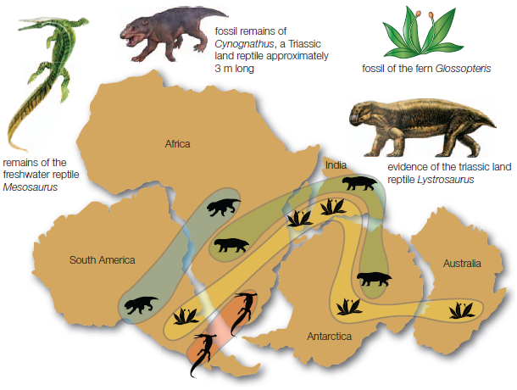

Glaciation
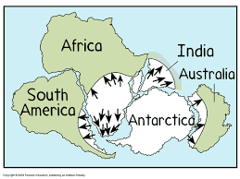

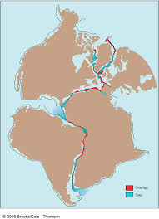
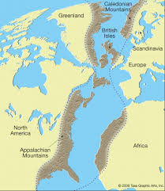
Rocks and Geological Formations Jigsaw Fit of Continents

Problems:

It was not until around 1970 that the scientific community, at large, began to accept the idea of continental drift. With all of this evidence why was Wegener’s theory generally discounted by scientists at the time?

