Basic Nuclear Reactor:

A nuclear reactor is really just a very fancy device to boil water. The nuclear fission reaction generates heat that boils the water (heavy water) in the reactor and generates steam. The steam is then used to turn a turbine and generate electricity.

The basic design (VASTLY SIMPLIFIED) looks like:

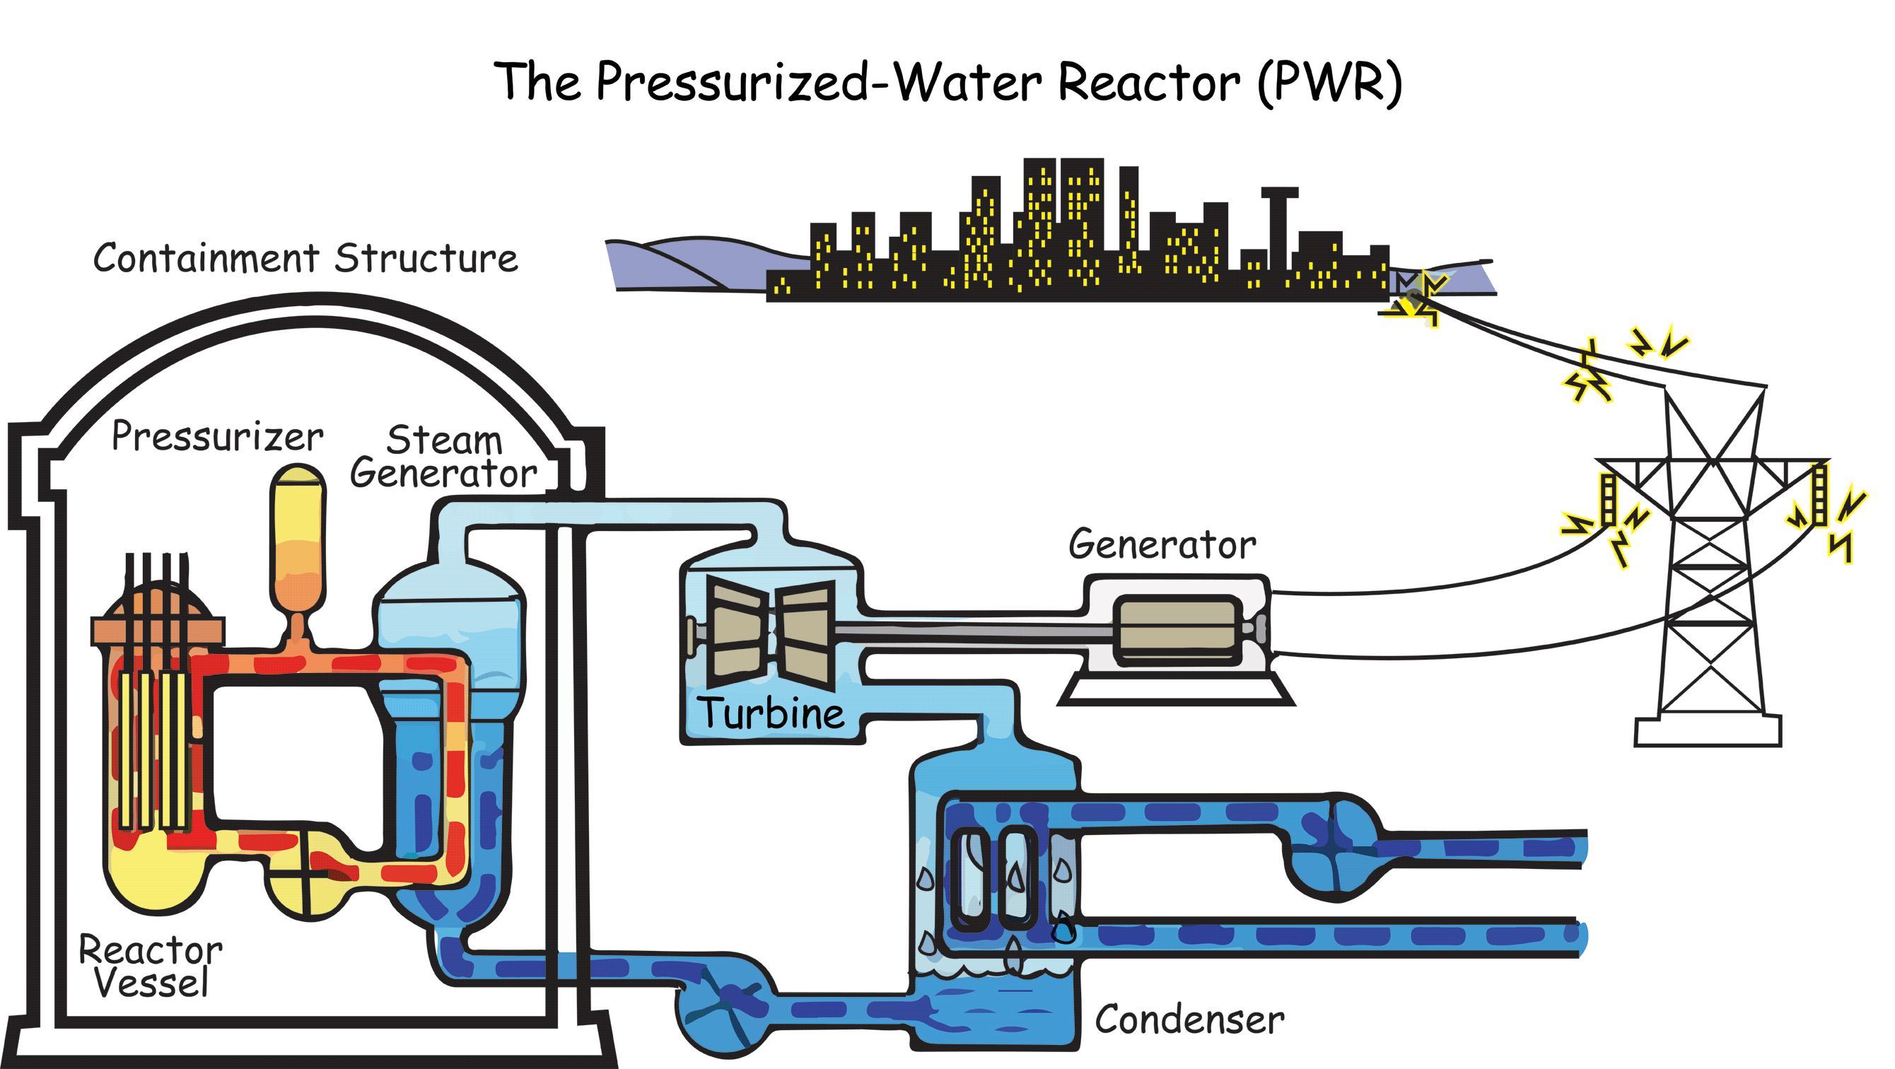
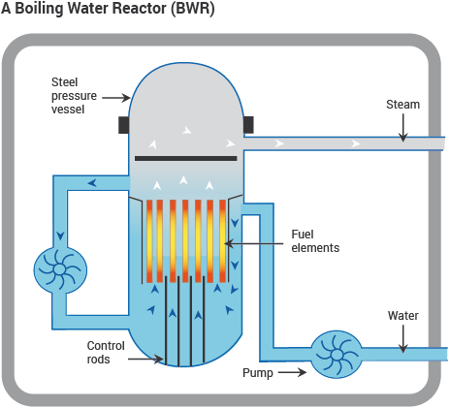

Moderator
(heavy water)

- The fuel elements or fuel rods are made of a fissionable material, usually Uranium-235.

- The control rods are made of boron or cadmium and can absorb neutrons to slow down the chain reaction.

- The moderator slows down the ejected neutrons so they can trigger more reactions.

- The energy released from the reaction is used to heat up water

- The steam produced is used to turn a turbine, generating electricity.

Many nuclear reactors use Uranium-235 as the fuel source. U-235 is called a fissionable material because it will undergo nuclear fission if induced by a neutron.
The most common reaction is as follows:

$${}_{0}^{1}n+{}_{92}^{235}U→ {}_{56}^{141}{Ba}+{}_{36}^{92}{Kr}+3{}_{0}^{1}n$$
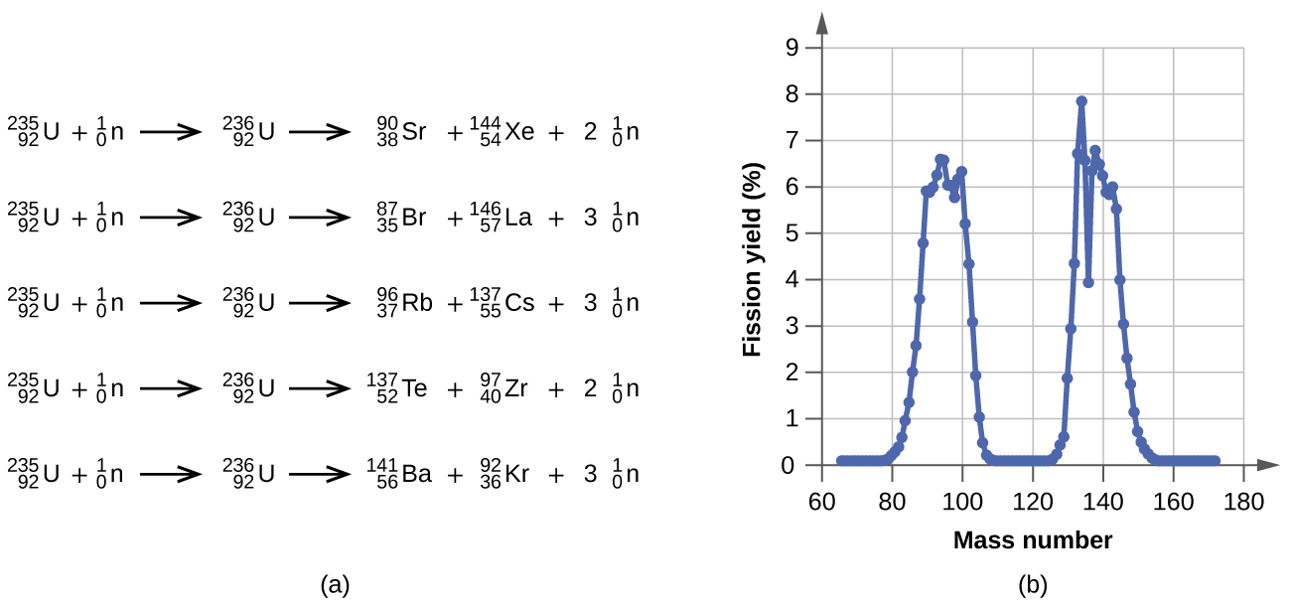
There are other possibilities, as shown below.

*YOU ARE NOT EXPECTED TO MEMORIZE ANY OF THESE REACTIONS. YOU SHOULD BE ABLE TO CONFIRM THAT THEY MEET THE CONDITIONS OF CONSERVATION OF CHARGE AND CONSERVATION OF NUCLEON NUMBER*

What is important to notice is that the reactions all produce energy, and they all produce more neutrons. These neutrons can then collide with other U-235 nuclei and trigger a chain reaction.
The neutrons that are released are high energy, meaning they are travelling very fast, in fact they are travelling too fast to induce a fission reaction.
The moderator, usually heavy water, sometimes carbon, functions to slow these neutrons down. This happens simply by collisions between the neutrons and the molecules of the moderator. Once slowed down, the neutrons can then start the chain reaction.
If the chain reaction proceeds too quickly, too much energy can be produced and there can be a nuclear meltdown, which can blow up the reactor and release radioactive material into the environment.
To control the reaction, control rods can be placed into the reactor core to absorb some of the neutrons. By moving the control rods into and out of the core, the reaction rate can be controlled. When the reaction is kept at stable controlled level it is said to be “CRITICAL”.

