Artificial Selection (Selective Breeding) and Genetic Engineering

Artificial selection is the intentional reproduction of individuals in a population that have desirable traits.

In organisms that reproduce only asexually (bacteria, many plants …) a breeder needs to simply separate individuals with the desired trait from others. Those individuals then produce copies of themselves and the entire population will possess the desired trait.

In organisms that reproduce sexually, two adults that possess a desired trait — such as two parent plants that are tall — are bred together. Offspring that possess the desired trait are then bred and the process is continued until 100% (or very close to it) possess the desired trait.

This is the old-fashioned method of genetic engineering.
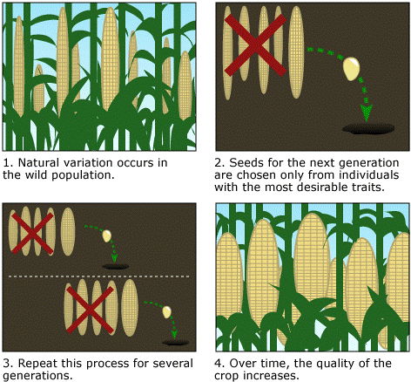

4. Over time the desired trait becomes common.
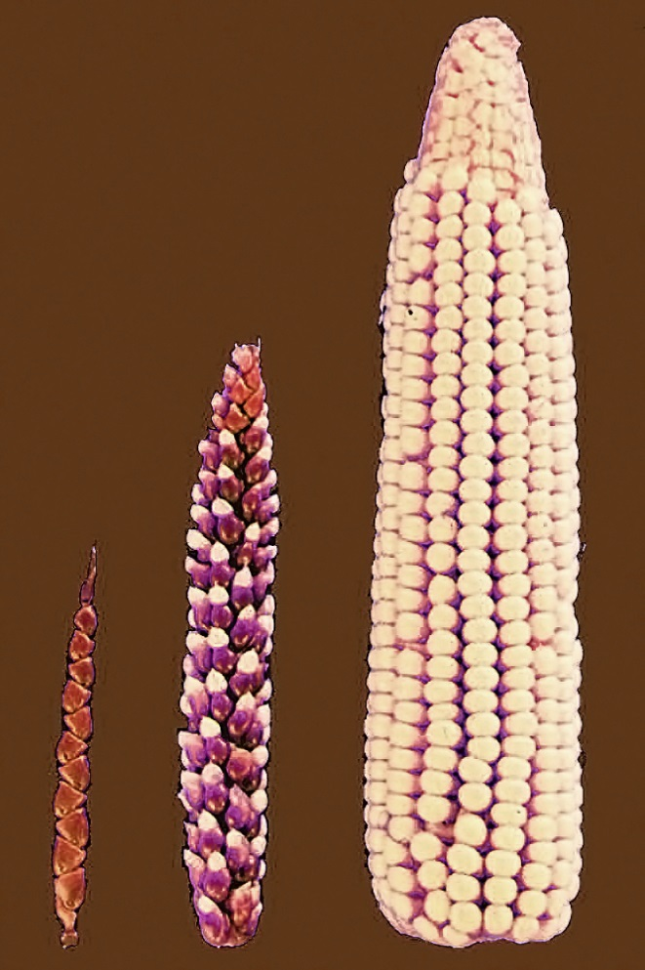
The effects of selective breeding can be seen very clearly in corn plants. The image to the left shows how corn has been modified from its original form to the form we see in our grocery stores today.
Did you know that all of these common vegetables have been selectively bred from the wild mustard plant?

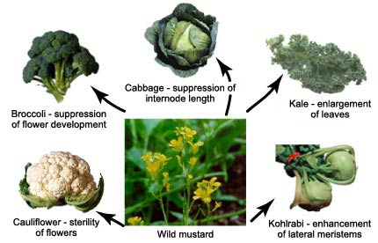

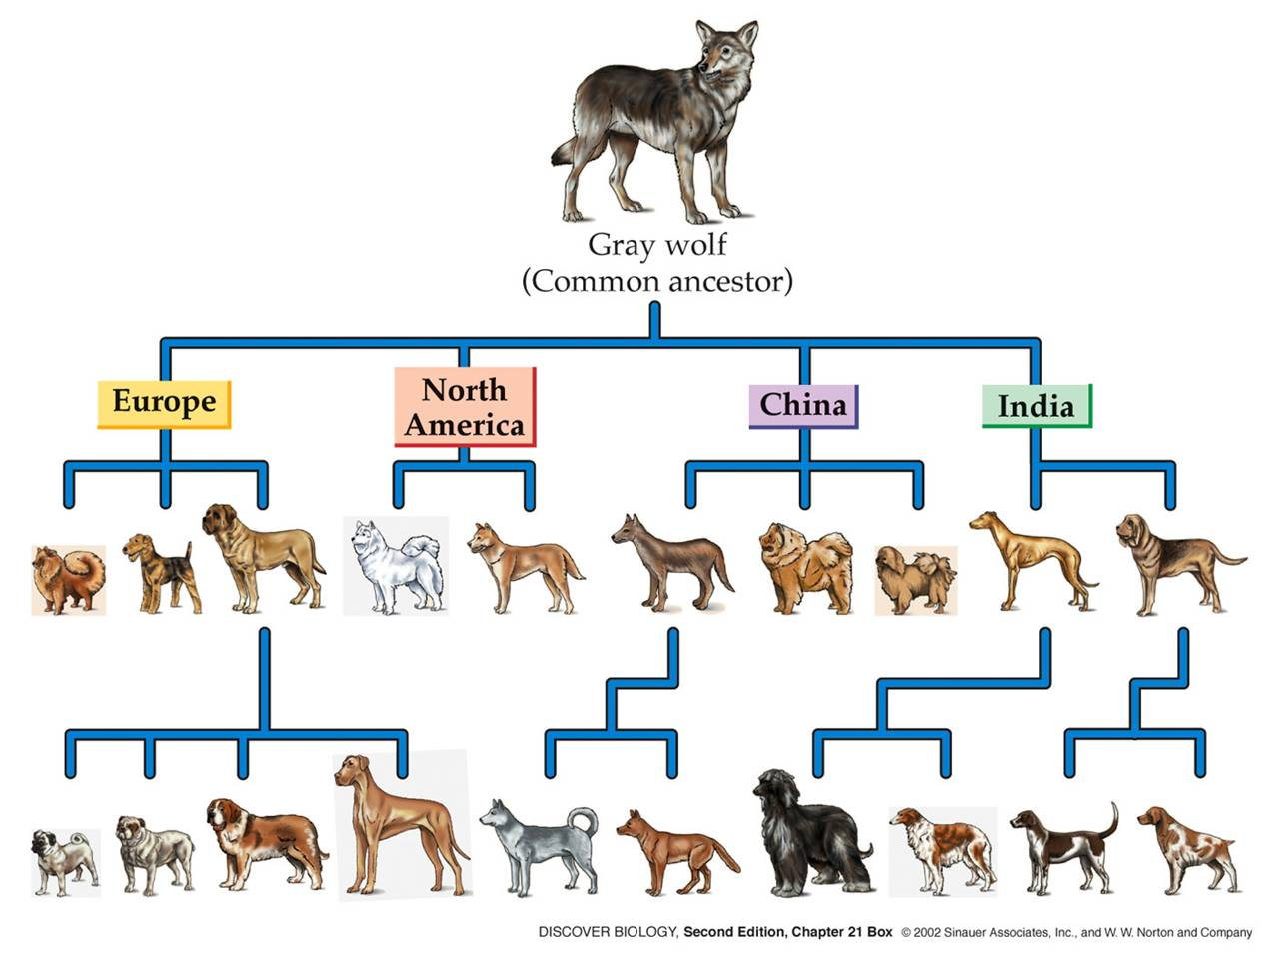
Artificial selection has also produced the many breeds of dogs we know today as well as many plant crops that are common in our grocery stores.

More aggressive methods of artificial selection include exposing organisms to chemicals and radiation to encourage mutations and then selecting individuals with desirable mutations. This practice has been in use since the 1930s and continues today.

Genetic Engineering

Selective breeding is still used in many applications, but direct genetic manipulation is now the more common method for selecting traits. When the genes of an organism are directly manipulated the organism is known as a Genetically Modified Organism (GMO). Genetic engineering often takes things one step further by mixing genetic materials from different organisms. This is extremely common is food products.

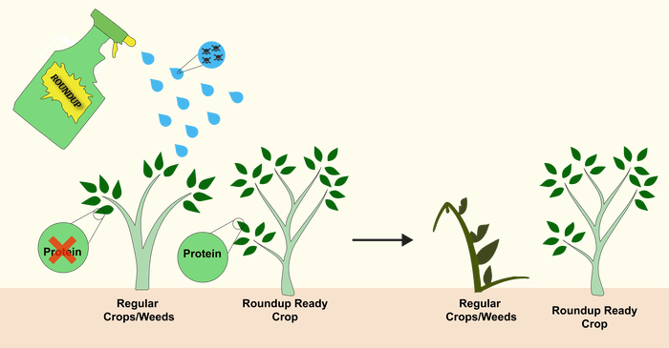
GMO chicken GMO corn/soy/cotton…
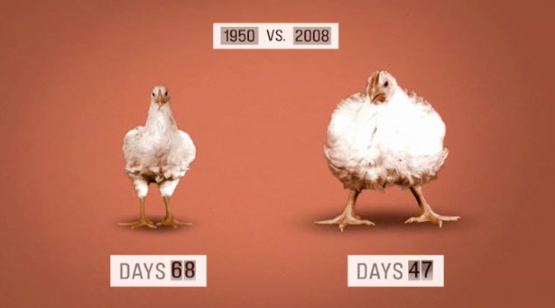

What are some potential problems with selective breeding and genetic modification?

