A Brief History of the Universe (As We Know It):
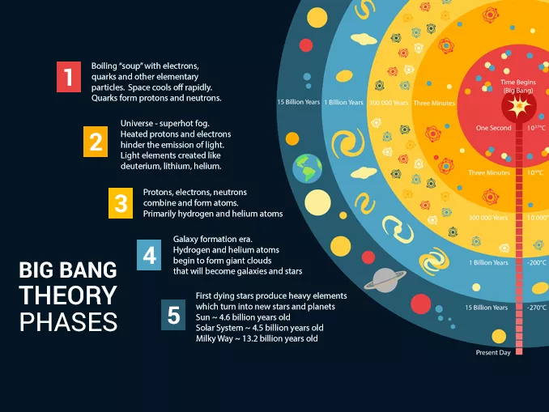

Background Information:

Very Large Distances:

As we discuss the solar system, the milky way galaxy and the universe in general, the distances involved are very large. One might say the distances are astronomical. To further complicate things, throughout much of the history of our knowledge of outer space the distances were unknown.

Astronomers have long used the Astronomical Unit(AU) as a reference unit. One astronomical unit is the distance from the Earth to the Sun. Other distances can be given in terms of multiples of the AU without knowing how large an AU is!

As our understanding of the universe developed it became obvious that the AU is actually an extremely small unit, and larger units would be needed for convenient measure of more distant objects, like stars beyond our solar system, or even beyond our galaxy. Below is a summary of the three most common units of measure we will be using in this discussion:

Astronomical Units (AU)

1 Astronomical Unit = The average distance from the Earth to the Sun
= The radius of the Earth’s orbit about the Sun
≈ 150 000 000km
≈ 1.5x10⁸km

Lightyears (ly)

1 Lightyear = The distance light will travel in 1 Julian year (365.25 days)
= speed of light x 1 year
= [3.0x10⁵ km/s x (60s/min) x (60min/h) x (24h/day) x (365.25days/year)] x 1 year
≈ 9 500 000 000 000km
≈ 9.5x10¹²km
≈ 63 000AU

Parsecs (pc)

1 Parsec = The distance at which 1 astronomical unit subtends an angle of 1 arcsecond ($\frac{1}{3600}$of a
degree)
≈ 3.1 x10¹³km
≈ 3.3 ly
≈ 210 000AU

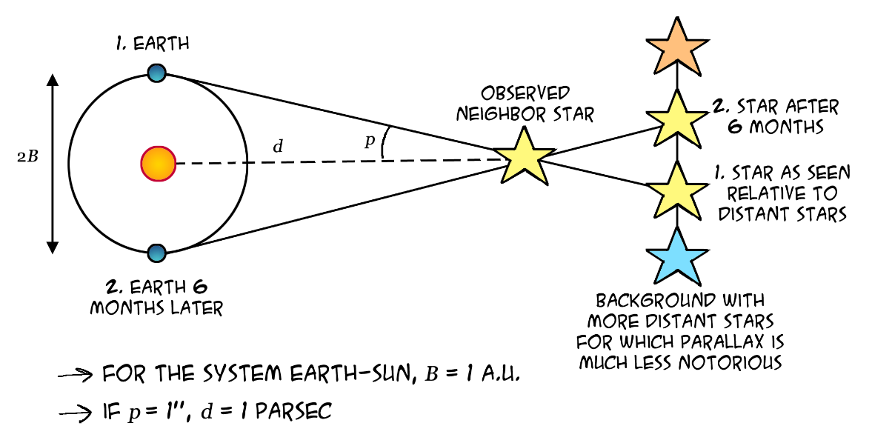

The Electromagnetic Spectrum:

When we say “light” in science, we are referring to more than just the light we can see. Visible light is just a tiny part of a broad array of light, known as the Electromagnetic Spectrum.

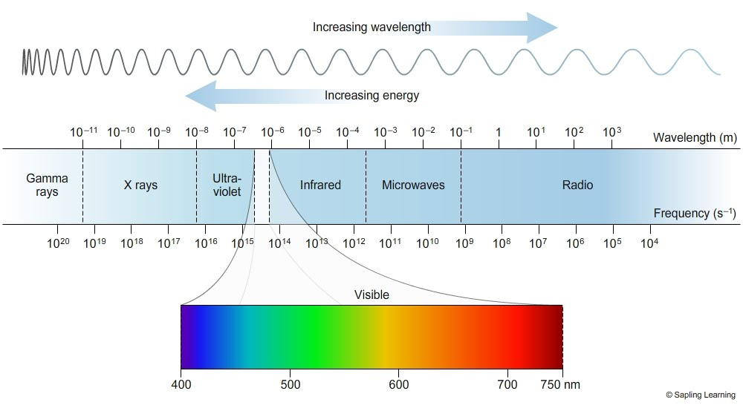

V B G Y O R

Light is a wave created when charged particles vibrate. Higher energy light has a faster vibration, or higher frequency, and a shorter wave length. The range of wavelengths and frequencies of light is enormous: Long wave radio signals can have a wavelength of 10 000m (10km) and a frequency of 10 000Hz, while high energy gamma rays may have wavelengths of 10⁻¹²m (one billionth of a millimeter!) and a frequency of 10²⁰Hz. Visible light fits into a narrow range between ~7.5x10⁻⁷m (Red) and 4.0x10⁻⁷m (Violet).

Different wavelengths/frequencies of light are used in different ways. Radio waves are used to transmit radio and television signals, microwaves are used to cook food* and to transmit cellular signals and radar. Infrared is used by short range remote controls and is the type of radiation that is given off as heat. Visible light is detected by our eyes, it’s the stuff we see! Ultra-violet is high energy and can cause sun-burns, but it can also be used to kill bacteria and disinfect surgical tools, tattoo needles and other objects. X-rays can penetrate through soft tissues, but not bone and can used to photograph our bones, or our luggage. Gamma rays are extremely high energy and extremely dangerous. Gamma radiation is released by nuclear weapons and in some radioactive decays. Although it can be dangerous, we still can use gamma rays to kill bacteria, to kill cancer cells and in other medical imaging. This is just a sample of the many ways that we use all types of light.

Although the different kinds of light have unique properties, they have one thing in common; they all travel very, very, very, very quickly. All light will travel through space at 300 000 000m/s or 300 000km/s. This speed is very high, but still finite. Thus, it does take time, often a very long time for light from different objects to reach us.

One important implication is that if we observe a star that is 1000ly away, the light we see today left the star 1000 years ago. So, when we observe very distant objects we can actually see back in time!

Doppler Shift:

The Doppler effect is an important property of waves. Most notably sound and light. When there is motion between the source of a wave and the observer, there is a difference between the frequency of the source and the observed frequency. If the source and observer are approaching the observed frequency is higher, if the source and observer are moving apart the observed frequency will be lower.

For light, a shift to a higher frequency is called a blue-shift while a shift to lower frequency is called a red-shift. This means that is a source of light (like a star) is moving toward us the light will be blue shifted, while if the source of light (like a star) is moving away, the light will be red shifted.

The greater the speed, the greater the amount of shift.

Introduction

The universe is all of space and time and all of its contents. This includes galaxy clusters, nebulae, galaxies, solar systems, stars, planets and all other matter, anti-matter and energy. The size of the universe is not known, however the observable universe is measurable.

Throughout human history, curiosity about the nature of space and “the heavens” has existed. For the vast majority of human history (~250 000 years for hominids, ~100 000years for modern humans) we could only guess as to what was above the sky.

However as science and technology steadily improved, observations of the stars and planets improved and so has our knowledge. Early conceptions of what exists beyond Earth were nearly entirely supernatural. Anything beyond Earth was considered the domain of gods. As humans evolved, so did our concepts of nature. It is only ~2500 years ago that the Moon, Sun and other planets became more fully understood and models of the solar system began to develop.

Still, any concept of objects beyond our solar system was out of reach. Philosophers and scientists had ideas, but without the tools to take proper measurements, these were only speculations. One of the earliest, and longest lasting astronomical debates was about our physical place in the “universe” which at the time was just the solar system. The real sticking point in the debate has to do with just how special we think we are.

Geocentric vs Heliocentric

In early models of the universe, from ancient Greek and Indian philosophers, the universe outside of our solar system was static with Earth at center. The Sun and other planets were believed to orbit around the stationary Earth. This is known as a Geocentric Model. It is worth noting that the Greek philosopher Arirstarchus of Samos did correctly propose that the Sun was at the center of our solar system and even placed the known planets in the correct order around the Sun circa 300 BCE. However his beliefs were not widely accepted.

This Geocentric model dominated until 1543, when Nicolaus Copernicus published his model with the Sun at the centre of the solar system. His model was based on based on careful observation of planets with telescopes and a great deal of mathematics. From that date forward the Heliocentric model of the universe dominated.

Timeline:
≈ 350 BC, Aristotle
Aristotle, a pupil of Plato, becomes the tutor of Alexander the Great. Aristotle's views of the world shape science for centuries. His influence lasts until the enlightenment. In his book On the Heavens (part 14), Aristotle asserts that:
From these considerations then it is clear that the earth does not move and does not lie elsewhere than at the center.
≈ 250 BC, Aristarchus
Aristarchus estimates the size of the sun to be much larger than the size of the earth. Based on this observation he then presents the heliocentric model.
≈ 150 AD, Ptolemy
In his book Almagest, Ptolemy introduces so called epicycles (small loops in the orbits of planets) to explain planetary retrograde motions (the apparent periodic reversal of the direction of motion of planets in the sky), based on the assumption that the earth is at the center and does not move. Almagest is considered to be one of the most influential scientific works in history. The geocentric view becomes the dominant view in Western civilizations.
1543, Nicholaus Copernicus
Just before his death, Copernicus publishes the book De Revolutionibus Orbium Coelestium (On the Revolutions of the Heavenly Spheres) in which he places the sun rather than the earth at the center of the universe. In his description Copernicus correctly places the planets in order according to distance from the Sun (Mercury, Venus, Earth, Mars, Jupiter, Saturn). The Copernican model accurately explained all observed motions and retrograde motions in a far simpler model than that of Ptolemy. However, the Copernican model still requires some small epicycles to fully explain all observations. This book is the beginning of the Copernican Revolution.
1572, Tycho Brahe
Tycho Brahe observes a star being born and publishes his observation in De Nova Stella. Brahe's observation refutes the commonly held view at the time, a view which dates back to Aristotle, that the stars are fix and never changing at the outskirts of the universe. Since Brahe couldn't observe a stellar parallax, he concluded that the earth did not move. He proposed a model where the planets move around the sun, and the sun moves around the earth. (It was later shown that it wasn't a star being born Brahe had observed, but the supernova SN 1572, i.e. a star exploding.)
1609, Johannes Kepler
Using the observational data collected by Tycho Brahe, Johannes Kepler introduces his first two laws of planetary motion in Astronomia Nova. The first law: the planets move in elliptical orbits with the sun at one focus. Kepler’s laws are by far the most mathematically advanced description of the solar system and his elliptical orbits managed to do away with epicycles once and for all.
1610, Galileo Galilei
Galileo observes several celestial bodies that are following erratic paths near Jupiter. Galileo carefully observes the motions and concludes that the objects are not stars or planets, but rather moons of Jupiter. Galileo makes predictions of the motion of these moons based on Kepler’s laws, which prove to be extremely accurate. These observations serve as an experimental confirmation of Kepler’s laws and provide conclusive evidence that not all objects orbit the Earth.
1616, Roman Inquisition
On 24 February 1616 a team of eleven consultants for the Roman Inquisition condemns the Copernican System, stating that the heliocentric system is “foolish and absurd in philosophy” and “formally heretical”.
1622, Galileo Galilei
Galileo Galilei stands trial on suspicion of heresy "for holding as true the false doctrine taught by some that the sun is the center of the world". At the trial he is found guilty and sentenced to formal imprisonment. During the trials Galileo formally renounces all of his scientific findings regarding the heliocentric view of the universe and “admits” that the Earth is central and stationary. He then famously states “...and yet, she moves.” Galileo spends the rest of his life under house arrest.
1687, Isaac Newton
Sir Isaac Newton publishes Philosophiae Naturalis Principia Mathematica (Principia). In Principia, Newton explains Kepler's laws of planetary motion in terms of universal gravitation. Newton’s calculations place the Sun in the center of the solar system. His Law of Gravitation allows him to explain all observed data AND later allows French astronomer le Verrier to predict the existence and location of Neptune in 1846.
1695, Christian Huygens
Christian Huygens is considered to be among the greatest scientists of all time and is credited as the founder of mathematical physics. Huygens was the first recorded scientist to attempt to measure the distance to stars based on the assumption that stars were simply distant Suns. He estimated the distance of the star Sirius to be 0.44 light years based on an assumption that it shines as brightly as the Sun. The actual distance is believed to be more than 8 ly. If Huygens had known that Sirius is actually more than 25 times as bright as our Sun his results would have been nearly perfect.
At this point the idea that the Sun is simply another star gained general acceptance.

1838, Friedrich Bessel
Friedrich Bessel is the first to accurately measure a stellar parallax. In 1838 he announces that the star 61 Cygni has a parallax of 0.314 arcseconds. This shows that the Earth is moving against the static background of stars.
1992, Roman Catholic Church
Pope John Paul II closes a 13-year investigation into the church's condemnation of Galileo in 1633 by declaring that Galileo was right:
“Thanks to his intuition as a brilliant physicist and by relying on different arguments, Galileo, who practically invented the experimental method, understood why only the sun could function as the centre of the world, as it was then known, that is to say, as a planetary system. The error of the theologians of the time, when they maintained the centrality of the earth, was to think that our understanding of the physical world's structure was, in some way, imposed by the literal sense of Sacred Scripture.”

By the late 1800s, early 1900s most scientists and most educated people have accepted that the Earth (and the other planets) orbit the Sun. The predominant belief at that time was that these motions occur against a background of stationary stars. That is to say that the common belief was that the universe is static. Bessel’s observations also led to the general acceptance that the Sun is in fact a star. Just one that is much closer than any other star to Earth.

As observations continued another major shift in our understanding of the universe began to develop:

Static vs. Dynamic Universe

A series of observations and studies, aided by improved telescopes and improved spectroscopy techniques and tools, led to a major shift in our understanding of the universe: The shift from a static universe to a universe that is expanding.

Further observations and improvements to telescopes provided clear evidence that our Sun is simply one of billions of stars in our galaxy, the Milky Way. The reason the Sun appears so large and bright is due to its proximity. It is only an average sized star. In fact the star Betelgeuse is 700 times as large and 14,000 times as bright as the Sun!

We now understand that not only is the Earth not stationary at the center of the universe but that the entire solar system is just one of BILLIONS and BILLIONS in the Milky Way galaxy!

As science continued to evolve and improve, many new techniques were devised with which to observe distant galaxies planets and stars. As a result it was discovered by Edwin Hubble in 1929 that all other observable stars and galaxies are moving away from Earth. In addition his observational evidence showed that the further away an object was, the more quickly it was moving away! This shows that the universe is expanding!

If the universe is expanding it is growing. If it is growing it must have been smaller in the past. If we trace that idea back far enough, we get to the idea of the Big Bang Theory.

Timeline:
≈ 1910, Vesto Slipher
Slipher spots and measures redshifts in the spectra of nebulae. This redshift is not due only to the rotations of the nebulae. The conclusion is that these objects are moving in space. By 1921 he had measured the speeds of 41 distant cosmic objects.
1905, Albert Einstein
Einstein publishes the Law of Special Relativity which provides new insights into the way that the motion of light must be measured. The Theory of Special Relativity is widely considered one of the most important scientific papers of all time and cemented Einstein as one of the greatest scientific geniuses of all time. Einstein did not believe in the expanding universe for most of his life. However, the evidence did eventually convince him.
1915, Albert Einstein
Einstein follows Special Relativity with The Theory of General Relativity which completely reformulated Newton’s Law of Universal Gravitation. Einstein’s theory is massively more complex than Newton’s Law and explains gravity not as a force pulling massive objects together, but as a curvature in space-time created by massive objects. The most important aspect for this discussion is that Einstein proposed that light itself is affected by gravity, and so measurements of light from distant stars must take this into account.
1919, Edwin Hubble
Hubble is the first to discover and measure objects outside of the Milky Way Galaxy.
1927, Georges Lemaitre
Lemaitre was a Belgian catholic priest and astronomer. He managed to combine the measurements and observations taken by Slipher and Einstein’s revolutionary Theory of General Relativity. As a result, Lemaitre was the first to propose an expanding universe.
1929, Edwin Hubble
By studying the redshifts newly discovered objects beyond the Milky way as well looking at the data of Vesto Slipher, Hubble found that (nearly) every observable object in space is moving away from Earth. Hubble also used this data to establish a POSTIVE LINEAR CORRELATION between the distance to an object and its recessional speed.
1941, Fred Hoyle
Hoyle was an English astronomer who first correctly described the formation of elements larger than helium by stellar nucleosynthesis. Hoyle did not believe in the theory of an expanding universe and first used the term “Big Bang” in an attempt to mock the theory. The name stuck.
1964, Arno Penzias , Robert Wilson and Robert H. Dicke, Jim Peebles and David Wilkinson
Penzias and Wilson detect microwave radiation coming from the galaxy uniformly in all directions. Separately Dicke, Peebles and Wilkinson predicted that the blast of radiation from the big bang should be detectable everywhere in the sky. They further predicted that the radiation should be in the microwave range. The two teams together are credited with measuring the COSMIC BACKGROUND RADIATION (CBR) and finding first comprehensive evidence of the massive explosion called the BIG BANG.

1970s-Present
Through the 1970s astrophysicists have gathered a great deal of evidence based upon the structure of stars. Early stars should consist of almost entirely of hydrogen and helium. Later stars should contain more larger elements as they incorporate material from the supernova of earlier stars. The observations of various stars confirm these predictions very well.

There are still some issues with the Big Bang theory, such as the exact nature of dark matter and dark energy, and the dwarf galaxy problem. While there are some variations on the exact version of the theory and there are some scientists who continue to investigate versions of the Steady State model, the current consensus is that the Big Bang theory explains the vast majority of observable data.

The Big Bang Theory:

At the beginning the entire universe was condensed into an unimaginably dense point smaller than the size of a single atom. At this point the universe was entirely composed of an unknown form of energy. Then for reasons that we do not know, and likely will never know, 13.8 billion years ago, the universe exploded and began to expand. BANG.

Everything that we know grew out of that tiny point, all of the matter, energy, space and time grew out of the expansion. That’s right, as far as we know before the Big Bang, even space and time did not exist.

Since the Big Bang, 13.8 billion years ago, the universe has passed through many different phases or epochs. Due to the extreme conditions and chaos of its very early stages, it arguably saw more activity and change during the first second than in all the billions of years since.
From our current understanding of how the Big Bang might have progressed, we can put together an approximate timeline as follows:

PHASE 1 – From Zero to Quarks 0s - 3minutes
- Planck Epoch (or Planck Era): 0 - 10⁻⁴³seconds 10^{40o}C
This is the closest that current physics can get to the absolute beginning of time, and very little can be known about this period. At this point, the universe spans a region of only 10⁻³⁵ m, and has a temperature of over 10³²°C.
- Expansion/Inflation: 10^{–43}s - 10^{–32}s 10^{27o}C
The force of gravity separates from the other fundamental forces (which remain unified), and the earliest elementary particles (and antiparticles) begin to be created.
Triggered by the separation of the strong nuclear force, the universe undergoes an extremely rapid exponential expansion, known as cosmic inflation. The universe expands by 100 000 000 000 000 000 000 000 000x, to around 10 centimeters in diameter (about the size of an orange).
- Quark Epoch: 10^{–12}s - 10^{–6}s 10^{17o}C
Quarks, electrons and neutrinos form in large numbers as the universe cools off to below 10 quadrillion degrees Celsius (10¹⁷ ºC) , and the four fundamental forces assume their present forms. Quarks and antiquarks annihilate each other upon contact, but, in a process known as baryogenesis, a surplus of quarks (about one for every billion pairs) survives, which will ultimately combine to form matter.
- Hadron Epoch: 10^{–6}s - 3 minutes 10^{12o}C
The temperature of the universe cools to about a trillion 10¹² degrees, cool enough to allow quarks and electrons to combine to form hadrons (like protons and neutrons). The only rules governing all this apparently random combining and re-combining are that the overall charge and energy (including mass-energy) be conserved.
PHASE 2 – Nuclear Age (Nucleosynthesis) 3 minutes-240 000years
- Nucleosynthesis: 3 minutes - 20 minutes 10^{9o}C
The temperature of the universe falls to the point (about a billion degrees) where the simplest atomic nuclei can begin to form as protons and neutrons combine through nuclear fusion to form the nuclei of the simple elements of hydrogen, helium and lithium. After about 20 minutes, the temperature and density of the universe has fallen to the point where nuclear fusion cannot continue.
- Photon Epoch: 20 minutes - 240,000 years 10 000ºC
During this long period of gradual cooling, the universe is filled with plasma, a hot, opaque soup of atomic nuclei and electrons. The energy of the universe is dominated by photons, which continue to interact frequently with the charged protons, electrons and nuclei.
PHASE 3 – Atomic Age (Atom Formation) 240 000years – 1 billion years
- Atom Formation: 240,000 - 300,000 years: 3700ºC
As the temperature of the universe falls to around 3,000 degrees (about the same heat as the surface of the Sun) and its density also continues to fall, ionized hydrogen and helium atoms capture electrons, thus forming neutral atoms . With the electrons now bound to atoms, the universe finally becomes transparent to light, making this the earliest epoch see-able today. As neutral atoms form gravity becomes a more important force within the universe.
- Dark Age (or Dark Era): 300,000 - 150 million years 1000ºC
The period after the formation of the first atoms and before the first stars is sometimes referred to as the Dark Age. Although photons exist, the universe at this time is literally dark, with no stars having formed to give off light. With only very diffuse matter remaining, activity in the universe has tailed off dramatically, with very low energy levels and very large time scales. Little of note happens during this period, and the universe is dominated by mysterious “dark matter”.
- Primordial Gas Cloud Formation: 150 million - 1 billion years -200ºC
Gravity pulls neutral hydrogen and helium atoms together to form massive clouds of gas. As these gain in size they attract more and more atoms and continue to grow. As the clouds grow the density of the gas at the center increases and increases.

PHASE 4 – A Star(s) is Born

- Star and Galaxy Formation 1 billion years to 13.8 billion years (present) -250ºC
Gravity amplifies slight irregularities in the density of the primordial gas and pockets of gas become more and more dense, even as the universe continues to expand rapidly. The density in the center of the clouds becomes so great that the clouds collapse under their own gravity, becoming hot enough to trigger nuclear fusion reactions between hydrogen atoms, creating the very first stars.
- The fusion within stars forms larger nuclei up to iron. Nuclei larger than iron are not formed until stars explode in a supernova.

PHASE 5 – Heavy Metal (and non metals) 8.5 billion years to 13.8 billion years (present) -260ºC

- Large Elements 8.5 billion years to 9 billion years
The first-generation stars begin to die. The resulting super novae form the first large elements. These elements are absolutely necessary for the formation of Earth or Earth-like planets.
- Solar System Formation 8.5 - 9 billion years to present:
Our Sun is a late-generation star, incorporating the debris from many generations of earlier stars, and it and the Solar System around it formed roughly 4.5 to 5 billion years ago (8.5 to 9 billion years after the Big Bang).
- Today: -270ºC
The expansion of the universe and recycling of star materials into new stars continues.

Some Final Thoughts:

Abundance of light elements:

Observations of the universe, including our own Sun and the exo-planets, consistently confirms that hydrogen and helium account for nearly 98% of all matter in the universe. This observation confirms predictions made by how elements are formed in the big bang.

Because elements larger than helium are formed by stellar nucleosynthesis (nuclear fusion inside stars), or during a supernova not formed until stars form, these elements are very rare and are relatively new.

By looking into distant space, astronomers can essentially look back in time: If we observe a star that is 2 million light years away, the light we see is 2 million years old. The light from an object 5 billion light years away is 5 billion years old. By looking at the atomic spectra from these stars we can determine their atomic make up. We can see what elements were present in the past!

Cosmic Background Radiation (CBR):

The big bang was essentially a massive explosion of energy. Physicists determined that if the big bang did occur it should have produced a huge amount of very high energy gamma radiation. This energy should have expanded in a fairly uniform manner until gravity began to cause matter to form into clumps. Cosmic background radiation is this leftover radiation signature from the big bang.

Because of the expansion of space, we -and all other things- are moving away from the location of the initial big bang. The doppler effect predicts that the light (gamma radiation) from the big bang should be red-shifted as a result. Predictions based on Hubble’s Law stated that the radiation should be red-shifted all the way into the microwave region.

This background radiation was detected (by mistake) in 1964. The wavelengths measured matched predictions nearly perfectly. Astronomers commonly attribute a temperature to different types of radiation based on Plank’s quantum blackbody theory; longer wavelength have lower temperatures.

Predictions estimated that the CBR should have a temperature of -270ºC. The measured temperature of the CBR was -269ºC. How’s that for a prediction?

Measuring distances and Standard Candles:

Earlier in these notes units for very large distances were discussed. The notion of measuring distances by using stellar parallax was also discussed. However, stellar parallax is only useful for distances extending to about 30 parsecs (100 light years). In terms of the universe, that is an extremely small distance.

To put it in perspective, a circle of 100 ly radius around earth is the equivalent to a circle of 4.0cm radius on Earth. Imagine trying to map the Earth if you could not observe further than 4.0cm from where you are in any direction!

So here is a summary of how astronomical distances are determined, from near to far.

- Radar: Pulses of microwave radiation can be sent out and bounced off of objects. By measuring the time for the pulse to travel there and back distance can be measured. This is the same way that radar is used to measure speeds of objects on Earth. The major problem with this is time. If an object is 2 light years away, the radio pulse would take 4 years to return to the Earth. That is a long time to wait for a measurement. If the object is 200 light years away…

As a result this technique is only useful to confirm distances within the Solar System.

- Stellar parallax: The perceived change in postion of objects caused by a change in position of the observer. We can only use this to approximately 30pc

- Cepheid Variables: In 1912, Henrietta Swan Leavitt noted that 25 stars, called Cepheid stars, that would brighten and dim periodically. Leavitt was able to measure the period of each star by measuring the timing of its ups and downs in brightness. What she found was that the brighter the Cepheid, the longer its period. In fact, Cepheids are very special variable stars because their period (the time they take to brighten, dim and brighten again) is regular (that is, does not change with time), and is a uniform function of their brightness. That is, there is relation between the period and brightness such that once the period is known, the brightness can be inferred.
More distant objects appear dimmer when we observe them. Think of a flashlight shone straight into your eye compared to the same flashlight 500m away. By observing a distant Cepheid’s period we know its absolute brightness. Then by looking at the apparent brightness, the distance can be determined.
Using Earth-bound telescopes we can use Cepheids to a distance of about 20 Mpc (20 000 000 pc). By using space telescopes this method has allowed us to probe all the way to

Cepheid Variables:

Cepheid

