Unit 3: Nuclear Processes

Nuclear Structure:

Quarks, Protons and Neutrons:

In the very early universe (10⁻¹² - 10⁻⁶s) following the initial inflation in which the universe grew from less than the size of an atom to the size of an orange, the temperature of the universe dropped sufficiently for particles to form. Most of these particles were quarks, neutrinos, electrons and their anti-matter counterparts. As the universe continued to expand and cool (10⁻⁶s – 3 minutes), conditions allowed the quarks begin to fuse (join) together to form protons and neutrons.

The fact that protons and neutrons are composed of quarks was first proposed independently, in 1964, by two physicists: Murray Gell-Mann and George Zweig. The existence of quarks was confirmed experimentally in 1968.

There are 2 main types of quarks, called the up quark and the down quark. It was determined theoretically and confirmed experimentally that protons and neutrons should have the following structure:

- A proton consists of 2 up quarks and 1 down quark (2U + 1D)
- A neutron consists of 1 up quark and 2 down quarks (1U + 2D)

We already know that a proton has a charge of +1 (by definition), while a neutron has a charge of 0 (it is neutral).

It is an interesting little math problem to figure out what the charge must be on each type of quark:

Proton: 2U + 1D = +1

Neutron: 1U + 2D = 0

This is a simple system of equations. I’ll leave this as an exercise for you to solve.

If you solve this problem, you will find that there is only one solution:

- The up quark has a charge of $+\frac{2}{3}$

- The down quark has a charge of $-\frac{1}{3}$

So we have all 3 of the fundamental building blocks of matter. Protons and neutrons which together with electrons make up everything around us. Electrons are not made of quarks.

PROTON: NEUTRON:

D
$$-\frac{1}{3}$$

D
$$-\frac{1}{3}$$

U
$$+\frac{2}{3}$$

D
$$-\frac{1}{3}$$

U
$$+\frac{2}{3}$$

U
$$+\frac{2}{3}$$

Total Charge: Total Charge:

Atomic Nuclei

Together protons and neutrons are referred to as nucleons.

The temperature and pressure in the early universe was intense enough to allow the protons and neutrons to join together in a process called nuclear fusion. Nuclear fusion still happens today, inside of stars. In fact the Sun produces its energy by fusing hydrogen nuclei into helium nuclei.

An atomic nucleus is formed when protons and neutrons combine. In the early universe only very small nuclei could form: Hydrogen and Helium.

Hydrogen:

Hydrogen-1 Hydrogen-2 Hydrogen-3

Helium:

Helium-3 Helium-4 Helium-5

Isotopes: Versions of the same element with different numbers of neutrons, and thus, different masses. Isotopes will have identical chemical properties to one another, but may have important differences physically.
Nuclear Notation:
nucleon number Nuclear symbol/Chemical symbol
atomic number
$${}_{Z}^{A}X$$
A:

Z:

Nuclear Reactions:

Nuclear reactions occur when atomic nuclei either collide and join together, or when a large atomic nucleus is struck by a sub-atomic particle, usually a neutron, and splits into smaller nuclei.

Nuclear reactions are different from chemical reactions in three important ways:

- In a nuclear reaction new elements are formed. In a chemical reaction elements are rearranged, but no new elements are formed.
- In nuclear reactions mass is gained or lost. This mass is converted to/from energy by the famous equation E=mc². In chemical reactions mass is always conserved.
- Nuclear reactions involve MUCH higher energies than chemical reactions.

In all nuclear reactions there are two important rules that are always followed. Scientists don’t fully understand why, but these rules are always obeyed in every one of the billions of reactions we have ever observed and tested.

- The total number of nucleons before and after the reaction is always the same. This is the
Law of Conservation of Nucleons.
- The total charge of all particles is the same before and after the reaction. This is the
Law of Conservation of Charge.

Endothermic and Exothermic

All natural processes, including nuclear (and chemical) reactions involve energy. A process that releases energy to the surroundings is called EXOTHERMIC. A reaction that absorbs energy from the surroundings is called ENDOTHERMIC.

In general, an exothermic reaction will cause the surroundings to get hotter, like a fire. An endothermic reaction will cause the surroundings to get colder, like ice melting or sweat evaporating.

For nuclear reactions there is a change in mass between the reactants and products.

- In an exothermic nuclear reaction, the products have LESS MASS than the reactants. The “lost” mass is released to the surroundings as energy.
- In an endothermic nuclear reaction, the products will have MORE MASS than the reactants. The “gained” mass comes from energy absorbed from the surroundings.

Fusion:

A nuclear fusion reaction occurs when two (or more) smaller nuclei collide with sufficient force to combine, or fuse, and form a larger nucleus. Fusion reactions only occur at extremely high temperatures and pressures.

The conditions in the early universe (~3min-20min after the Big Bang) were right to form Hydrogen and Helium nuclei, but not larger nuclei. The conditions to form nuclei do not exist anywhere in nature today, except for the interior of stars. The fusion of smaller nuclei is nearly always exothermic, releasing energy as heat and light and the kinetic energy of the fusion products. The formation of all nuclei up to iron-56 is exothermic and occurs regularly within stars. Fusion of larger nuclei is endothermic, absorbing energy from the surroundings. The energy needed to fuse these larger nuclei comes from the energy released when a star explodes as a super-nova.

This implies that when smaller nuclei are formed by fusion the product has a lower mass than the reactants. When larger (larger than iron-56) nuclei are formed by fusion the product will have a greater mass than the reactants.

Fusion is when 2 (or more) small nuclei join to form a larger nucleus.

Examples:

The fusion of hydrogen-1 and hydrogen-3 to form helium-4

The fusion of beryllium-8 and helium-4 to form carbon-12

The fusion of hydrogen-2 and nitrogen-15 to form _____________________ and 1 neutron

Fission:

Nuclear fission is the breaking of a large nucleus down into smaller nuclei. Usually this break is induced by hitting the large nucleus with a small particle. A nuclear fission reaction occurs when the small particle (usually a neutron), with the right amount of kinetic energy, hits a sufficiently large nucleus. The smaller particle is temporarily absorbed by the large nucleus, forming a highly unstable intermediate nucleus. This intermediate then splits, or fissures, into smaller nuclei.

Fission reactions do not require the same intense temperature and pressure to occur as fusion reactions. However fissionable nuclei are relatively rare in nature, and therefore sustained (long lasting) fission reactions are also very rare in nature. Fission reactions require special conditions to occur and to maintain in a controlled way. All nuclear power plants on Earth (about 15% of global energy), nuclear submarines and most nuclear weapons operate by using nuclear fission.

Fission reactions are exothermic for nuclei larger than iron-56, releasing energy to the surroundings. For smaller nuclei, fission reactions are endothermic, absorbing energy from the surroundings.

This implies that when nuclei smaller than iron-56 are split, the products will have more mass than the reactants, whereas when nuclei larger than iron-56 are split in a fission reaction the products will have less mass than the reactants.

Fission is when 1 large nucleus is split into 2 (or more) smaller nuclei.

Examples:

A neutron is fired into uranium-235 forming uranium-236. U-236 splits into Barium-141 and Krypton-92 and 3 neutrons.
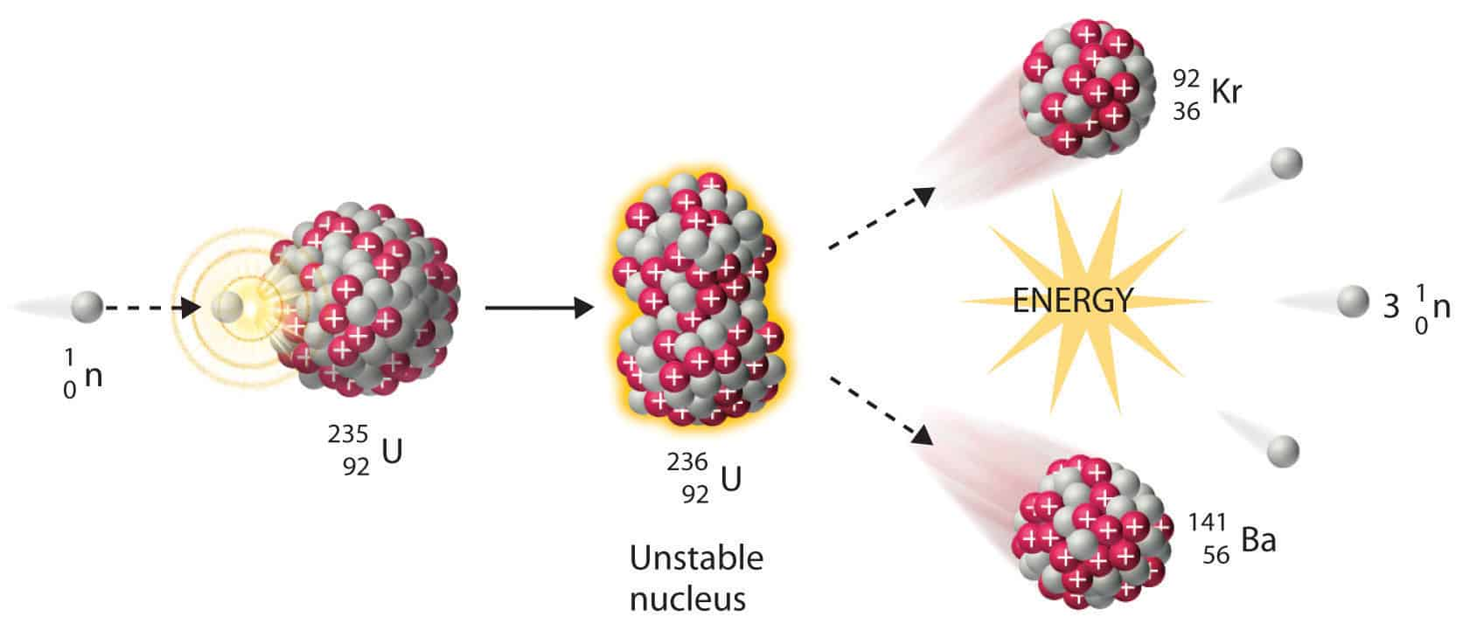

Notice that 3 more neutrons were released. Each of these can now hit another U-235 nucleus and split it. This may lead to a chain reaction!

A neutron is fired into a Plutonium-244 nucleus forming Pu-245. Pu-245 then fissions into Gold-204 and ___________-35 and ___ neutrons.

Nuclear Decay and Radioactivity

The nucleus is a tightly packed little clump of protons and neutrons. These protons repel each other electrically. What keeps the nucleus from blowing apart as a result of this repulsion is the strong nuclear force. The strong nuclear force is an attractive force between the protons and the neutrons that acts over incredibly short distances (~10⁻¹⁵m).

The strong force is much stronger than the electrostatic force so small nuclei tend to be very stable. However as nuclei become larger, the strong nuclear force can no longer “reach” across the entire nucleus and so eventually the nucleus can get too large and despite the neutrons’ best effort, the repulsive electrostatic force wins out and the nucleus becomes unstable and spontaneously breaks apart. All nuclei with more than 83 protons are unstable. These nuclei are called radioactive and the process of breaking apart is called radioactive decay. Radioactive decay happens in four main ways:

Radioactivity was discovered in 1896 by Henri Becquerel, although he did not understand the mechanisms. It was Marie Curie (the first woman to win the Nobel Prize, first person to win the Nobel Prize twice and the only scientist to have ever won the Nobel Prize in two different branches of science, chemistry and physics) who discovered that the radiation was emitted by the element itself. She also discovered two new elements, polonium and radium and coined the term radioactivity.

Each of the four ways is named after the decay particle that is ejected from the nucleus.

Alpha Decay:

First type of decay discovered. Named after the first letter of the Greek alphabet, alpha (α). Experiments by Henri Becquerel and Ernest Rutherford showed that the alpha particle had a positive charge and a relatively large mass.

The atomic symbol for an alpha particle is: ${}_{2}^{4}α$

The general form of an alpha decay is:

$${}_{Z}^{A}P→{}_{2}^{4}α + {}_{ Z-2}^{A-4}D$$

Parent Decay Particle Daughter

Examples:

Alpha decay of lead-210:
210 = 4 + 206
82 = 2 + 80

$${}_{82}^{210}{Pb}→{}_{2}^{4}α + {}_{ 80}^{206}{Hg}$$

Alpha decay of francium-223:

$${}_{87}^{223}{Fr}→{}_{2}^{4}α + {}_{}^{}{}$$

Beta (negative) decay:

Second type of radioactive decay discovered. Named after the second letter of the Greek alphabet, beta (β). Experiments by Henri Becquerel and Ernest Rutherford showed that the beta particle had a negative charge and an extremely small mass.

The atomic symbol for a beta (negative) particle is: ${}_{-1}^{0}β$

The general form of a beta decay is:

$${}_{Z}^{A}P→{}_{-1}^{0}β + {}_{ Z+1}^{A}D$$

Parent Decay Particle Daughter

Examples:

Beta negative decay of Thorium-231:
231 = 0 + 231

$${}_{90}^{231}{Th}→{}_{-1}^{0}β + {}_{ 91}^{231}{Pa}$$

90 = -1 + 91
Beta negative decay of Osmium-191:

$${}_{76}^{191}{Os}→{}_{-1}^{0}β + {}_{}^{}{}$$

Beta (positive) decay:

Beta positive is the fourth type of decay discovered. Named after the second letter of the Greek alphabet, beta (β). Experiments by Dmitri Skobeltsyn, Chung-Yao Chao and Carl David Andersen showed that the beta-positive particle had a positive charge and an extremely small mass. It behaved exactly like an electron (β⁻) except that it curved in the opposite direction when exposed to electric or magnetic fields. The beta-positive particle is also known as an anti-electron or a positron.

The atomic symbol for a beta (negative) particle is: ${}_{1}^{0}β$

The general form of a beta-positive decay is:

$${}_{Z}^{A}P→{}_{1}^{0}β + {}_{ Z-1}^{A}D$$

Parent Decay Particle Daughter

Examples:

Beta-positive decay of fluorine-18
18 = 0 + 18

$${}_{9}^{18}F→{}_{1}^{0}β + {}_{ 8}^{18}O$$
9 = 1 + 8

Beta-positive decay of zinc-64

$${}_{30}^{64}{Zn}→{}_{1}^{0}β + {}_{}^{}{}$$

Gamma decay:

Third type of decay discovered. Named after the third letter of the Greek alphabet, gamma (γ). Discovered by French chemist Paul Villard in 1900. These rays behaved much like X-rays, but had much higher penetrative power.

The atomic symbol for a gamma particle is: ${}_{0}^{0}γ$

The general form of a gamma decay is:

$${{}_{Z}^{A}P}^{*}→{}_{0}^{0}γ + {}_{ Z}^{A}D$$

Parent Decay Particle Daughter
Examples:

Gamma decay of cesium-134
134 = 0 + 134

$${}_{55}^{134}{Cs^{*}}→{}_{0}^{0}γ + {}_{ 55}^{134}{Cs}$$
55 = 0 + 55

Gamma decay of Iodine-131

$${{}_{53}^{131}I}^{*}→{}_{0}^{0}γ + {}_{}^{}$$

Practice:

Write the equation for the alpha decay of the following nuclei:

Actinium-227
Einsteinium-254
Uranium-238
Americium-241

Write the equation for the beta-negative decay of the following nuclei:

Rhenium-187
Silicon-31
Carbon-14
Barium-141

Write the equation for the beta-positive decay of the following nuclei:

Sodium-22
Carbon-11
Fluorine-18

Write the equation for the gamma decay of the following nuclei:

Cobalt-60
Beryllium-10
Mass Defect and Energy

What is very interesting (and somewhat counter intuitive) about nuclear reactions is that the mass of the products is different from the mass of the reactants that formed them. The whole is LESS than the sum of its parts in some cases, and GREATER in others. This change of mass was predicted by Albert Einstein and is summarized by the formula:

E=Δmc²

Where E is energy, Δm is the difference of mass between the products and reactants and c is the speed of light in a vacuum. Δm is called the mass defect.

- In exothermic nuclear reactions the products have less mass than the reactants. This “lost” mass (Δm) is released to the surroundings as energy.

- In endothermic nuclear reactions the products have more mass than the reactants. The “gained” mass comes from energy absorbed from the surroundings.

Example:

In a nuclear fusion reaction hydrogen-2 fuses with hydrogen-3 to form helium-4 and a neutron. Every 1.000kg of reactant (hydrogen) yields 0.9937kg of product (helium). How much energy is released in this process?

First, we need to find the mass defect. The convention is to always report this as a positive value.

Δm=1.000kg-0.9937kg=0.0063kg

Next use the formula E=Δmc² to find energy.

E=Δmc²
E=(0.0063kg)(3.00x10⁸m/s)²
E=5.67x10¹⁴J

This is the same amount of energy that would be released by burning 20000 tonnes of coal. This amount of coal would fill a train approximately 1.5-2km in length.

Alternate Units:

When we are dealing with nuclei we are dealing with extremely small objects with extremely small masses. Until now we have said that the mass of a proton is 1. What you should be wondering is 1 what? 1kg? 1 gram? 1 ounce? 1 floostroople?

The answer is 1 atomic mass unit or 1u. This is a convenient mass to use when dealing with atoms or with nuclei. It is also very tiny. The conversion factor between kg and u is:

$$1u=1.66×10^{-27}kg$$
The standard unit for energy is the Joule. 1 Joule is 1 kilogram(meter)² per second². What matters here is that to find energy in joules from E=mc², the mass must be in kg and the speed of light, c, must be in m/s.

A convenient unit for energy when dealing with very small masses is the electron-Volt (eV) or the Mega electron-Volt (MeV). There is a historic significance to this unit and its name, but I won’t get into that here. Let’s just worry about conversions.

$$1ev=1.6×10^{-19}J$$

$$1Mev=1.6×10^{-13}J$$

Finally, we want to know how to convert from mass defect to energy released or absorbed, so let’s go through a little calculation to figure out how much energy in MeV is equivalent to 1u of mass.

$$E=∆mc^{2}$$

$$∆m=1u×\left(\frac{1.66×10^{-27}kg}{1u}\right)=1.66×10^{-27}kg$$

$$E=1.66×10^{-27}kg c^{2}=1.66×10^{-27}kg({3.00×10^{8}m/s)}^{2}$$

$$E=1.49×10^{-10}J$$

Okay, almost there. Now we can just convert Joules to MeV:

$$E=1.49×10^{-10}J ×\left(\frac{1MeV}{1.6×10^{-13}J}\right)=930MeV$$

Every 1u of mass that is lost/gained corresponds to 930MeV of energy. Indeed, this idea is so central to nuclear ant atomic physics that scientists, being a lazy bunch, often take a short cut and refer to the mass of a particle in MeV. This is technically not quite correct as the unit for mass should be MeV/c² as shown below:

$$E=∆mc^{2}$$

$$930MeV=(1u)c^{2}$$

$$\frac{930MeV}{c^{2}}=1u$$

$$1u=930\frac{MeV}{c^{2}}$$

Summary:

Mass: There are three main mass units you will need to be familiar with: kg, u, and MeV/c²

$$1u=1.66×10^{-27}kg$$

$$1u=930\frac{MeV}{c^{2}}$$

Energy: There are two main energy units you will need to be familiar with: J and MeV

$$1Mev=1.6×10^{-13}J$$

And one formula:

E=Δmc²

Example 2: Find the energy in MeV released in the following reaction.

$${}_{49}^{115}{In}→{}_{-1}^{0}β + {}_{50}^{115}{Sn}$$

Given: Mass of 1 indium-115 nucleus: 114.900u
Mass of beta particle: 0.000 6u
Mass of tin-115: 114.899u

First find the mass defect: Δm= 114.900u – (114.899u + 0.0006u) = 0.000 4u

Now convert mass defect to MeV/c²:

$$0.0004u×\frac{(930\frac{MeV}{c^{2}})}{1u}=0.372\frac{MeV}{c^{2}}$$

Finally use E=Δmc²

$$E=0.372\frac{MeV}{c^{2}}×c^{2}=0.372MeV$$

This is a tiny amount of energy, but it is for a single nucleus.

Basic Nuclear Reactor:

A nuclear reactor is just a very fancy device to boil water. The nuclear fission reaction generates heat that boils the water (heavy water) in the reactor and generates steam. The steam is then used to turn a turbine and generate electricity.

The basic design (VASTLY SIMPLIFIED) looks like:

Boiling-Water Reactor (BWR)
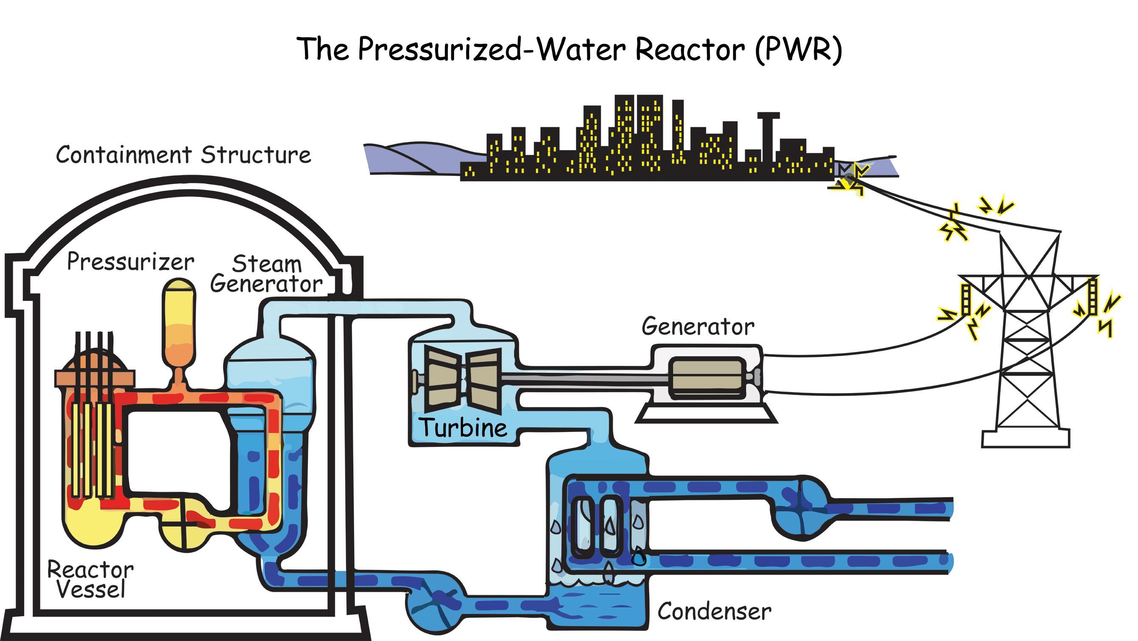

- The fuel elements or fuel rods are made of a fissionable material, usually Uranium-235.

- The control rods are made of boron or cadmium and can absorb neutrons to slow down the chain reaction.

- The moderator slows down the ejected neutrons so they can trigger more reactions.

- The energy released from the reaction is used to heat up water

- The steam produced is used to turn a turbine, generating electricity.

Many nuclear reactors use Uranium-235 as the fuel source. U-235 is called a fissionable material because it will undergo nuclear fission if induced by a neutron.
The most common reaction is as follows:

$${}_{0}^{1}n+{}_{92}^{235}U→ {}_{56}^{141}{Ba}+{}_{36}^{92}{Kr}+3{}_{0}^{1}n$$
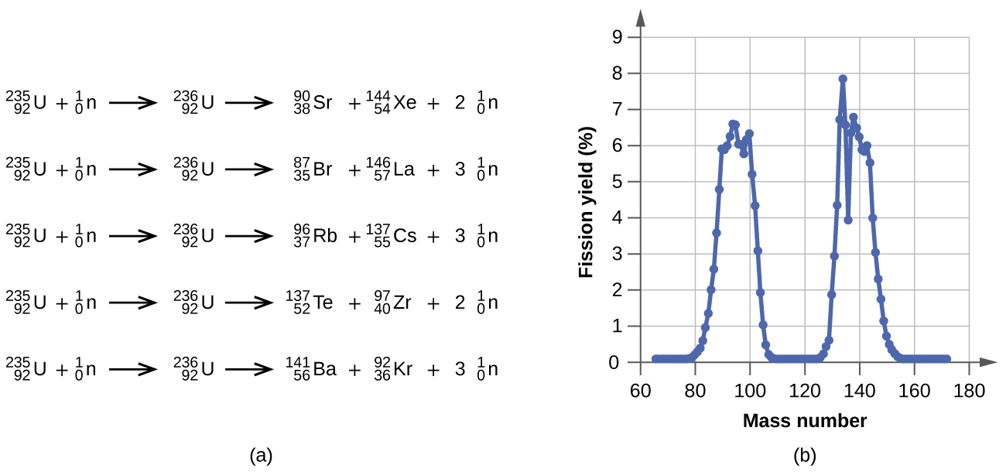
There are other possibilities, as shown below.

*YOU ARE NOT EXPECTED TO MEMORIZE ANY OF THESE REACTIONS. YOU SHOULD BE ABLE TO CONFIRM THAT THEY MEET THE CONDITIONS OF CONSERVATION OF CHARGE AND CONSERVATION OF NUCLEON NUMBER*

What is important to notice is that the reactions all produce energy, and they all produce more neutrons. These neutrons can then collide with other U-235 nuclei and trigger a chain reaction.
The neutrons that are released are high energy, meaning they are travelling very fast, in fact they are travelling too fast to induce a fission reaction.
The moderator, usually water, sometimes heavy water or graphite, functions to slow these neutrons down. This happens simply by collisions between the neutrons and the molecules of the moderator. Once slowed down, the neutrons can then start the chain reaction.
If the chain reaction proceeds too quickly, too much energy can be produced and there can be a nuclear meltdown, which can blow up the reactor and release radioactive material into the environment.
To control the reaction, control rods can be placed into the reactor core to absorb some of the neutrons. By moving the control rods into and out of the core, the reaction rate can be controlled. When the reaction is kept at stable controlled level it is said to be “CRITICAL”.

