Nuclear Structure:

Quarks:

In the early universe (10⁻⁶s – 1s) tiny particles called quarks begin to join together to form protons and neutrons.

There are 2 main types of quarks, called the up quark and the down quark.

- A proton consists of 2 up quarks and 1 down quark
- A neutron consists of 1 up quark and 2 down quarks

We already know that a proton has a charge of +1, while a neutron has a charge of 0 (it is neutral).

It is an interesting little math problem to figure out what the charge must be on each type of quark:

Proton: 2U + 1D = +1

Neutron: 1U + 2D = 0

This is a simple system of equations. I’ll leave this as an exercise for you to solve.

If you solve this problem you will find that there is only one solution:

- The up quark has a charge of $+\frac{2}{3}$

- The down quark has a charge of $-\frac{1}{3}$

So we have 2 of the fundamental building blocks of matter, which is the stuff that makes up everything around us.

PROTON: NEUTRON:

D
$$-\frac{1}{3}$$

D
$$-\frac{1}{3}$$

U
$$+\frac{2}{3}$$

D
$$-\frac{1}{3}$$

U
$$+\frac{2}{3}$$

U
$$+\frac{2}{3}$$

Total Charge: Total Charge:

Together protons and neutrons are referred to as nucleons.
The temperature and pressure in the early universe was intense enough to allow the protons and neutrons to join together in a process called nuclear fusion. Nuclear fusion still happens today, inside of stars. In fact the Sun produces its energy by fusing Hydrogen nuclei into Helium nuclei.

An atomic nucleus is formed when protons and neutrons combine. In the early universe only very small nuclei could form: Hydrogen and Helium.

Hydrogen:

Hydrogen-1 Hydrogen-2 Hydrogen-3

Helium:

Helium-3 Helium-4 Helium-5

Isotopes: Versions of the same element with different numbers of neutrons, and thus, different masses. Isotopes will have identical chemical properties to one another, but may have important differences physically.

Nuclear Notation:
nucleon number Nuclear symbol/Chemical symbol
atomic number
$${}_{Z}^{A}X$$

A:

Z:
Nuclear Reactions:

Nuclear reactions occur when atomic nuclei either collide and join together, or when a large atomic nucleus is struck by a sub-atomic particle, usually a neutron, and splits into smaller nuclei.

Nuclear reactions are different from chemical reactions in three important ways:

- In a nuclear reaction new elements are formed. In a chemical reaction elements are rearranged, but no new elements are formed.
- In nuclear reactions mass may be gained or lost. This mass is converted to/from energy by the famous equation E=mc². In chemical reactions mass is always conserved.
- Nuclear reactions involve MUCH higher energies than chemical reactions.

In all nuclear reactions there are two important rules that are always followed. Scientists don’t fully understand why, but these rules are always obeyed in every one of the billions of reactions we have ever observed and tested.

- The total number of nucleons before and after the reaction is always the same. This is the
Law of Conservation of Nucleons.
- The total charge of all particles is the same before and after the reaction. This is the
Law of Conservation of Charge.

Fusion:

A nuclear fusion reaction occurs when two (or more) smaller nuclei collide with sufficient force to combine, or fuse, and form a larger nucleus. Fusion reactions only occur at extremely high temperatures and pressures.

The conditions in the early universe (~1-20s after the Big Bang) were right to form Hydrogen and Helium nuclei, but not larger nuclei. The conditions to form nuclei do not exist anywhere in nature today, except for the interior of stars. In fact all large nuclei (larger than Helium) were, and continue to be, made in the interior of stars.

Examples:

The fusion of hydrogen-1 and hydrogen-3 to form helium-4

The fusion of beryllium-8 and helium-4 to form carbon-12

The fusion of hydrogen-2 and nitrogen-15 to form _____________________ and 1 neutron

What is very interesting (and somewhat counter intuitive) about nuclear reactions is that the mass of the new nucleus is different from the mass of the nuclei that formed it. The whole is LESS than the sum of its parts in some cases, and GREATER in others. This change of mass was predicted by Albert Einstein and is summarized by the formula ΔE=Δmc². We don’t need to worry about the exact details, but what it means is that the lost mass is released as energy, and the amount of energy is huge!

Fission:

A nuclear fission reaction occurs when a sufficiently large nuclei collides with a small particle, usually a neutron. The smaller particle is temporarily absorbed by the large nucleus, forming a highly unstable intermediate nucleus. This intermediate then splits, or fissures, into smaller nuclei.

Fission reactions do not require the same intense temperature and pressure to occur as fusion reactions. However fissionable nuclei are relatively rare in nature and these reactions require special conditions to occur. Sustained fission reactions are very rare in nature. All nuclear power plants on Earth (about 15% of global energy), nuclear submarines and most nuclear weapons operate on nuclear fission.

Examples:

A neutron is fired into uranium-235 forming uranium-236. U-236 splits into Barium-141 and Krypton-92 and 3 neutrons.
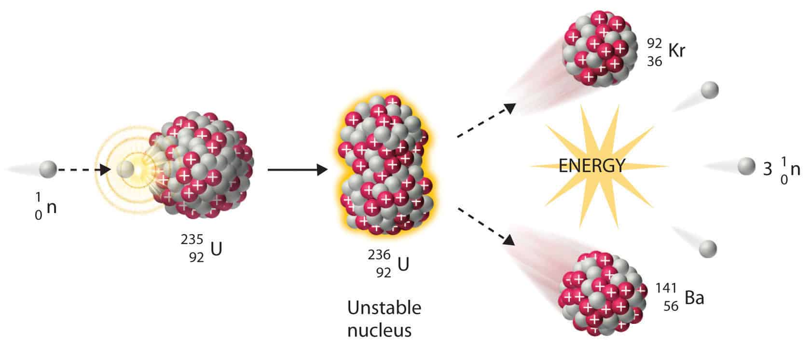

Notice that 3 more neutrons were released. Each of these can now hit another U-235 nucleus and split it. This may lead to a chain reaction!

A neutron is fired into a Plutonium-244 nucleus forming Pu-245. Pu-245 then fissions into Gold-204 and ___________-35 and ___ neutrons.

Nuclear Decay and Radioactivity

As discussed before the nucleus is a tightly packed little clump of protons and neutrons. These protons repel each other electrically. What keeps the nucleus from blowing apart as a result of this repulsion is the strong nuclear force between the protons and the neutrons. The strong nuclear force only acts over incredibly short distances, so as the nucleus gets larger, more and more neutrons are needed to keep the nucleus together. Eventually the nucleus can get too large and despite the neutrons’ best effort, the repulsive electrostatic force wins out and the nucleus becomes unstable and spontaneously breaks apart. This is known as radioactive decay. Radioactive decay happens in four main ways:

Radioactivity was discovered in 1896 by Henri Becquerel, although he did not understand the mechanisms. It was Marie Curie (the first woman to win the Nobel Prize, first person to win the Nobel Prize twice and the only scientist to have ever won the Nobel Prize in two different branches of science) who discovered that the radiation was emitted by the element itself. She also discovered two new elements, polonium and radium and coined the term radioactivity.

Each of the four ways is named after the decay particle that is ejected from the nucleus.

Alpha Decay:

First type of decay discovered. Named after the first letter of the Greek alphabet, alpha (α). Experiments by Henri Becquerel and Ernest Rutherford showed that the alpha particle had a positive charge and a relatively large mass.

The atomic symbol for an alpha particle is: ${}_{2}^{4}α$

The general form of an alpha decay is:

$${}_{Z}^{A}P→{}_{2}^{4}α + {}_{ Z-2}^{A-4}D$$

Parent Decay Particle Daughter

Examples:

Alpha decay of lead-210:
210 = 4 + 206
82 = 2 + 80

$${}_{82}^{210}{Pb}→{}_{2}^{4}α + {}_{ 80}^{206}{Hg}$$

Alpha decay of francium-223:

$${}_{87}^{223}{Fr}→{}_{2}^{4}α + {}_{}^{}{}$$

Beta (negative) decay:

Second type of radioactive decay discovered. Named after the second letter of the Greek alphabet, beta (β). Experiments by Henri Becquerel and Ernest Rutherford showed that the beta particle had a negative charge and an extremely small mass.

The atomic symbol for a beta (negative) particle is: ${}_{-1}^{0}β$

The general form of a beta decay is:

$${}_{Z}^{A}P→{}_{-1}^{0}β + {}_{ Z+1}^{A}D$$

Parent Decay Particle Daughter

Examples:

Beta negative decay of Thorium-231:
231 = 0 + 231

$${}_{90}^{231}{Th}→{}_{-1}^{0}β + {}_{ 91}^{231}{Pa}$$

90 = -1 + 91
Beta negative decay of Osmium-191:

$${}_{76}^{191}{Os}→{}_{-1}^{0}β + {}_{}^{}{}$$

Beta (positive) decay:

Fourth type of decay discovered. Named after the second letter of the Greek alphabet, beta (β). Experiments by Dmitri Skobeltsyn, Chung-Yao Chao and Carl David Andersen showed that the beta-positive particle had a positive charge and an extremely small mass. It behaved exactly like an electron (β⁻) except that it curved in the opposite direction when exposed to electric or magnetic fields.

The atomic symbol for a beta (negative) particle is: ${}_{1}^{0}β$

The general form of a beta-positive decay is:

$${}_{Z}^{A}P→{}_{1}^{0}β + {}_{ Z-1}^{A}D$$

Parent Decay Particle Daughter

Examples:

Beta-positive decay of fluorine-18
18 = 0 + 18

$${}_{9}^{18}F→{}_{1}^{0}β + {}_{ 8}^{18}O$$
9 = 1 + 8

Beta-positive decay of zinc-64

$${}_{30}^{64}{Zn}→{}_{1}^{0}β + {}_{}^{}{}$$

Gamma decay:

Third type of decay discovered. Named after the third letter of the Greek alphabet, gamma (γ). Discovered by French chemist Paul Villard in 1900. These rays behaved much like X-rays, but had much higher penetrative power.

The atomic symbol for a gamma particle is: ${}_{0}^{0}γ$

The general form of a gamma decay is:

$${{}_{Z}^{A}P}^{*}→{}_{0}^{0}γ + {}_{ Z}^{A}D$$

Parent Decay Particle Daughter

Examples:

Gamma decay of cesium-134
134 = 0 + 134

$${}_{55}^{134}{Cs^{*}}→{}_{0}^{0}γ + {}_{ 55}^{134}{Cs}$$
55 = 0 + 55

Gamma decay of Iodine-131

$${{}_{53}^{131}I}^{*}→{}_{0}^{0}γ + {}_{}^{}$$

Practice:

Write the equation for the alpha decay of the following nuclei:

Actinium-227
Einsteinium-254
Uranium-238
Americium-241

Write the equation for the beta-negative decay of the following nuclei:

Rhenium-187
Silicon-31
Carbon-14
Barium-141

Write the equation for the beta-positive decay of the following nuclei:

Sodium-22
Carbon-11
Fluorine-18

Write the equation for the gamma decay of the following nuclei:

Cobalt-60
Beryllium-10

