Heredity, DNA and Mutations

Heredity

“a recessive allele affects the phenotype
only if the genotype is homozygous”

Heredity is the study of how traits, or characteristics, can be passed on from generation to generation. By studying this, scientists learn how to fight disease, how to increase crop productivity, how natural selection works, how to treat and prevent genetic disorders and many other important questions, including questions about the very origins of life.

By the end of this first unit you should have developed a basic understanding of inheritance and a basic command of some of the technical language involved. More concisely, you should have a clear understanding of the meaning of the statement at the top of the page.

Mendelian Genetics

You have most likely noticed that many traits run in families. For instance, members of a family may share similar facial features (like the noses on Mike Ilitch and his son, Ron), hair color (like the brother and sister below), or a predisposition to health problems such as diabetes. Characteristics that run in families often have a genetic basis, meaning that they depend on genetic information a person inherits from his or her parents.

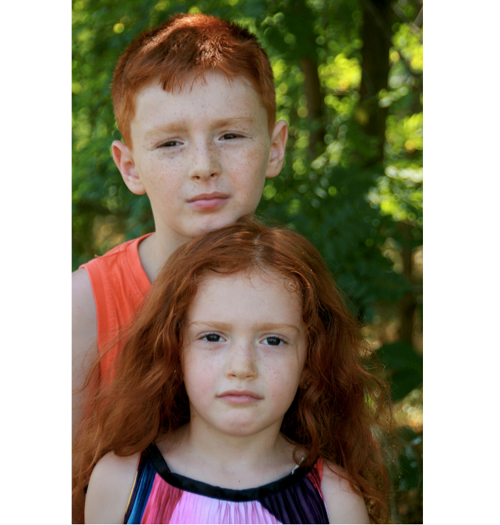

What if you wanted to figure out how genetic information is transmitted between generations? For instance, you might be curious how traits can "skip" a generation, why do two siblings look more like their father and one more like their mother, or why one child in a family may suffer from a genetic disease while another does not. How could you go about asking these kinds of questions scientifically?

An obvious first idea would be to study human inheritance patterns directly, but that turns out to be a tricky proposition. Scientists cannot conduct experiments on humans without consent and humans are very complex. Beyond this it can be very hard, if not impossible, to quantify a physical trait like bigness of a nose, or the shape of someone’s head.
So how do scientists study genetics? Well, the beginning of understanding of how traits are passed from one generation to the next came in the mid-1800s courtesy of a Russian monk and scientist named Johann Gregor Mendel (1822–1884), often called the “father of genetics”.

Research on heredity

In 1856, Mendel began a decade-long research project to investigate patterns of inheritance. Although he began his research using mice, he later switched to honeybees and plants, ultimately settling on garden peas. Mendel chose peas for several reasons:

- Easy to breed.
- Relatively short growth time.
- Many traits that were very clear to distinguish (tall/short, green/yellow, wrinkled/smooth…)
- Many traits with only two alternatives (tall/short, green/yellow, wrinkled/smooth…)
- Can self pollinate or cross pollinate (can reproduce alone or with two parents)

Mendel studied the inheritance of seven different features in peas, including height, flower color, seed color, and seed shape. First established pea lines with two different forms of a feature, such as yellow peas vs green peas. He grew these lines for generations until they were pure-breeding (always produced offspring identical to the parent), then bred them to each other (cross-bred) and observed how the traits were inherited.

In addition to recording how the plants in each generation looked, Mendel counted the exact number of plants that showed each trait. Strikingly, he found very similar patterns of inheritance for all seven features he studied:

EXAMPLE:
1. Mendel developed two pure breeding strains of pea plants: Tall stem and Short Stem. This is called the parental generation or P generation.
2. He then cross pollinated (bred/mated) tall plants with short plants.
3. 100% of the offspring (babies) were tall. This is the F1 generation.
4. Mendel concluded that tall was the dominant trait and that short was the recessive trait.
5. Mendel then self pollinated plants from the F1 generation.
6. Surprisingly short plants re-appeared in this next generation, the F2 generation.
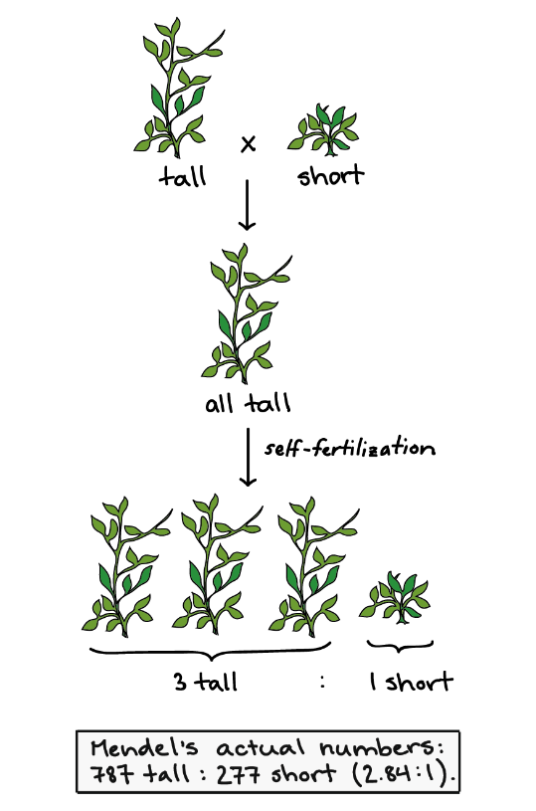
7. Mendel found that the F2 generation was 75% tall, 25% short. In other words, 3 tall plants for every 1 short plant.

P

F1

F2

Mendel’s Solution

Mendel started by assuming that each trait is controlled by a single gene (although he used the term element). He further proposed that each gene has two different forms, one of which will be dominant the other will be recessive. As the name applies the dominant form of the gene will dominate, or mask, the recessive form of the gene.

Mendel imagined that an offspring inherits one form of each gene from each parent. Each of these individual forms of a gene is called an allele. Thus each trait is controlled by a gene. And each individual has two alleles of each gene, the genotype. How the trait shows up, the phenotype, depends on the combination of alleles.

Mendel used letters to stand in for alleles; uppercase for dominant, lowercase for recessive.

Let’s try to understand with some examples.

Ex1.
Imagine that there is a single gene for flower colour in a type of flower. These flowers can only be blue or yellow. When pure bred blue flowers are crossed with pure bred yellow flowers the offspring is 100% yellow.

- The gene for colour thus has two forms, or alleles. One codes for blue flowers, the other codes for yellow.
- The allele for yellow is dominant. The allele for blue is recessive.
- Assign the following letters for the alleles: Y = yellow, y = blue.
- Each individual has 2 alleles for each trait. This is called the genotype.
- How the genotype is expressed is called phenotype.

For the example above (and for all examples with only two alleles) there are 3 possible genotypes:

Description | Genotype | Phenotype
Homozygous dominant | YY | Yellow flowers
Heterozygous | Yy | Yellow flowers
Homozygous recessive | yy | Blue flowers

*Can you think of a reason that the alleles were not labeled Y for Yellow and B for blue?

Before we get to actually predicting offspring and attempting to explain the Pea Plant Problem, lets practice a few examples:

A certain species of beetle has two possible forms for pincers, straight or curved. When pure bred straight pincered beetles are mated with pure-bred curved pincered beetles all the offspring have curved pincers. Complete the table below:

Description | Genotype | Phenotype
Homozygous dominant
Heterozygous | Cc
Homozygous recessive

Let’s try some more:

1. A type of coniferous tree has two possible cone types open cones and closed cones. Trees with heterozygous genotypes have open cones. Complete the table below: (Choose appropriate letters on your own).

Description | Genotype | Phenotype
Homozygous dominant
Heterozygous
Homozygous recessive

2. A species of mushroom has two distinct cap forms; pointed or flat. Pure bred pointed crossed with pure bred flat produce 100% pointed caps. Complete the table below: (Choose appropriate letters on your own).

Description | Genotype | Phenotype

3. A species of butterfly has two distinct phenotypes related to antenna length (long or short). Butterflies with a heterozygous genotype have short antennae. Complete the table below: (Choose appropriate letters on your own).

Description | Genotype | Phenotype

4. A species of bacteria has two forms of flagella, single flagella or dual flagella. Bacteria that are homozygous recessive have dual flagella. Complete the table below: (Choose appropriate letters on your own).

Description | Genotype | Phenotype

Now we are ready to see how Mendel used these ideas to explain patterns of inheritance.

Punnett Squares:

Each parent has two alleles for a certain gene. When they mate, they donate one of these alleles to their offspring, at random. Let’s go back to our pea plants:

There is a single gene that determines height, and there are two forms, tall or short. We know that if we breed pure bred tall plants with pure bred short plants the offspring is 100% tall. So…

Description | Genotype | Phenotype
Homozygous dominant
Heterozygous
Homozygous recessive

Now pure breeding plants are the homozygous varieties, so the parents’ generation will be one TT plant and one tt plant.

So all of the off spring are GENOTYPES: RATIO:

PHENOTYPES: RATIO:

When these offspring are crossed (self pollination is the same) the Punnett square will be:

So all of the off spring are GENOTYPE: RATIO:

PHENOTYPE: RATIO:
Dihybrid Crosses:

Mendel found the inheritance of one trait had no effect on the inheritance of another trait. For example, he found that tall plants were no more or less likely to have yellow peas; white flowered plants are no more or less likely to have wrinkled peas. And so on.

The following example illustrates a dihybrid cross between two double-heterozygote pea plants. R represents the dominant allele for seed shape (round), while r represents the recessive allele (wrinkled). Y represents the dominant allele for pea colour (yellow), while y represents the recessive allele (green).

There are 9 possible genotypes resulting from these two allele sets:

RRYY RRYy RRyy RrYY RrYy Rryy rrYY rrYy rryy

Notice that you could figure this out as we know there are three genotypes for each gene, thus for two genes the number of combinations is 3x3=9. If we had 3 genes there would be 3x3x3=27 possible geneotypes.

If we cross two plants that are heterozygous (HYBRID) for both traits, TtYy, then there are four different combinations for the combination of alleles (from each parent) passed to the offspring:

RY, Ry, rY, ry

 | RY | Ry | rY | ry
RY
Ry
rY
ry
What is the total number of possible combinations for offspring in the table above?

List all the possible genotypes of the off spring and count how often each appears in the table above.

What is the probability of each of the genotypes?

What is the ratio of the genotypes?
List all the possible phenotypes of the off spring and count how often each appears in the table above.

What is the probability of each of the phenotypes?

What is the ratio of the phenotypes?

Forked-line method

The forked-line method (also known as the tree method and the branching system) can also solve dihybrid and multihybrid crosses. A problem is converted to a series of monohybrid crosses, and the results are combined in a tree. However, a tree produces the same result as a Punnett square in less time and with more clarity. The example below assesses another double-heterozygote cross using RrYy x RrYy. As stated above, the phenotypic ratio is expected to be 9:3:3:1 if crossing unlinked genes from two double-heterozygotes. The genotypic ratio was obtained in the diagram below, this diagram will have more branches than if only analyzing for phenotypic ratio.
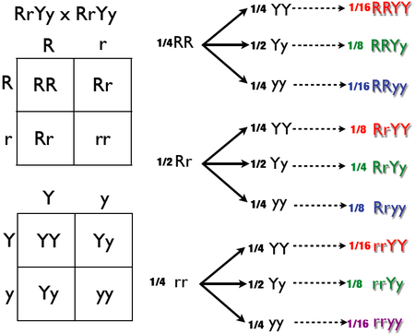

Mendel’s Laws:

Mendel summarized his results as a set of three laws.

1. Mendel hypothesized that allele pairs separate randomly, or segregate, from each other during the production of gametes: egg and sperm. Because allele pairs separate during gamete production, a sperm or egg carries only one allele for each inherited trait. This is called the Law of Segregation.

2. Each parent contributes one allele for each gene. When sperm and egg unite at fertilization, each contributes its allele, so the offspring have two alleles for each gene. If the offspring receives one of each allele (they are heterozygous for that trait), only one trait will be expressed in the phenotype. This is known as the Law of Dominance but it is not a transmission law: it concerns the expression of the genotype. The upper-case letters are used to represent dominant alleles whereas the lowercase letters are used to represent recessive alleles.

3. Mendel also found that each pair of alleles segregates independently of the other pairs of alleles during gamete formation. In other words the inheritance of one trait does not affect the probability of inheriting another trait. Genes are independent. This is known as the Law of Independent Assortment.
To summarize this summary:

1. Law of Segregation: During the formation of sex-cells the alleles for each gene separate (segregate) randomly so each gamete carries only one allele for each gene.

2. Law of Dominance: Individuals with one of each type of allele only express one allele. The allele that is expressed in the phenotype is the dominant allele. The allele that is hidden is the recessive allele.

3. Law of independent: Genes of different traits separate independently during gamete formation.
assortment.

Non-Mendelian Genetics:

Mendel’s laws were instrumental to the understanding of heredity. Mendel used proper scientific techniques and was the first person (that we know of) to treat inheritance as a science. His techniques and conclusions continue to be used and to shape our thinking today.

However, the inheritance of characteristics is not always as simple as it is for the characteristics that Mendel studied in pea plants. Each characteristic Mendel investigated was controlled by one gene that had two possible alleles, one of which was completely dominant to the other. This resulted in just two possible phenotypes for each characteristic. Mendel also only looked at genes that were inherited independently, which is often not the case.

Co-Dominance and Incomplete Dominance

Codominance
Codominance occurs when both alleles are expressed equally in the phenotype of the heterozygote. Both phenotypes are expressed simultaneously. The red and white flower in the figure has codominant alleles for red petals and white petals.
The flower is both red and white.

Incomplete Dominance occurs when the phenotype of the heterozygote is a blend of the two alleles. Neither phenotype is completely expressed. In incomplete dominance a cross between pure-breeding red and white flowers results in pink flowers.
The flower is neither red nor white, but a blend.
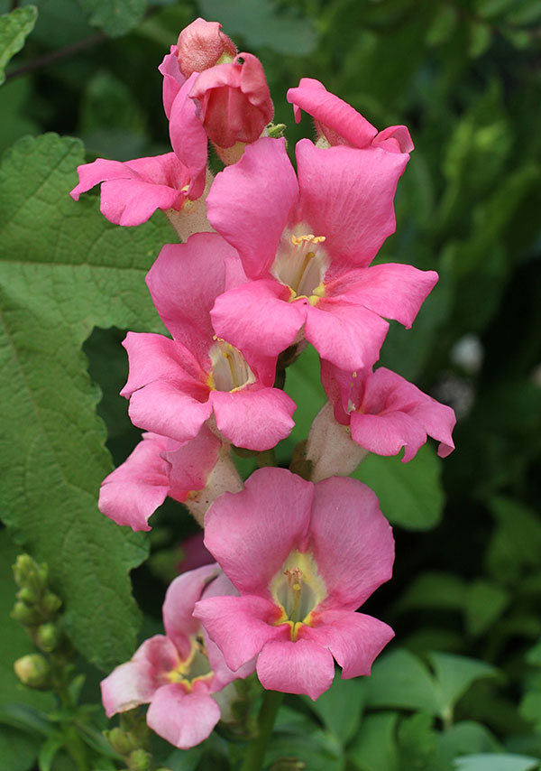
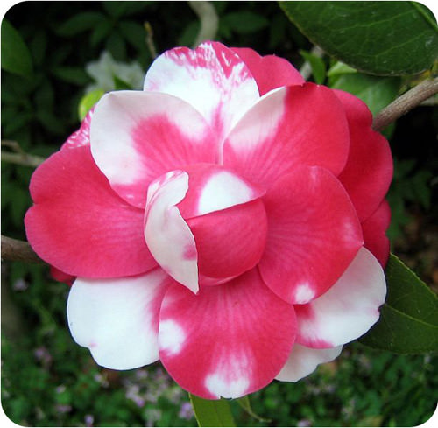

Codominance: The heterozygote is BOTH red and white. Incomplete Dominance: The heterozygote is NEITHER red nor white, but a blend

Multiple Alleles: Many genes have multiple (more than two) alleles. An example is ABO blood type in humans. There are three common alleles for the gene that controls this characteristic. The alleles I^{A} and I^{B}are dominant over i. A person who is homozygous recessive ii has type O blood. Homozygous dominant I^{A}I^{A} or heterozygous dominant I^{A}i have type A blood, and homozygous dominant I^{B}I^{B}or heterozygous dominant I^{B}i have type B blood. I^{A}I^{B} people have type AB blood, because the A and B alleles are codominant. Type A and type B parents can have a type AB child. Type A and type B parents can also have a child with Type O blood, if they are both heterozygous (I^{B}i, I^{A}i). Type A blood: I^{A}I^{A}, I^{A}i

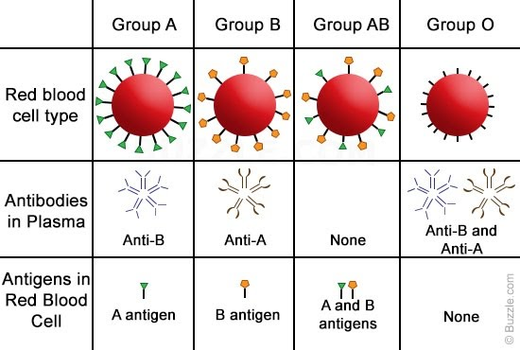
- Type A blood: I^{A} I^{A}, I^{A} i
- Type B blood: I^{B} I^{B}, I^{B} i
- Type AB blood: I^{A}I^{B}
- Type O blood: ii

