Physics 12 Circuits Lab:

Purpose:

* To practice building circuits and measuring current and potential difference.
* To investigate the behavior of chemical cells under various current loads.
* To determine a relationship between current and terminal voltage.

Materials:

* 1 1.5V Cell
* 3 1.5V Bulbs
* 9 Leads
* 1 Doorbell Switch
* 1 Digital Multimeter
* 1 Analog milliammeter

Setup:

* Construct the basic circuit shown below:

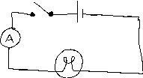

1. Close the switch to make sure the bulb lights.
2. Immediately read the ammeter and record the current in row 1 of the data table.
3. With the switch closed and the bulb lit, connect the multimeter (set to 2V DC) across the battery. Record the potential difference in row 1 of the data table.
4. Add one additional bulb in parallel with the first.

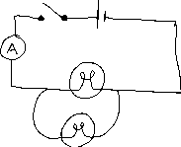

1. Repeat the measurements from steps 2 and 3 and record in row 2 of the table.
2. Add a third bulb in parallel.
3. Repeat the measurements from steps 2 and 3 and record in row 3 of the table.
4. Reconnect the circuit with two bulbs in series.

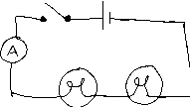

1. Repeat the measurements from steps 2 and 3 and record in row 4.
2. Disconnect the circuit, measure and record the potential difference of the cell.

Data and Observations:

|  |  |  |
| --- | --- | --- |
|  | Current (A) | Potential Difference (V) |
| 1 |  |  |
| 2 |  |  |
| 3 |  |  |
| 4 |  |  |

Battery Potential: ___________________________________

Record any observations and describe any difficulties with the lab:

Analysis:

1. Plot a graph of Potential difference vs. Current.

2. Normalize the resulting curve.

3. Find the equation of the normalized curve.

4. Describe the physical meaning of the y-intercept.

5. Describe the physical meaning of the slope.