DNA Extraction Lab:

DNA is often used in crime investigations to help identify victims and perpetrators. DNA can be obtained from hair, skin, blood and saliva. However before technicians can analyze a sample the DNA must be pulled out from the nuclei of the cells. Considering you can’t see a cell, let alone a nucleus, how can the DNA be removed? Well, the answer is, of course, SCIENCE!

PURPOSE:

- To extract the DNA from a sample of biotic material.
- To practice safe laboratory techniques.
- To preview some ideas about chemistry

MATERIALS:

!frozen strawberry or piece of kiwi 1 50mL beaker 1 test tube
1 test tube test tube rack metal probe graduated cylinder
eyedropper slide cover slip ~5mL dishsoap
~2.5mL salt 25mL tap water ethanol (0ºC)

PROCEDURE:

1. Place strawberry in 50mL beaker
2. Add: 1 squirt (~5mL) of dish soap, 1 spoon salt (~2.5mL) and then 25mL tap water
3. Gently mash the contents. Keep at room temp for 5 minutes.
4. Half-fill a test tube with the strwbwrry mixture.
5. Tilt the test tube just enough that you do not spill and slowly pour cold alchohol down the side of the test tube until it is ¾ full.
6. Observe. Make a sketch of what you see.
7. Look to see a layer that appears whit and cloudy between the layers of liquid. THIS IS THE DNA!
8. Using the probe, GENTLY spin and wrap the DNA around the rod. Pull the probe slowly from the test tube.
9. Observe the DNA.
10. Use the eyedropper to obtain a small bit of the DNA and wet mount it.
11. Observe the DNA under low medium and high power on the microscope.
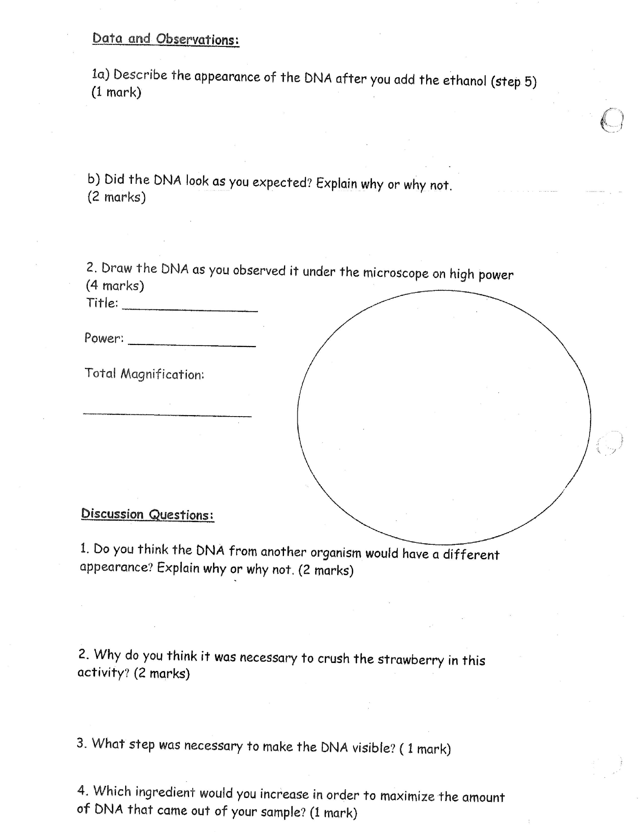
12. Make a sketch of the DNA as seen under high power.

