Name: __________________________________
Calorimetry Lab

Purpose:

To look at energy converted from chemical potential energy to thermal energy.
To consider and analyze error sources in experimentation.

Introduction:

What does it mean to say that we burn food in our bodies? The digestion and metabolism of food converts the chemical constituents of food to carbon dioxide and water. This is the same overall reaction that occurs when organic molecules—such as carbohydrates, proteins, and fats—are burned in the presence of oxygen. The reaction of an organic compound with oxygen to produce carbon dioxide, water and heat is called a combustion reaction. The chemical equation for the most important reaction in our metabolism, the combustion of glucose, is shown below.

C₆H₁₂O₆ + O₂ → CO₂ + H₂O + energy

Within our bodies, the chemical energy of food molecules is converted to heat energy (to maintain our constant body temperature), mechanical energy (to move our muscles), and electrical energy (for nerve transmission). The total amount of energy released by the digestion and metabolism of a food is referred to as its caloric content and is expressed in units of nutritional Calories (note the uppercase C). The caloric content of most prepared foods is listed on their nutritional information labels.

Nutritionists and food scientists measure the caloric content of food by burning the food in a special device called a calorimeter. Calorimetry is the measurement of the amount of heat energy produced in a reaction. Calorimetry experiments are carried out by measuring the temperature change in water (or some other substance) that is in contact with, or surrounds, the reaction. (The reactants and products together are referred to as the system, the water as the surroundings.)

Safety

Wear safety glasses when performing this or any lab that uses chemicals, heat or glassware. Care should be taken when handling or placing food onto the pin point. Allow the food sample to cool before touching or discarding it. Use a glass stirring rod to stir the liquid; never stir with a thermometer. Students should not be allowed to eat the snack foods once they are brought into the lab. This lab should be performed in a well-ventilated room.

Experimental Procedure:

1. Form a paperclip into a stand for food and create a tinfoil chimney (see instructor’s demo stand).
2. Assemble the ring stand and ring as shown.
3. Obtain 2 Cheetos (or approximation thereof), one puffy and one crispy. Find the mass of each of the samples and record its mass in the DATA TABLE.
4. Place 50.0 mL of water in the Florence flask, Place the flask into the ring clamp such that the bottom of the flask is ~2cm above the food.
5. Insert the thermometer into flask so thermometer bulb is submerged but does not contact the flask. Record this as the initial temperature, T₀, for trial 1.
6. Place the Cheeto on the stand under the flask as shown in the diagram. If necessary re-adjust height of the ring so that the bottom of the flask is about an 2cm from the top of the Cheeto.
7. Light the Cheeto on fire with the matches. Be sure the flask is directly over the flame. Immediately place the chimney around the flame. CAUTION: be careful not to burn yourself!
a. Relight it immediately if it goes out before all of the food is completely combusted (i.e. burned to a
black crisp.)
8. As the food sample is burning, monitor the temperature of the water. Carefully observe to catch the maximum temperature reached by the water. The highest temperature will likely occur after the Cheeto has completely burned (why?). Record as the final temperature, T.
9. Find the mass of the ash remaining and record as the final mass.
10. Repeat procedure for the other Cheeto sample.

Data:
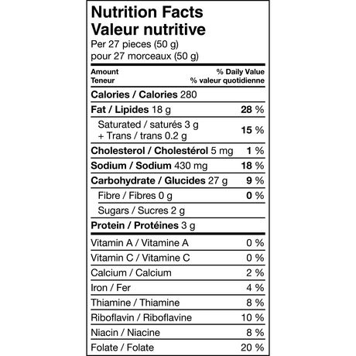
Cheetos Puffs Cheetos Crunchy
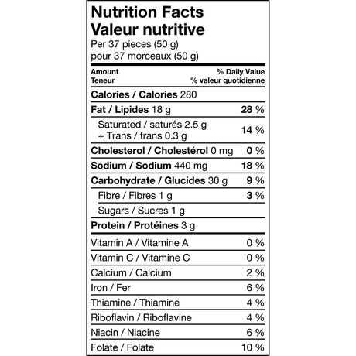

Name(s): ____________________________________________

Calorimetry Lab: Data and Analysis

Volume of Water: _______________________

Trial | Initial Mass (kg) | Final Mass (kg) | Δm (kg) | Initial Temperature (ºC) | Final Temperature (ºC) | ΔT (ºC)
Puffy
Crunchy

Analysis:

1. To estimate the calories in the food sample you will need the mass of the water you heated. Water has a density of 1.00g/mL and a specific heat of 4186J/(kg K)
a. Calculate the amount of energy transferred to the water in Joules. Use Q = mcΔT
b. Convert Joules to Calories. (1 Calorie = 1kcal = 1000 calories; 1 calorie = 4.184 J)

2. Calculate the number of nutritional calories (Kilocalories, Calories) per gram of Cheeto for each type of Cheeto.

3. Which type of Cheeto has a higher energy density?

4. Examine the Nutritional Value Information for the Cheetos food sample, found on the previous page. Use this information to determine the “accepted value” for the nutritional Calorie content per gram for each type of Cheeto.

5. What is the percent error for your experiment? $\frac{\left|actual-experimental\right|}{\left|actual\right|}×100\%$

6. Give 3 ways that the experiment could be changed in order to improve the accuracy. This could include changes to the procedure or to the equipment used.

