Preparing to Investigate

Energy Changes in Chemical Reactions
In this activity, you will explore the energy changes that accompany chemical reactions. To understand the energy implications of chemical reactions, it’s important to keep in mind two key ideas:
- It takes energy to break bonds.
- Energy is released when bonds are formed.
To understand this, consider the chemical reaction between vinegar (also known as acetic acid to chemists) and baking soda (known as sodium bicarbonate). Before the atoms of acetic acid and sodium bicarbonate can be rearranged to form the products, the bonds between the atoms in those molecules must be broken, and because the atoms are attracted to one another, it takes energy to pull them apart.
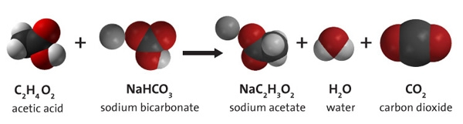
Then, when the products are formed (sodium acetate, water, and carbon dioxide) energy is released because atoms that have an attraction for one another are brought back together. Not every bond between atoms in the reactants is necessarily broken during a chemical reaction, but some bonds are.
By comparing the energy used when bonds in the reactants are broken with the energy released when bonds in the products are formed, you can determine whether a chemical reaction releases energy or absorbs energy overall.
Chemical reactions that release energy are called exothermic. In exothermic reactions, more energy is released when the bonds are formed in the products than is used to break the bonds in the reactants. Chemical reactions that absorb (or use) energy are called endothermic. In endothermic reactions, more energy is absorbed when the bonds in the reactants are broken than is released when new bonds are formed in the products. If a chemical reaction absorbs as much energy as it releases, it is called isothermic—there is no net energy change.
But because we can’t observe bonds breaking or being formed, how can we distinguish between exothermic and endothermic chemical reactions?

Identifying Exothermic & Endothermic Reactions
There are two methods for distinguishing between exothermic and endothermic reactions.
- Monitor temperature change
When energy is released in an exothermic reaction, the temperature of the reaction mixture increases. When energy is absorbed in an endothermic reaction, the temperature decreases. You can monitor changes in temperature by placing a thermometer in the reaction mixture.
- Calculate the change in enthalpy of reaction (ΔH)
To classify the net energy output or input of chemical reactions, you can calculate something called the enthalpy change (ΔH) or heat of reaction, which compares the energy of the reactants with the energy of the products.
Enthalpy is a measure of internal energy. So, when you calculate the difference between the enthalpy of the products and the enthalpy of the reactants, you find the enthalpy change (ΔH), which can be represented mathematically as:
ΔH = ΔH of bond breaking + ΔH of bond making
Remember: Energy used in reactant bond breaking is always positive (+) and energy released in product bond making is always negative (−).
If ΔH is negative (−) then the chemical reaction is exothermic, because more energy is released when the products are formed than energy is used to break up the reactants. If ΔH is positive (+) then the chemical reaction is endothermic, because less energy is released when the products are formed than the energy is used to break up the reactants.
You can also use energy level diagrams to visualize the energy change during a chemical reaction as a result of the energies used and released according to the above equation for ΔH. To understand these diagrams, compare the energy level of the reactants on the lefthand side with that of the products on the right-hand side.
The graph below charts the energy change when a candle burns. The wax (C₃₄H₇₀) combusts in the presence of oxygen (O₂) to yield carbon dioxide (CO₂) and water (H₂O). Because more energy is released when the products are formed than is used to break up the reactants, this reaction is exothermic, and ΔH for the reaction is negative.

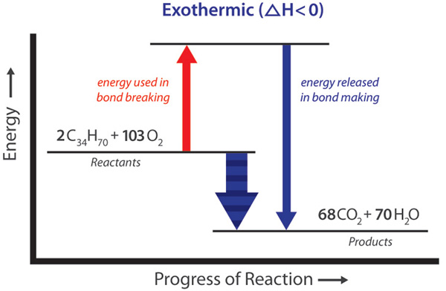

In this investigation, you will observe whether energy is absorbed or released in two different chemical reactions and categorize them as exothermic and endothermic. You will also explore the relationship between energy changes and chemical reactions.

Name: ___________________________________________

Energy in Chemical Reactions

Objective
Students will explore energy changes during chemical reactions, heat of reaction (ΔH), and the connection between energy changes and chemical changes.

Safety
- Be sure to wear properly fitting goggles.
- Acetic acid (vinegar) vapors can be irritating. Avoid breathing directly. In the event of eye contact, flush with water. The concentration of acetic acid in this experiment does not present any significant hazards.
- Calcium chloride can be an irritant to body tissues. In the event of contact, wash affected areas with water. Dispose of calcium chloride solutions according to local regulations.

Materials for Each Group

- ~10 mL Acetic acid
- ~20g Sodium bicarbonate
- ~5g Calcium chloride
- Water
- 2 small beakers, 1 medium beaker
- Gram balance
- Thermometer

Gathering Evidence

Sodium Bicarbonate and Acetic Acid
- Pour about 10 mL of acetic acid into a small beaker. Then, place a thermometer into the vinegar. Record the initial temperature (T_{i}) in the table below.
- While the thermometer is in the cup, add about 3g sodium bicarbonate to the beaker.
- Watch the thermometer for any change in temperature. After it has stopped changing, record the final temperature (T_{f}) and any other observations you made in the table below.

Sodium Bicarbonate and Calcium Chloride
- Make an aqueous solution of sodium bicarbonate by dissolving about 6g Na(HCO₃)₂ in 50mL of water in the medium beaker. Stir until no more baking soda will dissolve.
- Place about 20 mL of sodium bicarbonate solution in a small beaker. Then, place a thermometer into the baking soda solution. Record the initial temperature (T_{i}) in the table below.
- While the thermometer is in the cup, add 3.5g of calcium chloride to the cup.
- Watch the thermometer for any change in temperature. After it has stopped changing, record the final temperature (T_{f}) and any other observations you made in the table below.
Process | T_{i} | T_{f} | ΔT | Exothermic or Endothermic | Observations | ΔH (+/-)
Sodium bicarbonate +Acetic Acid
Sodium Bicarbonate + Calcium Chloride

Analyzing Evidence
- Based on your observations of the sodium bicarbonate and acetic acid reaction, is the reaction exothermic or endothermic? Apply your knowledge of energy changes in chemical reactions to complete the table above.
- Based on your observations of the sodium bicarbonate solution and calcium chloride reaction, is this chemical reaction exothermic or endothermic? Apply your knowledge of energy changes in chemical reactions to complete the table above.

Interpreting Evidence
- In the chemical reaction between sodium bicarbonate and acetic acid, what did you observe other than a temperature change? What might this tell you about one of the products of this chemical change?
- In the chemical reaction between sodium carbonate solution and calcium chloride, what did you observe other than a temperature change? What might this tell you about one of the products of this chemical change?
- Use your answers from questions 1 and 2 to help you write the chemical equation for:
  - the chemical reaction between sodium bicarbonate and acetic acid
  - the chemical reaction between sodium bicarbonate and calcium chloride
- Using the language of breaking and making bonds, explain the net energy change for both the chemical reaction between sodium bicarbonate and acetic acid and the chemical reaction between sodium bicarbonate and calcium chloride.
- Draw energy profiles for both chemical reactions. Refer to the exothermic energy profile shown previously as an example. Are they the same or different?
- What is the sign of the heat of reaction (ΔH) for an exothermic reaction? Why?

