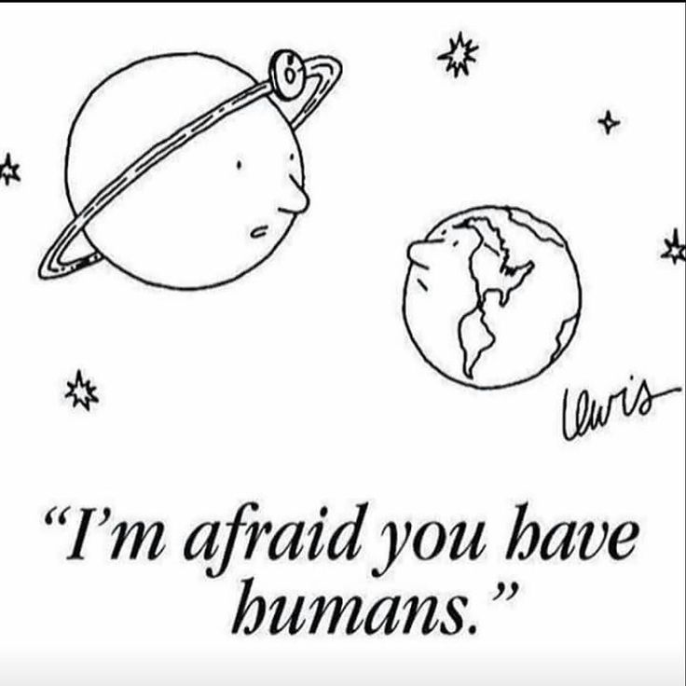

“I’m afraid it’s terminal. You have humans.”

Cartoon is by Eric Lewis and appeared in The New Yorker magazine October 2002. The original caption reads “I’m afraid you have humans”. The change was made for the purposed of discussion.
Questions/Discussion:
1. Explain what you think the cartoon means.

2. In the cartoon the Earth is presented as a “person”; what are people being compared to?

3. What does the word “terminal” mean in this context?

4. Do you agree or disagree with the idea presented by the cartoon? Explain why.

5. What does this have to do with science?

