How to Interpret Data:

Data is the information collected in a scientific experiment. Data can be qualitative, meaning descriptive, such as colour or smell, or it can be quantitative, meaning a measured numerical value like mass in grams or length in centimeters.
It is important to note that any observed and recorded information can be considered as data. Data does not only mean numbers.

Example: Consider the following observations made about a cat (named Steamy Gene). Identify each observation as Qualitative or Quantitative

- The cat has short fur
- The cat has four legs
- The cat is very large
- The cat is 108cm long
- The cat is 8.0kg
- The breed of that cat is a Maine Coon
- The cat is friendly
- The cat is grey
- Cats are mammals

Qualitative Data:

Qualitative data is information that can't actually be measured. Some examples of qualitative data are the softness of your skin, the level of pain you experience and the color of your eyes. However, try telling Photoshop you can't measure color with numbers.

Quantitative Data:

Quantitative data is generally displayed in Data Tables and in Graphs. Depending on the type of data collected there can be different types of graphs. The two main types of graph used in science are the bar graph and the scatter plot/best fit curve.

Bar graphs are usually used to compare variables when one is numerical and the other is not. For example the amount of rainfall (numerical) compared to the month of the year (not). Another example might be the number of chocolate bars sold (numerical) by each member of a soccer team (not) in a fund raiser. Sometimes a bar graph can be used to compare two numerical variable if one of them is discreet.

Scatter plots with best fit curves are usually used to compare two variables that are both numeric and continuous. For example the mass of a liquid (numerical) compared to the volume of the liquid (numerical). Another example is time for a sugar cube to dissolve (numerical) vs temperature of water (numerical).

Correlation types:

If two numerical values are somehow connected, like speed of a water wave and depth of the water, they are said to be correlated.
If both variables generally increase or decrease together (i.e. either both increase or both decrease at the same time) the correlation is called a POSITIVE CORRELATION.
If one variable generally decreases while the other increases the correlation is called a NEGATIVE CORRELATION.

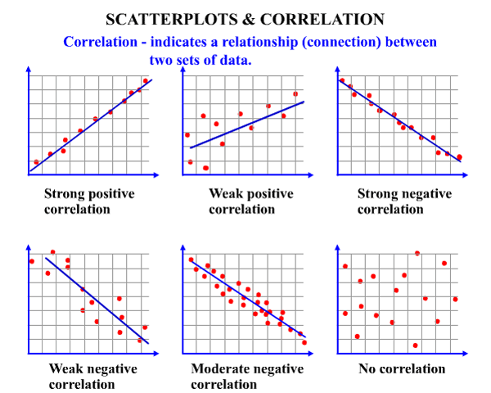

No correlation Strong positive
correlation (non-linear)

