Physics Group Questions:

For these questions show all work. You may do rough work on a sheet of paper. Make sure each member of the group in participating. The mark assigned will be a GROUP MARK and will be based on the process of discussion, debate, physics reasoning and the contributions of ALL GROUP MEMBERS.

A sprinter runs the 100.00m sprint in 10.00s. The sprinter starts at rest and accelerates uniformly to top speed over the first 40.00m. The sprinter then continues at top speed for the final 60.00m.

- Find the top speed reached by the sprinter, the acceleration for the first 40.00m and the time taken for each portion of the run.
- Sketch a graph of $\overset{⃑}{v}$ vs t, $\overset{⃑}{x}$ vs. t and $\overset{⃑}{a}$ vs. t

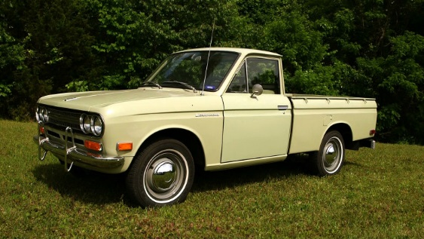
You are driving your beautiful 1972 Datsun 521 towards an intersection. A Porsche is stopped at the red light. You are traveling at 40.00 km/h (11.11 m/s). When you’re 15.0 m from the light, the light turns green, and the Porsche accelerates from rest at 3.00 m/s². You continue at constant speed.

- How far from the stop line do you pass the Porsche? At what time, measured from when the light turned green, do you pass the Porsche?

- As the Porsche keeps accelerating, it eventually catches up to you again. How far from the stop line does it pass you? At what time, measured from when the light turned green, does it pass you?

- Sketch a graph showing the motion of both cars. Set your initial position as the origin. Clearly show both times the cars pass one another.

- If a police officer happens to get you and the Porsche on a radar gun at the instant the Porsche passes you, will either of you be pulled over for speeding? Assume the speed limit is 50 km/h.

