Hubble’s Law and the Big Bang:

Look at the above scatterplot showing the original data from 23 observed galaxies that Edwin Hubble published in 1929.

1. What is the independent variable?
2. What is the dependent variable?
3. What does Mpc mean?
4. What does recessional mean?
5. What does km/s mean?
6. What type of correlation is shown from this data?
7. Describe in words what relationship is shown by this graph.

This data marks one of the most important moments in our understanding of the Universe. This tiny amount of data created a massive shift in astronomy and cosmology. From this data Edwin Hubble conjectured that the universe must be expanding. To try to understand his thinking complete the following activity.

Balloon Universe, or Ballooniverse.

- Get a balloon.
- Draw dots spaced over the surface of the balloon with a marker.
- At random select one galaxy to represent the Milky Way, the galaxy containing Earth. This is the galaxy from which all of our measurements are made.
- Select three other galaxies to observe. Each should be a different distance from the Milky Way.
- Measure the distance, in millimeters, from the Milky Way to each other galaxy before you inflate the Ballooniverse. Record.
- Partially inflate the Ballooniverse. Without allowing any air to escape, measure the distance from the Milky Way to each other galaxy using a piece of string. Record.
- Inflate the Ballooniverse more and again measure the distance from the Milky Way to each other galaxy. Record.
- Calculate how far each galaxy moved relative to the Milky Way for each period of inflation. Record.

Data Table:

Galaxy | Initial Distance (d₀) from Milky Way (mm) | Distance after First Inflation  (d₁)  (mm) | Distance travelled during First Inflation  (d₁-d₀)  (mm) | Distance after Second Inflation (d₂)  (mm) | Distance travelled during Second Inflation  (d₂-d₁)  (mm) | Distance travelled during Total Inflation  (d₂-d₀)  (mm)
1
2
3

1. What do you notice about the distance travelled by the three galaxies over the inflation?
2. Which galaxy was travelling most quickly?
3. Do the galaxies actually move from their positions on the Ballooniverse?
4. What is actually growing to push the galaxies apart?
5. How does this apply to Edwin Hubble’s 1929 data?

Essentially, what Hubble had discovered was that not only are galaxies moving, which was itself a breakthrough, but also that more distant galaxies move faster. Hubble was insightful enough to realize that this implied that the actual space between the galaxies was expanding!

Galaxies are not moving through space.
Rather the space between the galaxies is expanding!
It is the emptiness that is growing.

Take a second to let that sink in.

You may notice that Hubble’s original data is not indicating a strong correlation. But look what occurs as the data increases:
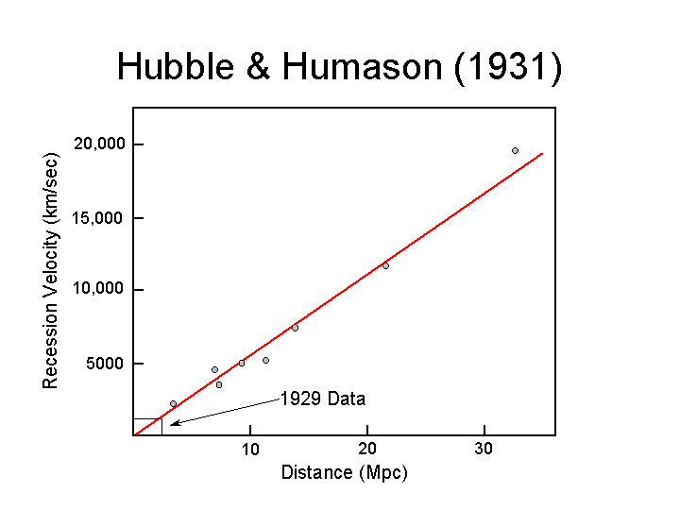
1355 Galaxies 2006
