A Brief History of the Universe (As We Know It):
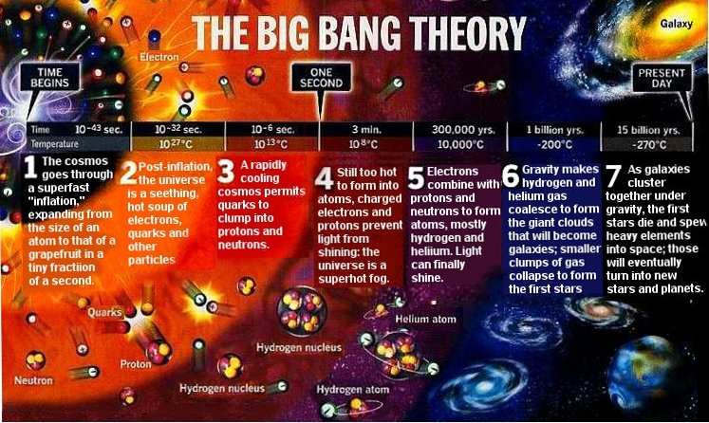
13.8

The universe is all of space and time and all of its contents. This includes galaxy clusters, nebulae, galaxies, solar systems, stars, planets and all other matter, anti-matter and energy. The size of the universe is not known, however the observable universe is measurable.

Geocentric vs Heliocentric

In early models of the universe, from ancient Greek and Indian philosophers, the universe outside of our solar system was static with Earth at centre. The Sun and other planets were believed to orbit around the stationary Earth. This is known as a Geocentric Model. It is worth noting that the Greek philosopher Arirstarchus of Samos did correctly propose that the Sun was at the center of our solar system and even placed the known planets in the correct order around the Sun circa 300 BCE. However his beliefs were not widely accepted.

This Geocentric model dominated until 1543, when Nicolaus Copernicus published his model with the Sun at the centre of the solar system. His model was based on based on careful observation of planets with telescopes and a great deal of mathematics. From that date forward the Heliocentric model of the universe dominated.

Timeline:
≈ 350 BC, Aristotle
Aristotle, a pupil of Plato, becomes the tutor of Alexander the Great. Aristotle's views of the world shape science for centuries. His influence lasts until the enlightenment. In his book On the Heavens (part 14), Aristotle asserts that:
From these considerations then it is clear that the earth does not move and does not lie elsewhere than at the centre.
≈ 250 BC, Aristarchus
Aristarchus estimates the size of the sun to be much larger than the size of the earth. Based on this observation he then presents the heliocentric model.
≈ 250 BC, Archimedes
In The Sand-Reckoner, Archimedes estimates the number of sand corns in the universe using the heliocentric model of Aristarchus.
≈ 150 AD, Ptolemy
In his book Almagest, Ptolemy introduces so called epicycles to explain planetary motions, based on the assumption that the earth is at the centre and does not move. Almagest is considered to be one of the most influential scientific works in history.
1543, Nicholaus Copernicus
Just before his death, Copernicus publishes the book De Revolutionibus Orbium Coelestium (On the Revolutions of the Heavenly Spheres) in which he places the sun rather than the earth at the centre of the universe. This book is the beginning of the Copernican Revolution.
1572, Tycho Brahe
Tycho Brahe observes a star being born and publishes his observation in De nova stella. Brahe's observation refutes the commonly held view at the time, a view which dates back to Aristotle, that the stars are fix and never changing at the outskirts of the universe. Since Brahe couldn't observe a stellar parallax, he concluded that the earth did not move. He proposed a model where the planets move around the sun, and the sun moves around the earth. (It was later shown that it wasn't a star being born Brahe had observed, but the supernova SN 1572, i.e. a star exploding.)
1609, Johannes Kepler
Using the observational data collected by Tycho Brahe, Johannes Kepler introduces his first two laws of planetary motion in Astronomia nova. The first law: the planets move in elliptical orbits with the sun at one focus.
1616, Roman Inquisition
On 24 February 1616 a team of eleven consultants for the Roman Inquisition condemns the Copernican System, stating that the heliocentric system is “foolish and absurd in philosophy” and “formally heretical”.
1633, Galileo Galilei
Galileo Galilei stands trial on suspicion of heresy "for holding as true the false doctrine taught by some that the sun is the centre of the world". At the trial he is found guilty and sentenced to formal imprisonment. Galileo spends the rest of his life under house arrest.
1687, Isaac Newton
Sir Isaac Newton publishes Philosophiae Naturalis Principia Mathematica (Principia). In Principia, Newton explains Kepler's laws of planetary motion in terms of universal gravitation. Newton doesn't consider the sun to be at rest, instead he uses the center of gravity of the solar system.
1838, Friedrich Bessel
Friedrich Bessel is the first to accurately measure a stellar parallax. In 1838 he announces that the star 61 Cygni has a parallax of 0.314 arcseconds.

1992, Roman Catholic Church
Pope John Paul II closes a 13-year investigation into the church's condemnation of Galileo in 1633 by declaring that Galileo was right:
“Thanks to his intuition as a brilliant physicist and by relying on different arguments, Galileo, who practically invented the experimental method, understood why only the sun could function as the centre of the world, as it was then known, that is to say, as a planetary system. The error of the theologians of the time, when they maintained the centrality of the earth, was to think that our understanding of the physical world's structure was, in some way, imposed by the literal sense of Sacred Scripture.”

Further observations and improvements to telescopes provided clear evidence that our Sun is simply one of billions of stars in our galaxy, the Milky Way. The reason the Sun appears so large and bright is due to its proximity. It is only an average sized star. In fact the star Betelgeuse is 700 times as large and 14,000 times as bright!

A science continued to evolve and improve many new techniques were devised with which to observe planets and stars. As a result it was discovered by Edwin Hubble in 1929 that all other observable stars and galaxies are moving away from Earth. Further he found that the further away an object was, the more quickly it was moving away! This shows that the universe is expanding!

If the universe is expanding it is growing. If it is growing it must have been smaller in the past. If we trace that idea back far enough we get to the idea of the Big Bang Theory.

The Big Bang Theory:

At the beginning the entire universe was condensed into an unimaginably dense point smaller than the size of a single atom. At this point the universe was entirely composed of an unknown form of energy. Then for reasons that we do not know, and likely will never know, 13.8 billion years ago, the universe exploded and began to expand.

Everything that we know grew out of that tiny point, all of the matter energy space and time grew out of the expansion. That’s right, as far as we know before the Big Bang, even space and time did not exist. This is important to understand, anything that exists outside of the universe is currently thought to be unknowable scientifically, as we can observe it.

Initially the universe was very hot (~ a billion billion billion Kelvin). It was so hot that no matter could exist. In the early universe radiation dominated. This was known as the Radiation Era and it lasted for a whopping 200 seconds. That’s just over 3 minutes of the 13.8 billion year history, and yet it has provided some of the strongest evidence of the Big Bang.

